Affective Video Tutoring System
User Manual

Note: Internet Explorer is not fully supported and may cause issues.

To open the Affective Video Tutoring, use the following steps:
- The system is a part of the BECK Centre developed during the project. Open the BECK project website http://beck-erasmus.com/ to access the system (Fig. 1).
- Go to the BECK project website, select BECK Centre in the menu and click Affective Video Tutoring System in the drop-down menu (Fig. 1).
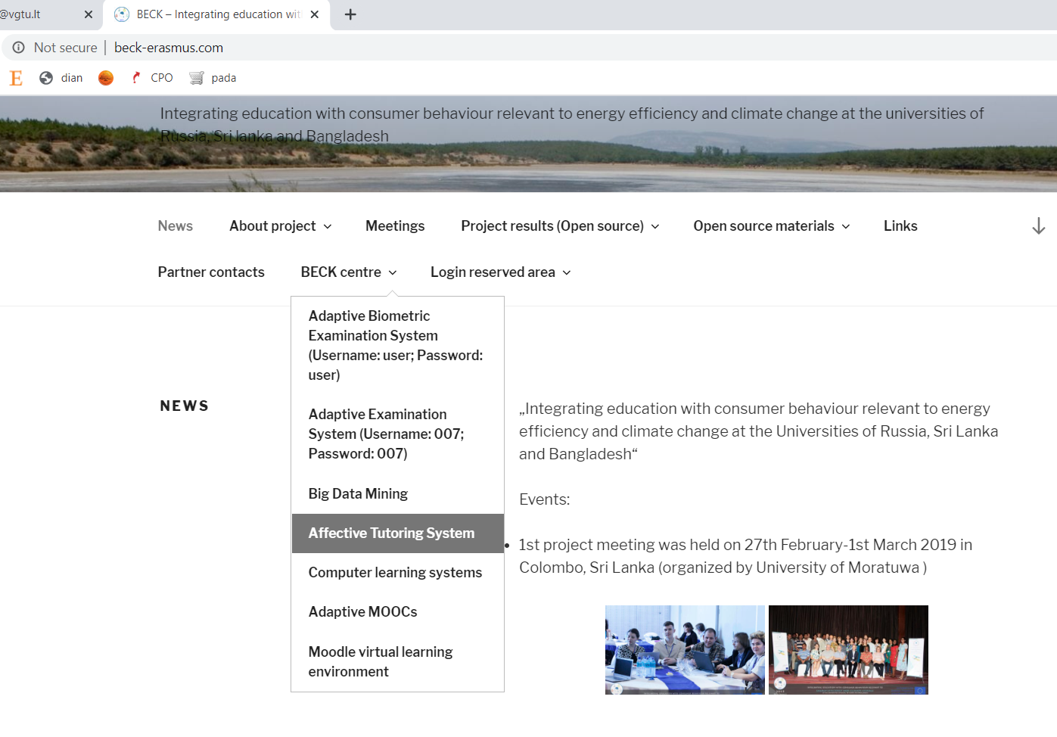
Fig. 1. The BECK project website.

- A window will open choose Affective Video Tutoring System (Username: user; Password:user) (Fig. 2).

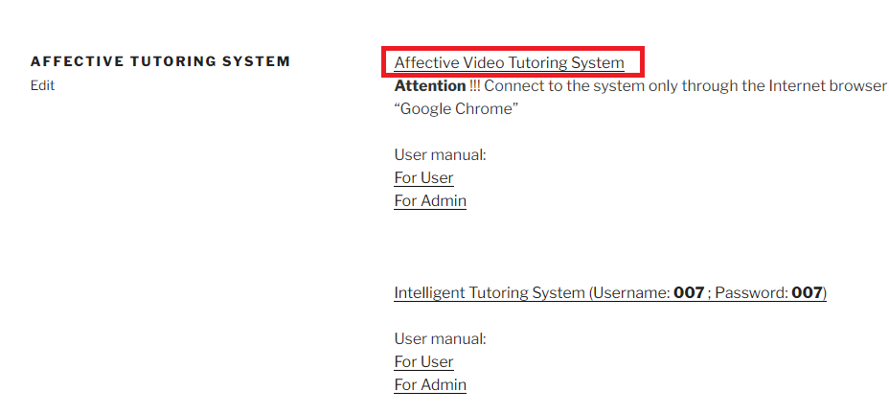
Fig. 2. Affective Video Tutoring System options.

- A window will open. Enter the login details in the window (Fig. 3):
  - Username: test@test.lt
  - Passvord: test
Click the Login button.

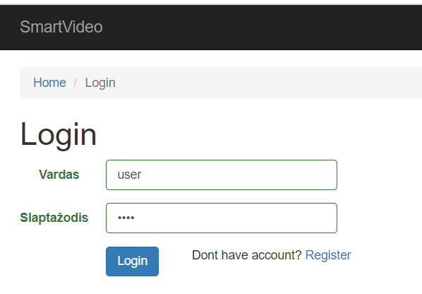
Fig. 3. The log-in window of Affective Video Tutoring System.

- Log into the system and select Climate Change (Fig. 4):

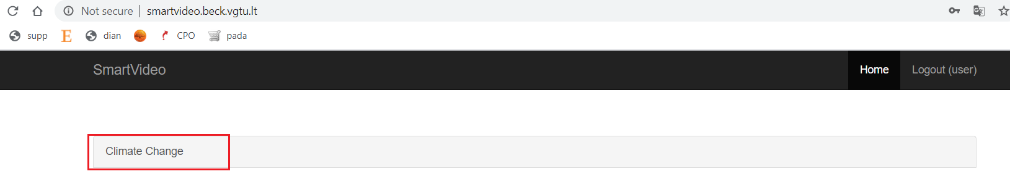
Fig. 4. Climate Change option.

- A questionnaire will open (Fig. 5). Select any topics you want to see and click Save.
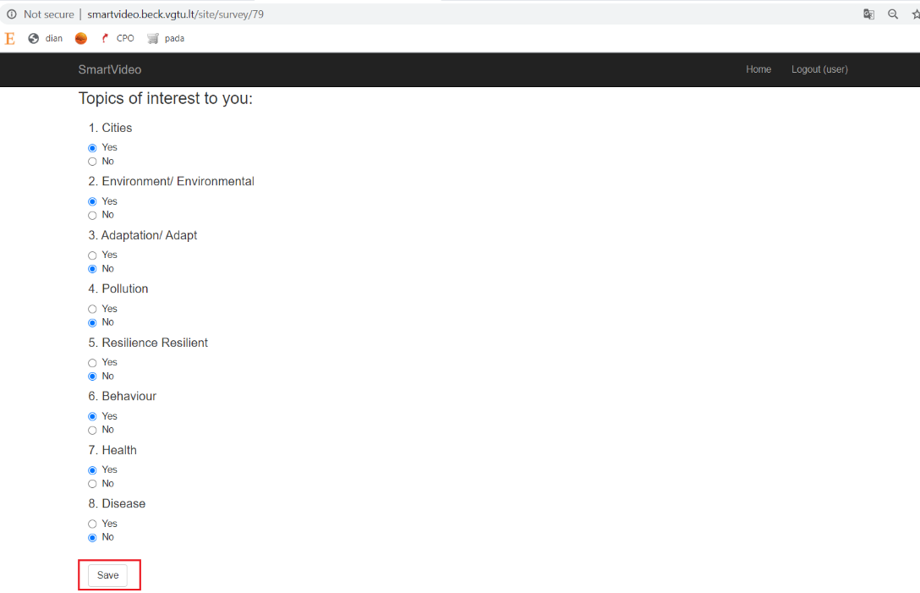
Fig. 5. Choice of topics of Climate Change.

- When users select the topics they want, they will get video materials (1). A camera shows the user’s image on the left side (2). Users can make sure their faces are clearly visible and in focus. The bottom right panel shows the user’s emotions (3) and their visualisation in a chart (4) (Fig. 6).
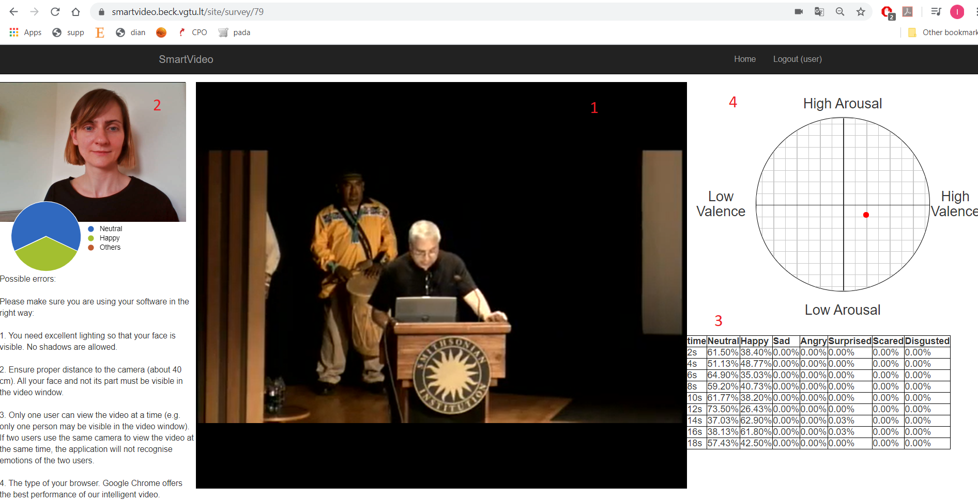
Fig. 6. Video materials and emotion tracking.
- When the user loses interest in video materials and neutral emotions exceed 90%, the system automatically switches to the next video to boost the user’s interest. The example below (Fig. 7) shows that 14 seconds into the video material the user’s interest dropped with neutral emotions totalling 99.87%. The system then automatically switched to another video and the user’s interest went up.
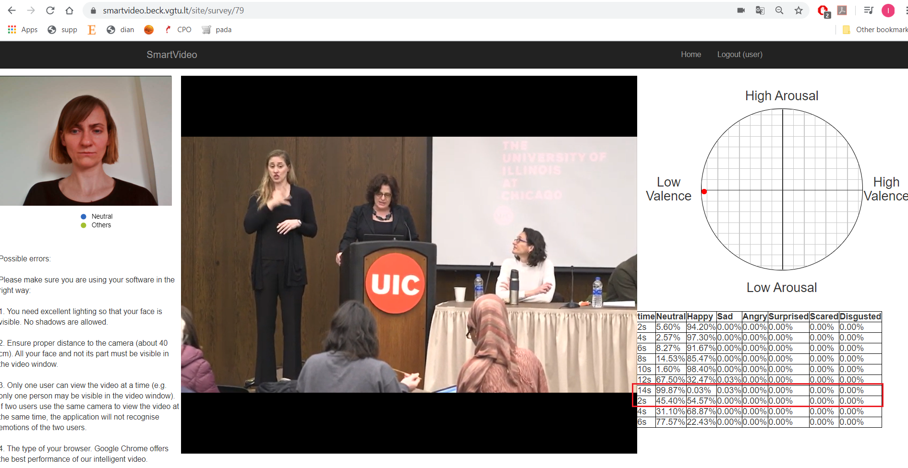
Fig. 7. Example of switching to the next video to boost the user’s interest

Note: Internet Explorer is not fully supported and may cause issues.
1. Select Allow and Remember (to make it turn on automatically the next time the same user logs in from the same computer)
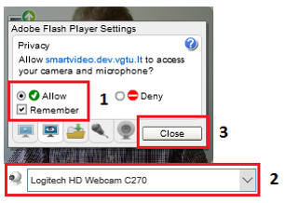
2. Make sure the right camera has been set (if not, select the right camera).
If your computer has a built-in webcam, but you do not see the camera in the list, activate the camera by clicking https://www.onlinemictest.com/webcam-test and Allow.

3. Click Close. Your image will appear in the box.
4. When the user loses interest in video materials and neutral emotions exceed 90%, the system automatically switches to the next video to boost the user’s interest.

Possible errors
Make sure you are using the software as required:
- You need very good lighting to make sure your face is visible and no shadows hide any part of your face.​
- Make sure the distance from your camera is right (about 40 cm.). The video box must show your full face, not part of it.
- Only one user can take the quiz at a time (only one person must be shown in the video box). If two users are taking a quiz simultaneously using the same camera, the software cannot recognise the emotions of two users.
- Browser type. Google Chrome is the recommended browser for quiz taking. Please adjust your filming behaviour, if possible.
- Make sure your hardware and software meets current standards, otherwise issues with quiz viewing or emotion recognition and display are possible.
- You need fast and stable internet connection (Wi-Fi might cause issues with quiz viewing or emotion recognition and display).
- Emotion recognition largely depends on the user’s facial expressions (when faces show no change in emotions, correct quiz question management cannot be ensured).

