Adaptive Examination System
User Manual

Note: Internet Explorer is not fully supported and may cause issues.

To open the Adaptive Examination System, use the following steps:
- The system is a part of the BECK Centre developed during the project. Open the BECK project website http://beck-erasmus.com/ to access the system (Fig. 1).
- Go to the BECK project website, select BECK Centre in the menu and click Adaptive Examination System (Username:007; Password:007) in the drop-down menu (Fig. 1).
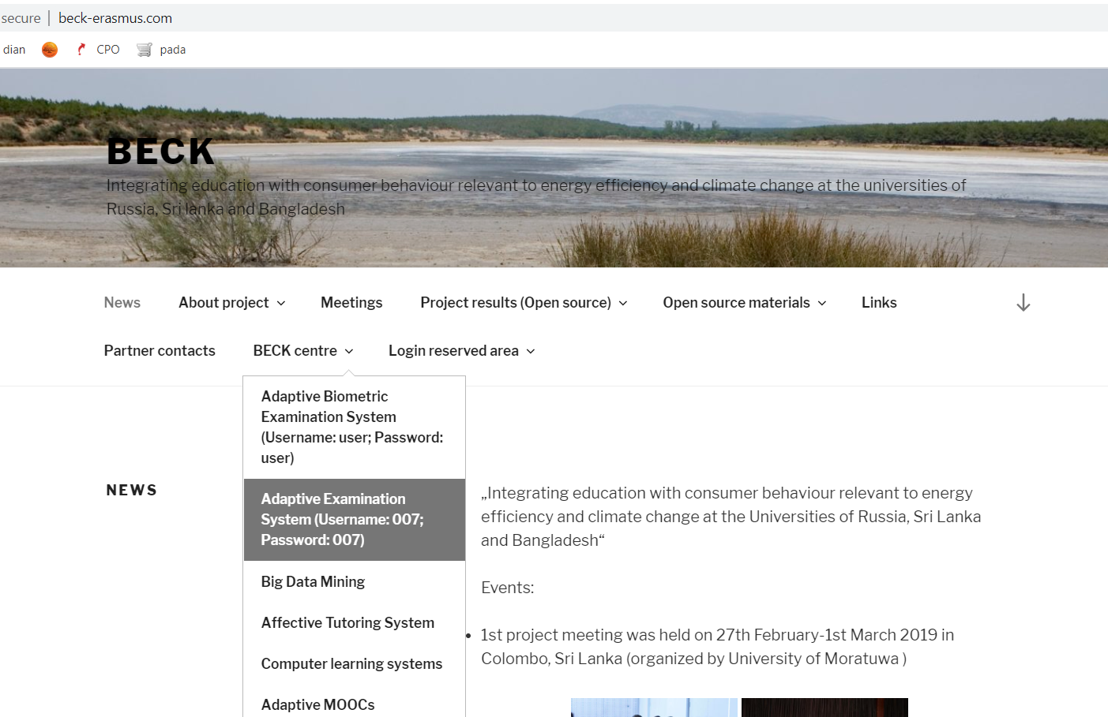
Fig. 1. The BECK project website.

- A window will open. Enter the login details in the window (Fig. 2):
  - Username: 007
  - Passvord: 007
Click the Login button.

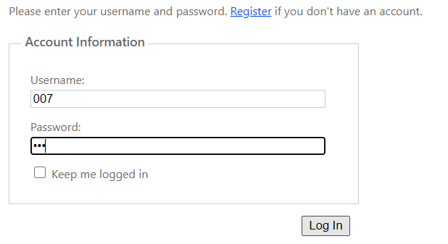
Fig. 2. The log-in window of the Adaptive Biometric Examination System.

- Log into the system and select Self control in the toolbar (Fig. 3):

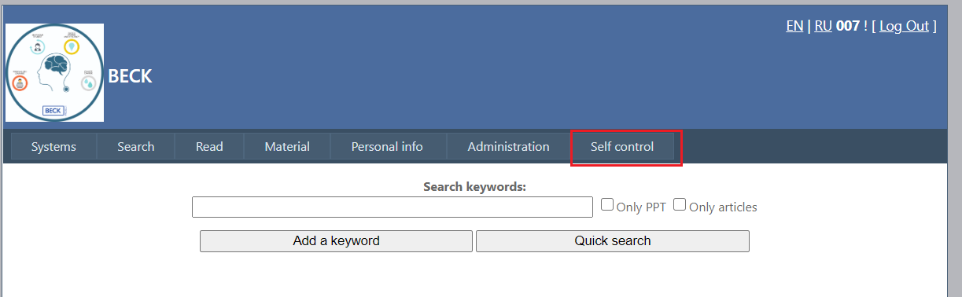
Fig. 3. Self Control function

- Select the module and topic you want for your self-assessment quiz. You can also set the difficulty level: easy, medium, or hard. Select the option Dynamically change the severity level (Fig. 4) to turn on automatic level adjustment depending on correct or incorrect answers to quiz questions.
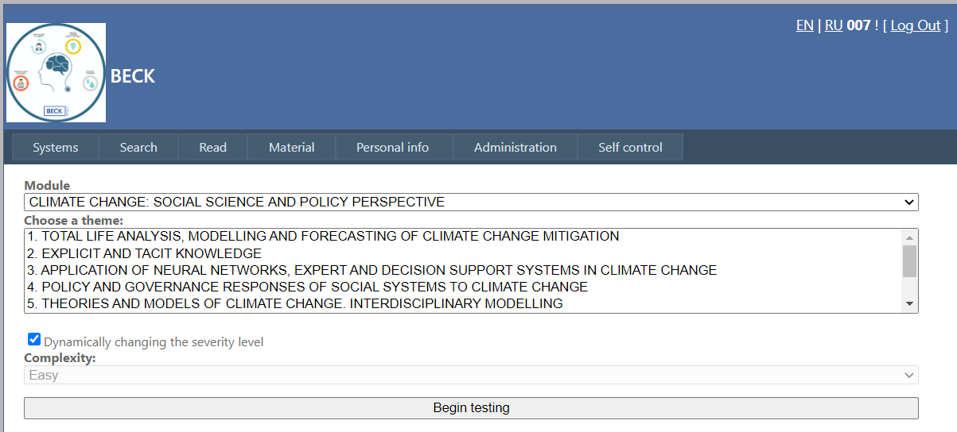
Fig. 4. Self-assessment quiz options.
- Figure 5 shows the selected quiz variant. Click Begin testing.

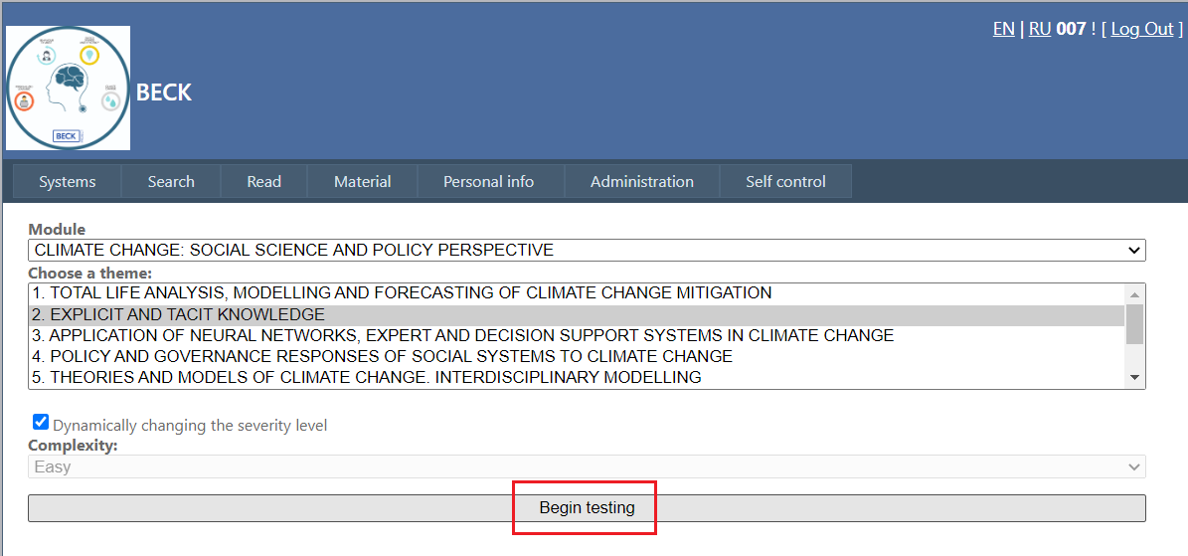
Fig. 5. The start of a self-assessment quiz.

- The self-assessment quiz starts from a medium-difficulty question (1) with possible answers (2) (Fig. 6). The question’s difficulty level is shown as well (3). Answer the question and click Go to the next question. NOTE: once you move to the next question, you cannot go back.

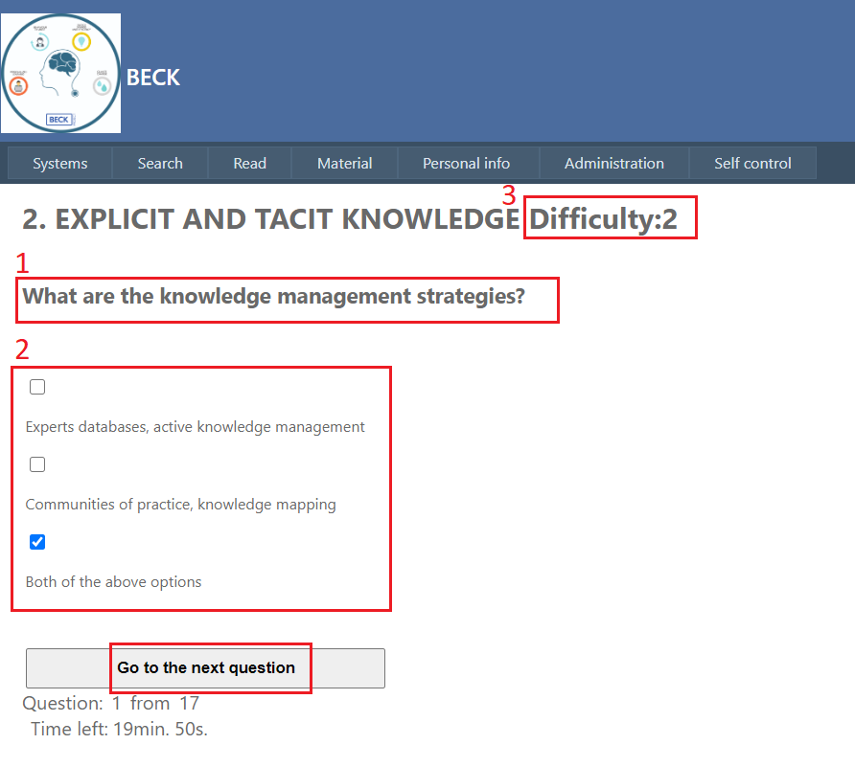
Fig. 6. The interface of self-assessment quiz questions.

- If three questions in a row get incorrect answers, the quiz will switch to lower difficulty and the user will get easy questions (Difficulty: 1) (Fig. 7). If the answers this time are correct, the system will move on to more difficult questions (Difficulty: 3).
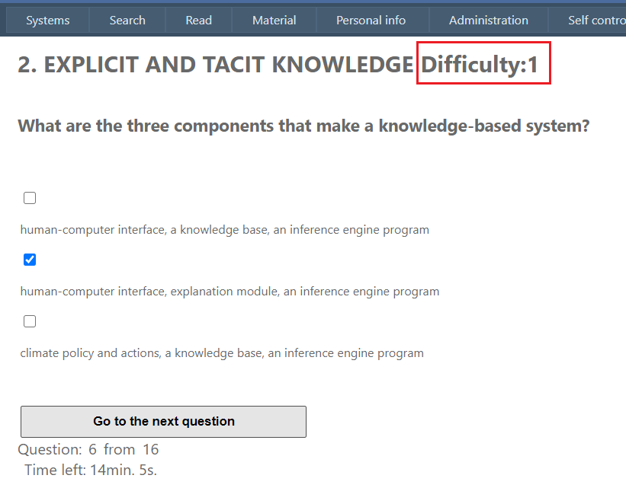
Fig. 7. Switching the difficulty of self-assessment quiz questions.

- When a quiz is over, the quiz answers will be shown. Users can see their answers, both correct or incorrect. If an answer was incorrect, the correct answer will also be shown with a link to reading materials (click Read).

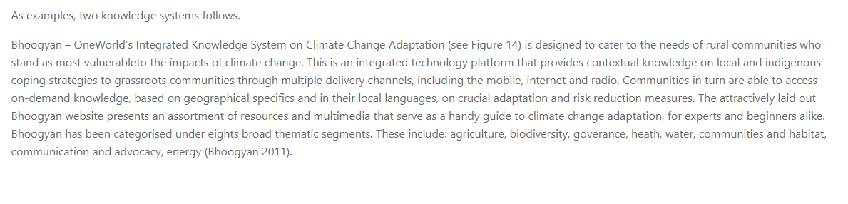
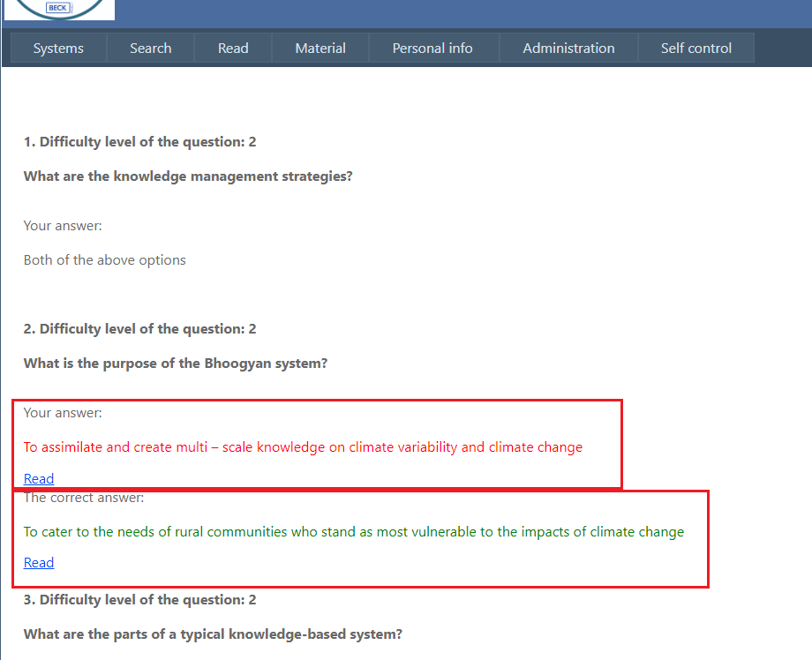
Fig. 8. The interface of quiz answers

