Adaptive Biometric Examination System
User Manual

Attention! Connection to the System available only through Internet browser Opera

To open the Adaptive Biometric Examination System, use the following steps:
- The system is a part of the BECK Centre developed during the project. Open the BECK project website http://beck-erasmus.com/ to access the system (Fig. 1).
- Go to the BECK project website, select BECK Centre in the menu and click Adaptive Biometric Examination System (Username:user; Password:user) in the drop-down menu (Fig. 1).
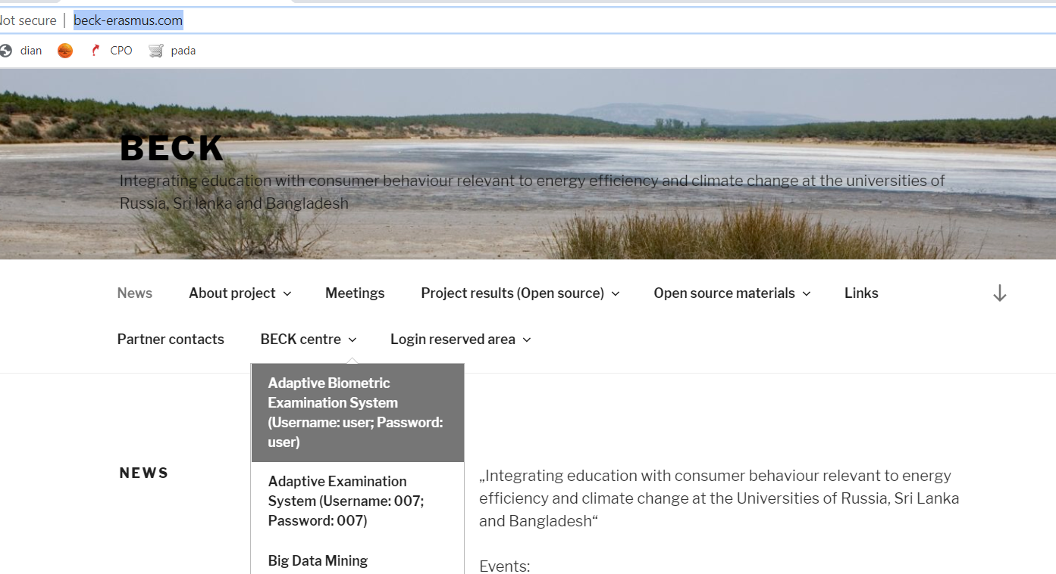
Fig. 1. The BECK project website.

- A window will open. Enter the login details in the window (Fig. 2):
  - Username: user
  - Passvord: user
Click the Login button.

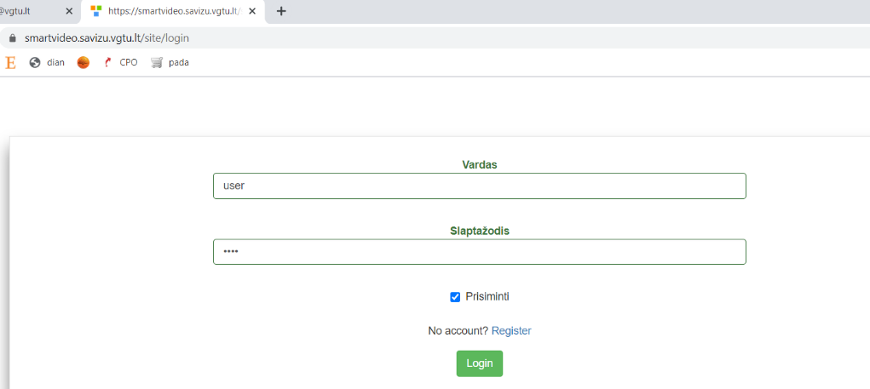
Fig. 2. The log-in window of the Adaptive Biometric Examination System.

- When you log into the system, you will see three exam quizzes (Fig. 3):
  - Climate Change: Social Science and Policy Perspective
  - Master and Post Graduate Education and Training in Multidisciplinary Teams Implementing EPBD and Beyond
  - Biometrics and Intelligent Technologies.

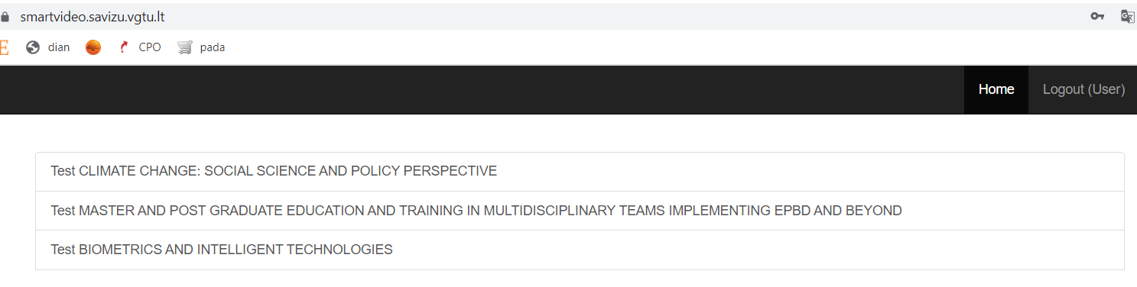
Fig. 3. The list of exam quizzes.

- Select the quiz you want to take and click its title. The examination Climate Change: Social Science and Policy Perspective is presented below as an example.
- When the examination starts, the user will get a set of questions (1) (Fig. 3). Answer a question and then click Next. To go back to a previous question, click Previous. A camera shows the user’s image (2) in the left bottom corner of the examination window. Users can make sure their faces are clearly visible and in focus. The right panel shows the user’s emotions (3). The upper left panel shows the emotions visualised in a chart (4).

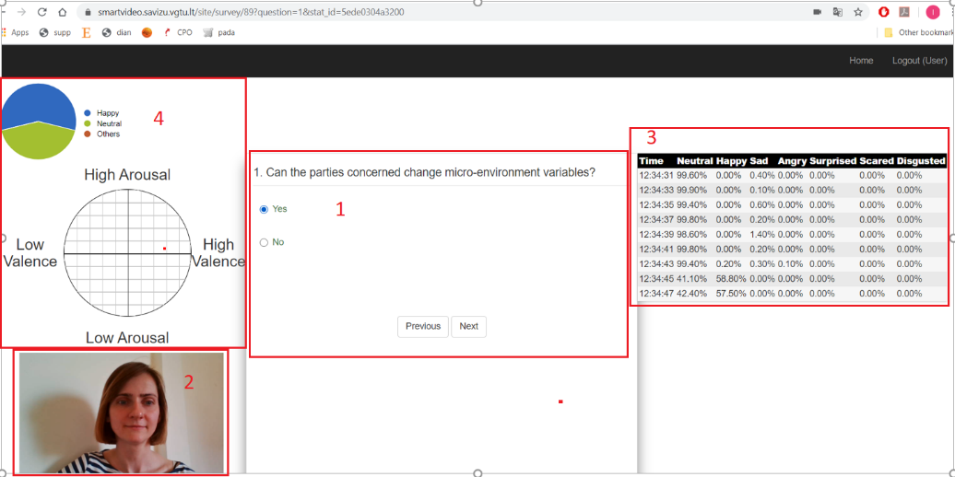
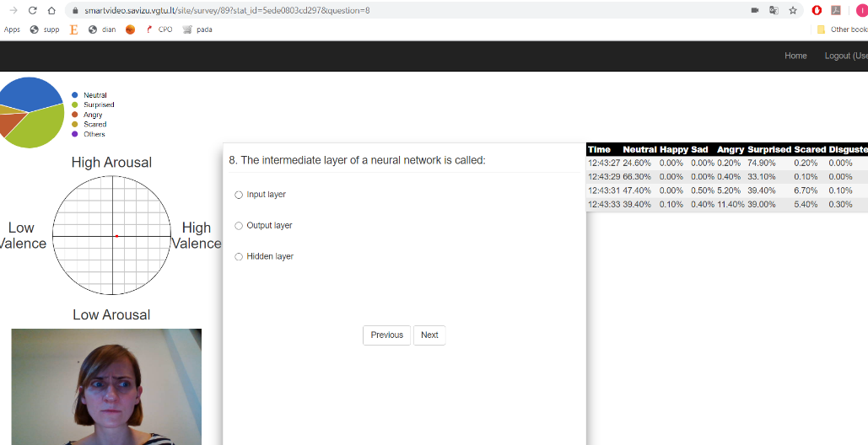
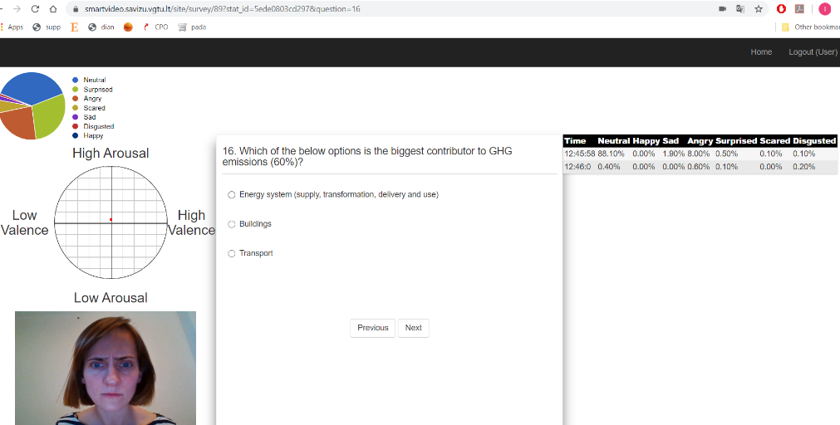
Fig. 3. An examination in progress.

- If the camera unexpectedly loses connection, a warning will be shown (Fig. 4). Click OK.

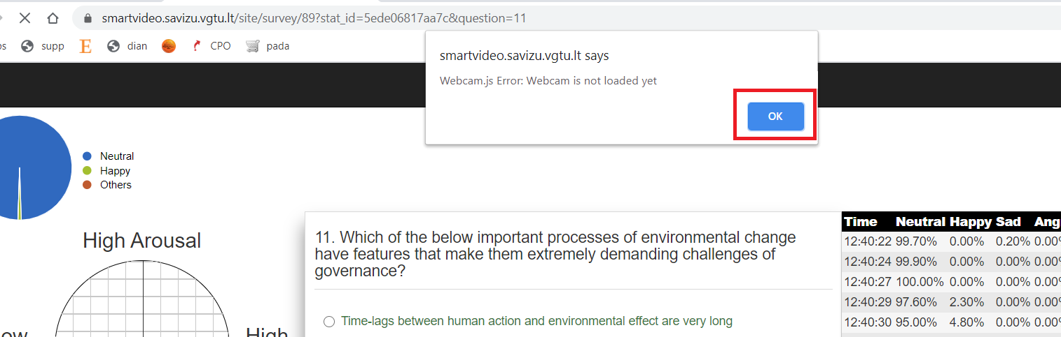
Fig. 4. Connecting the camera.

- When the quiz is over, the system will show the analysis of the user’s emotions for each question (Fig. 5) and the overall assessment of the user’s psychological state below the results (Fig. 6).

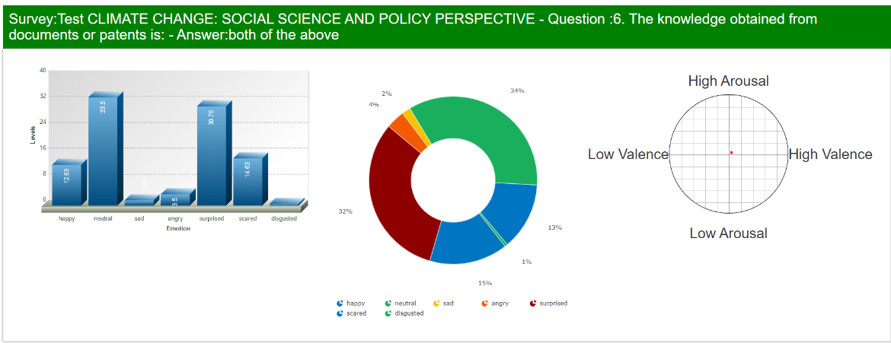

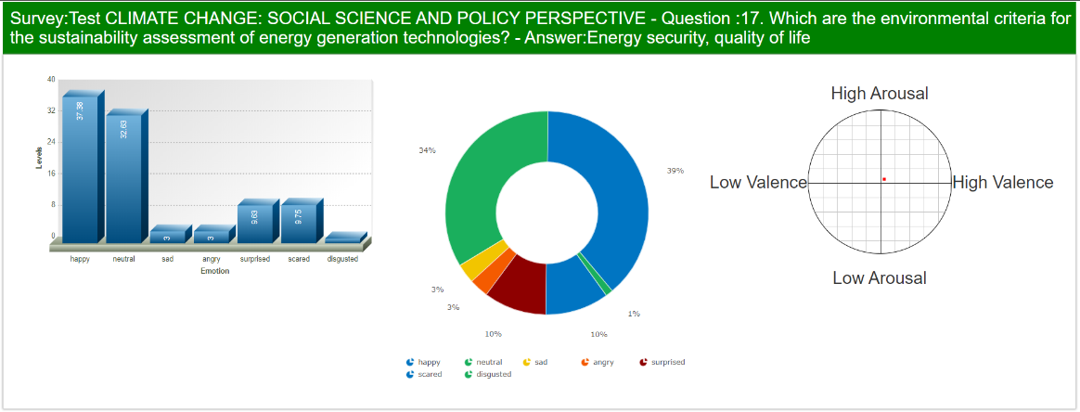
Fig. 5. The analysis of the user’s emotions for each question.

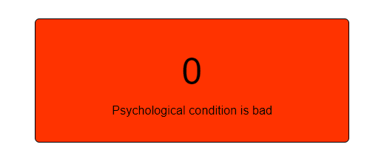
Fig. 6. The user’s overall psychological state.

Note: Make sure to turn on the camera at the start of the exam quiz.
1. Select Allow and Remember (to make it turn on automatically the next time the same user logs in from the same computer).
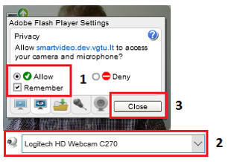
2. Make sure the right camera has been set (if not, select the right camera).
If your computer has a built-in webcam, but you do not see the camera in the list, activate the camera by clicking https://www.onlinemictest.com/webcam-test and Allow.

3. Click Close. Your image will appear in the box.
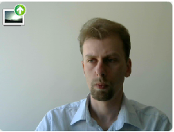

Possible errors
Make sure you are using the software as required:
- You need very good lighting to make sure your face is visible and no shadows hide any part of your face.​
- Make sure the distance from your camera is right (about 40 cm.). The video box must show your full face, not part of it.
- Only one user can take the quiz at a time (only one person must be shown in the video box). If two users are taking a quiz simultaneously using the same camera, the software cannot recognise the emotions of two users.
- Browser type. Google Chrome is the recommended browser for quiz taking. Please adjust your filming behaviour, if possible.
- Make sure your hardware and software meets current standards, otherwise issues with quiz viewing or emotion recognition and display are possible.
- You need fast and stable internet connection (Wi-Fi might cause issues with quiz viewing or emotion recognition and display).
- Emotion recognition largely depends on the user’s facial expressions (when faces show no change in emotions, correct quiz question management cannot be ensured).

