Instruction for personalized learning with MOODLE
Contents
- Delivering student academic performance details to the teacher 3
- It should be possible to add and manage the details of course module topics, add topic keywords, indicate which topics should be learned before and after a topic, add references to additional topic-related resources (publications and online links). 6
- It should be possible to add and manage learning materials and practical tasks for a module’s topic. Learning materials are divided into paragraphs that include text, tables, graphic files, audio files, links to other topics, hyperlinks. 7
- It should be possible to add and manage examination questions for learning modules. Questions comprise the following elements: a reference number, the question text, possible responses, response grading, links to paragraphs of learning materials, difficulty rating at the module and topic level, and importance to the module and the topic. 8
- It should be possible to add and manage student details such as name, contact information and student record-book number. Automatic selection of learning materials for students matched to any market and student needs should be possible. 11
- It should be possible to add and manage details of a student’s preferred and selected learning module topics. 15
- It should be possible to add and manage details of a student’s module-related theoretical and practical knowledge, skill set, any subjects taken before and work-related activity. 18
- MOODLE should store a student’s personal learning history, educational background, educational needs, practice schedule, previous test results. 22
- It should be possible to give students information about any selected learning module tasks and practical assignments or quiz grades. 23
- It should be possible to provide statistical information about the learning module topics and practical assignments selected by students 24
- It should be possible to add and manage details of the teacher’s teaching and field-related work experience. 25
- It should be possible to add and manage details of the teacher’s psychological skills and competence. 25
- MOODLE can give quizzes to test a student’s theoretical knowledge, as well as knowledge and skills acquired during practical assignments. 25
- MOODLE can start with easier quiz questions and then move to more difficult ones or vice versa, depending on the student’s responses. 26
- Based on a student’s previous average practice performance, interests and experience, MOODLE can set a certain quiz difficulty. 27
- MOODLE can explain why a response to a quiz question was correct or incorrect, suggest further similar tasks and examples, and give links to additional resources for failed tasks. 27
- MOODLE can repeat the learning process for any topic students fail (based on a student’s quiz/examination performance). 30
- MOODLE can give practice assignments of medium difficulty to learners new to practice sessions 31
- Students should be allowed to choose the level of difficulty they want 31
- MOODLE can automatically create random quizzes from questions of similar difficulty for specific learning module topics. 31
- MOODLE can automatically grade and analyse a student’s quiz responses and then send the analysis results to the student. The result analysis should include details such as the correct and incorrect responses, grades, examples, notes on where to look for more question-specific information and the responses explained. 32
- MOODLE can display testing details as a matrix or chart including the correct and incorrect responses, the time taken to respond, how many times students changed their solving approach and the grade scored for each task. 33
- MOODLE can set and show advanced criteria which, in addition to whether the response is correct or incorrect, also take into account the time a student took to solve a practical task and hesitation before choosing a response. These advanced performance criteria may impact the final grade students get for their skills. 34
- MOODLE shows the teacher the statistical analysis of student responses by sex or type of studies (remote or full-time). 37
- MOODLE stores the following information: 38
- MOODLE can add and manage student e-portfolio information about qualification, graduation and other certificates, achievements, goals, experience and other personal details that can be submitted to employers. 39
- MOODLE can automatically store quiz response and practice assignment data. 39
- MOODLE can automatically process quiz response details. 40

Delivering student academic performance details to the teacher
MOODLE stores activity grades, login time reports, detailed quiz result analytics.
The grades section (Fig. 1) shows the main grader reports. The main grader report includes the list of learners and their grades for each assignment. The grade history (Fig. 2) makes it possible to keep track of changing grades sorted by user and assignment submission/grading date. The user report includes a list of courses the user is enrolled in and their final grades.
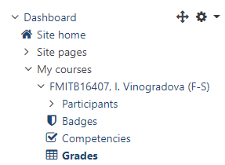
Fig. 1. Grades reports link in the dashboard page
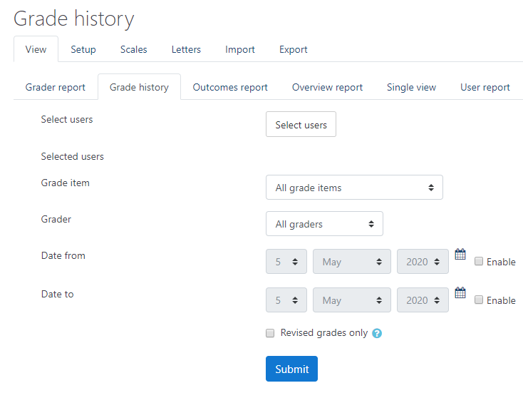
Fig. 2. Grade history tab
The single view report (Fig. 3) makes it easy to view reports filtered by different aspects (users or activities). In addition to viewing, this report can also be edited to change grades and add related feedback.
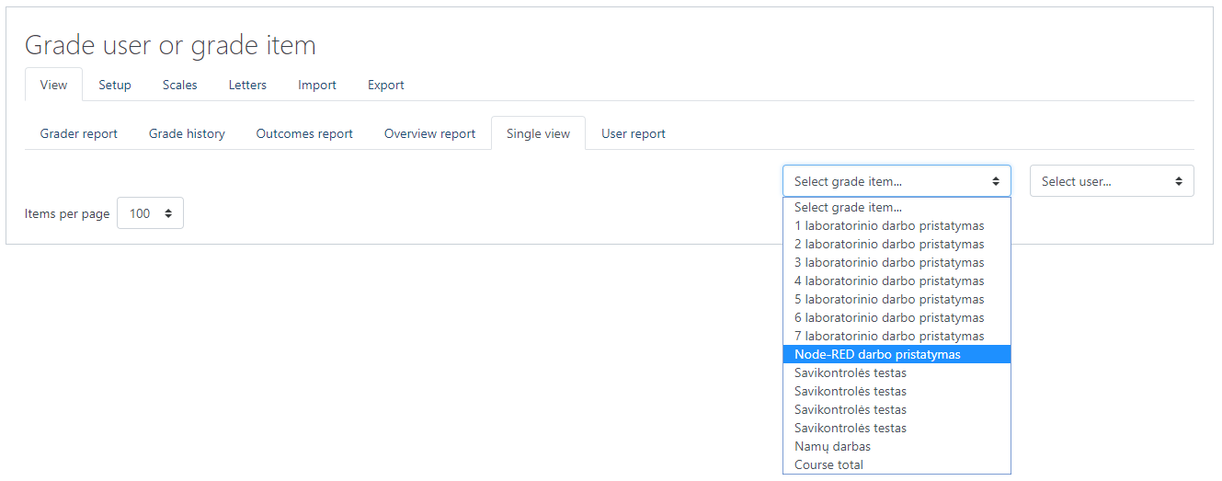
Fig. 3. Grade user or grade item tab
Only the teacher and administrator can access complete course users lists in MOODLE. Students only see their own grades and have no access to the assignments submitted by other students.
Course logs (Fig. 4) give course login details, including the login time, user, component, event description, source origin and the user’s IP address.
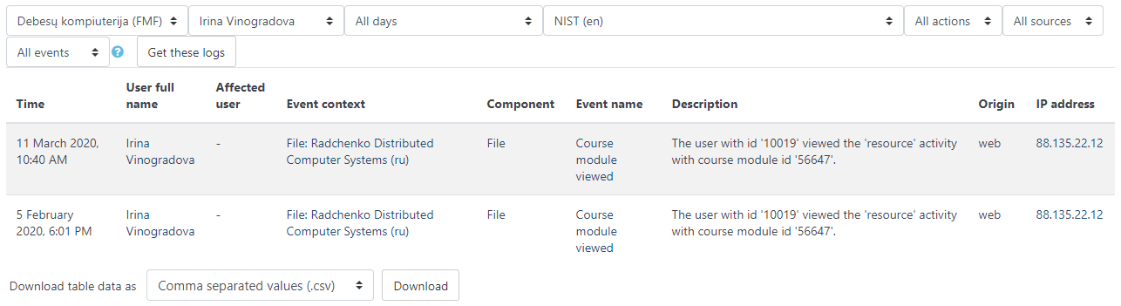
Fig. 4. Log reports page
Quiz reports are a separate group of reports. They show grades, responses and the statistical analysis of question parameters to help make quiz questions better (Fig. 5).
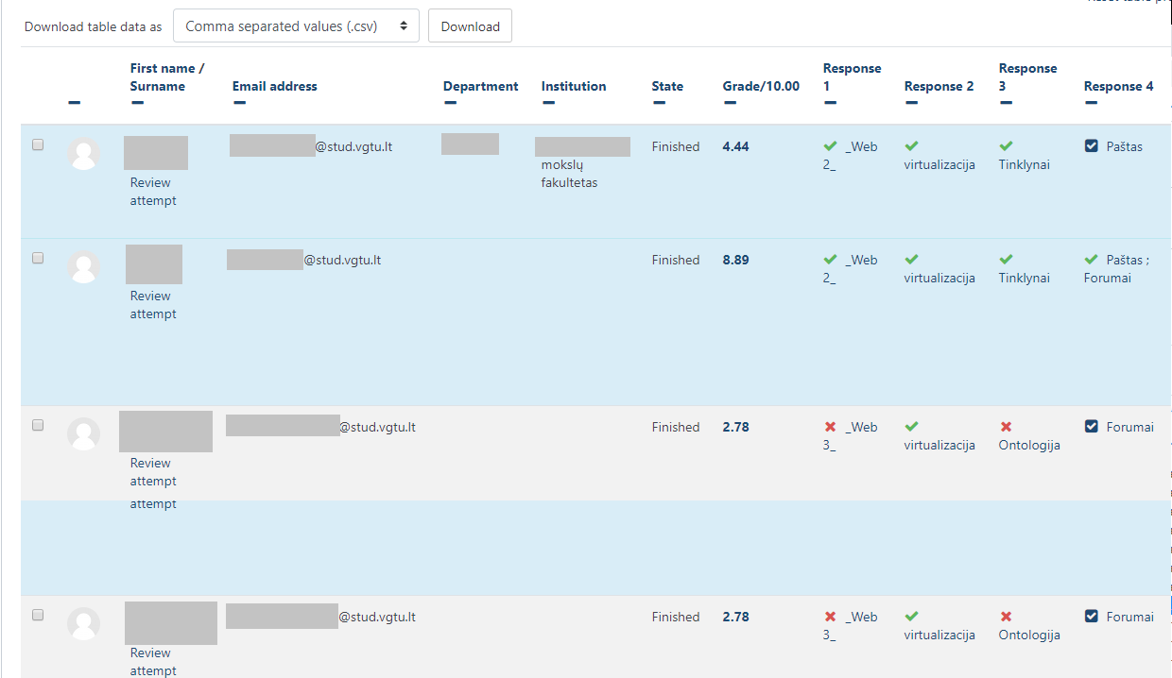
Fig. 5. Quiz responses page

It should be possible to add and manage the details of course module topics, add topic keywords, indicate which topics should be learned before and after a topic, add references to additional topic-related resources (publications and online links).
A MOODLE course can include several topics with description fields (Fig. 6) that can contain any important details, as well as links to other resources and course topics. The text editor allows you to add paragraphs, justify and highlight your text as required, change font and size, create and number lists, add links, images and footage, work in an HTML editor, etc.
Topics can have their access restricted by parameters such as date, grade and group (Fig. 6). Several restriction parameters can be defined.
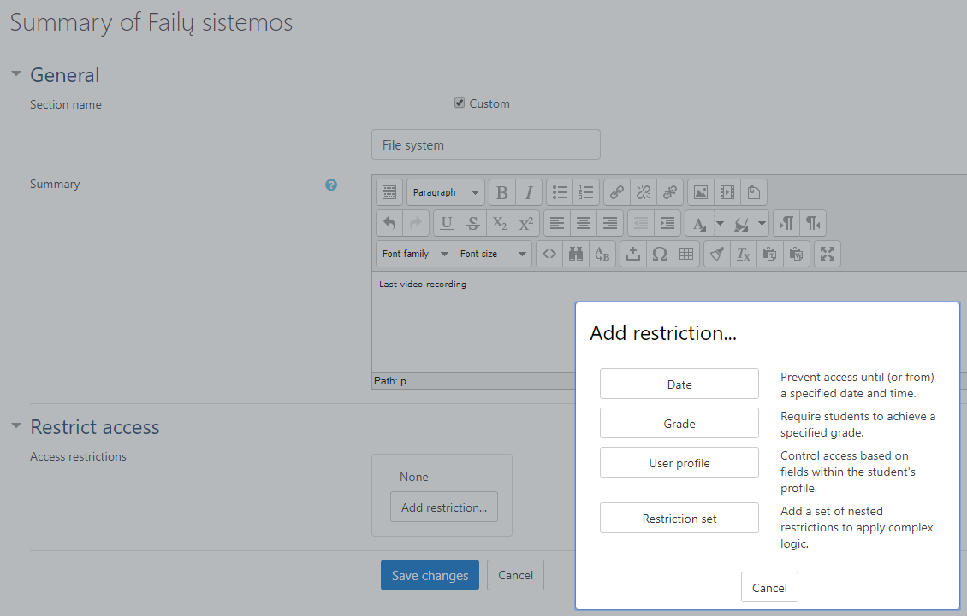
Fig. 6. Restriction parameters

It should be possible to add and manage learning materials and practical tasks for a module’s topic. Learning materials are divided into paragraphs that include text, tables, graphic files, audio files, links to other topics, hyperlinks.
The system offers a wide range of resources and activities.
Resources are static course/lecture materials. They can be text files, images, websites, audio files, video files, etc. The Label tool can be used to add hypertext and other media elements directly to the course page.
Activities are active course elements. They are interactive tools that allow the teacher to test knowledge or to communicate and collaborate. A single topic can include an unlimited number of activities/resources (Fig. 7).
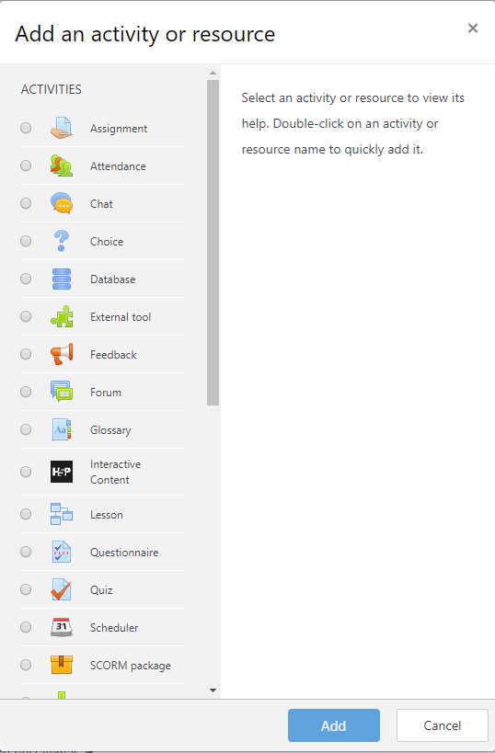
Fig. 7. Add activity or resource window
List of tools by purpose
Learning materials are stored by using all possible resources and activities such as Lesson, Glossary, SCORM package, External tool. Use File to upload a single document (PDF, AVI, FLV, MOV, etc). Use Folder to upload multiple documents (e.g. several videos for a single lecture). The LightBox gallery is the best option for multiple image uploads as it shows their previews. Folders only show image names. To create a document, i.e. a website in the MOODLE environment, use Page or Book. Book can include several pages and a table of contents. Lesson is similar to Book, but each of its pages ends with a question. In case of Lesson, the teacher must determine what will send students from one page to another. Creating a Lesson is, therefore, time consuming, but then you can monitor and grade the progress. URL is a link to a website added to a course. The Label tool embeds your text directly in the course content. It can be key details, comments, images, links.
A course or any of its chapters can include a Glossary. IMS content package, LAMS lesson and SCORM package are lessons or courses for specific programs. External tool allows course participants to use external learning systems and resources. The external tool must support the LTI (Learning Tools Interoperability) standard.
Other tools that support the learning process are news (updates) and discussion Forums, Choice, Attendance, Attendance record, Log, as well as survey tools such as Questionnaire, Survey, Feedback.
Quiz is a handy tool to test knowledge. Assignment is a space where students upload their work into the MOODLE environment. Student work can be presented or ideas gathered in a Database. The information available in the database can be viewed by any course participant. Any work submitted via Assignment can be only viewed by the teacher.
Communication is either synchronous (real-time) or asynchronous. Real time communication is possible by text messages or in Chat. Asynchronous communication tools are discussion Forums and internal MOODLE messaging. Group work tools are Wiki and Workshop. Forum, Glossary and Database can also be used for group work.
Switching between course materials such as files, catalogues or resources can be easily managed and a clear table of contents or tree of the materials created (similar to a book). Fig. 8 shows possible structure of course materials.
Fig. 8. The document hierarchy

It should be possible to add and manage examination questions for learning modules. Questions comprise the following elements: a reference number, the question text, possible responses, response grading, links to paragraphs of learning materials, difficulty rating at the module and topic level, and importance to the module and the topic.
MOODLE questions can be created and stored in a question bank (Fig. 9). Questions can be attributed to categories defined by the course creator. Categories can be based on individual topics or the purpose of questions (e.g. self-assessment or examination). Questions can be imported from and exported to different courses.
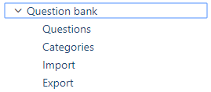
Fig. 9. Question bank functionality
Questions of different types can be used in the system to create a quiz.
Each question is assigned a difficulty rating (score) (Fig. 11), reference number, etc. Fourteen types of questions are available in MOODLE (Fig. 12). The list of question types can be expanded by installing a plugin from the official MOODLE page. Each question has a name, question text and possible responses. Responses can be given as a list, answer matching (Fig. 10), scrolling (drag and drop) blocks, open-ended answers, automatic response calculations in MOODLE with equations pre-set by the course creator, etc. Each quiz can be assigned a weight to define its contribution towards the final course grade.
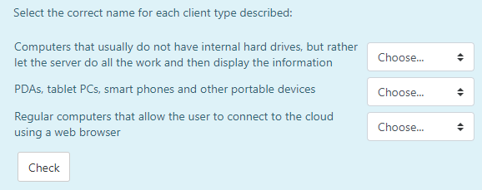
Fig. 10. Example of the matching type question
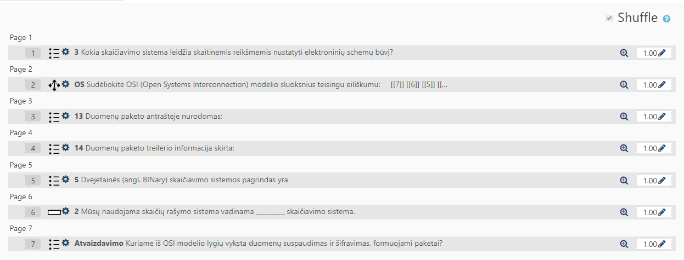
Fig. 11. Question weights defining their contribution towards the final grade

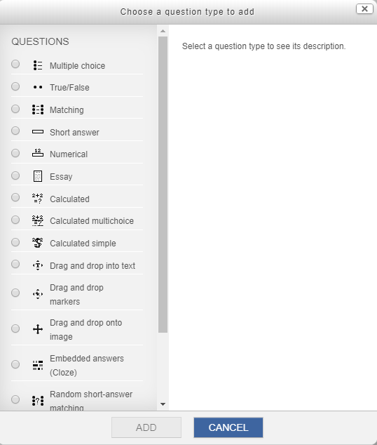
Fig. 12. Question types window

It should be possible to add and manage student details such as name, contact information and student record-book number. Automatic selection of learning materials for students matched to any market and student needs should be possible.
Several user authentication ways are possible: authentication from another database, from file and self-registration (Fig. 13). Each institution determines its preferred user authentication method and the MOODLE system administrator sets up the selected option. Lecturers have no access to this feature. The MOODLE administrator can add more fields to the user profile.
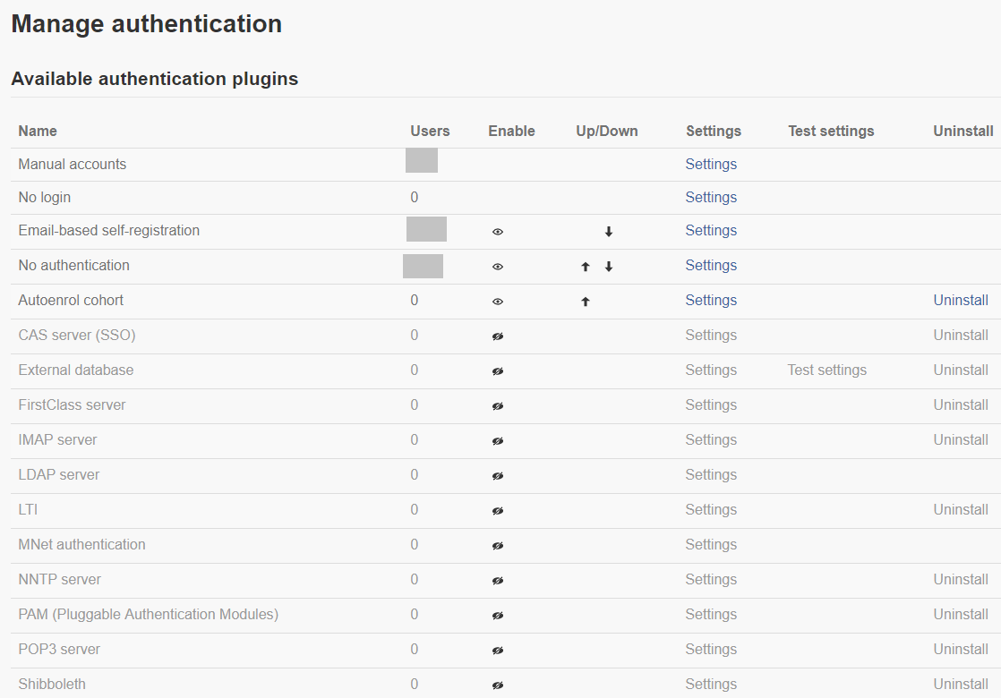
Fig. 13. Available authentication plugins window
Email-based self-registration can be activated in MOODLE (Fig. 14). Then any user can join the learning system. Universities disable this feature for security reasons to make their virtual learning environment accessible only to campus members.
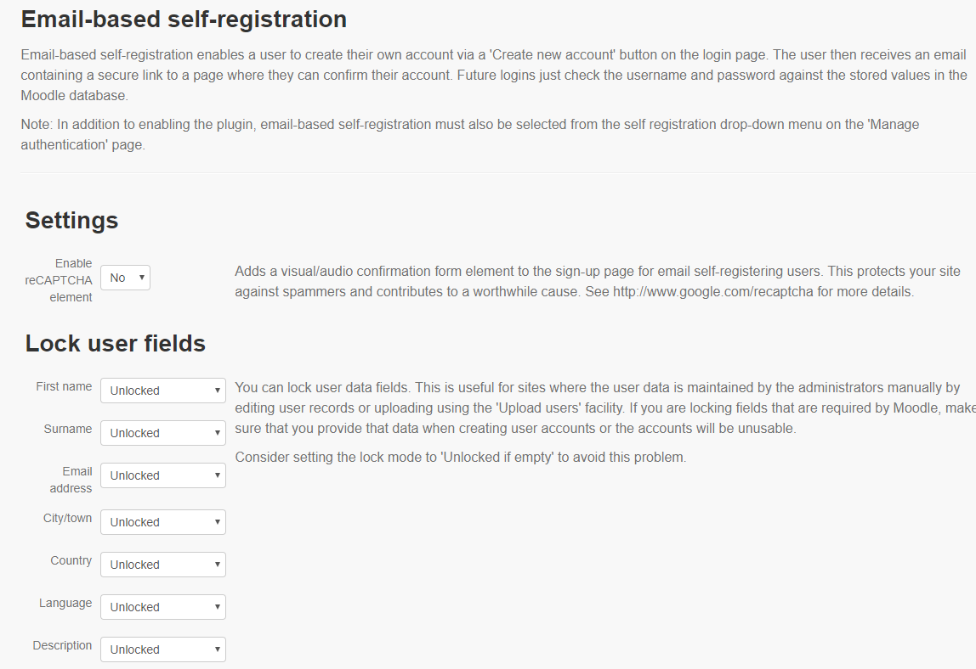
Fig. 14. Email-based self-registration settings
MOODLE allows exporting user data from a file (Fig. 15).
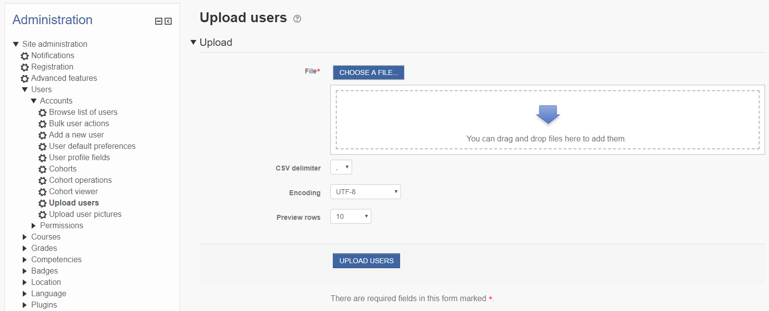
Fig. 15. User upload window
Administrators manage the type of user authentication by controlling user profile fields, which can be locked or uneditable.
Each MOODLE user can access their profile. The teacher or student can add details to their profile in the fields determined by the institution.
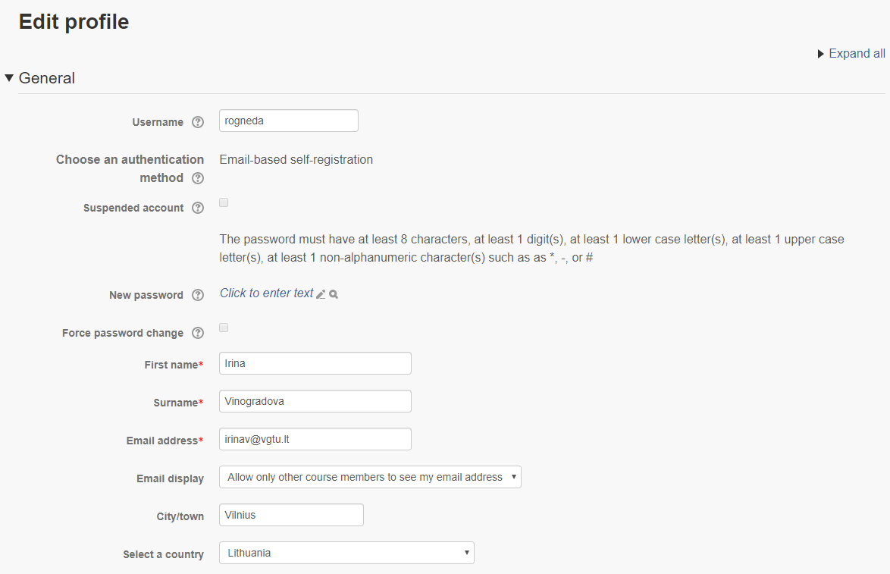
Fig. 16. Edit profile window
As for customised materials, it should be noted that customisation is only possible when multiple learning materials of different styles and difficulty are already available. The creators or teachers must create several variants of the same topics, lecture materials, assignments and quizzes. In MOODLE, all materials can be uploaded to a course with access restrictions based on certain parameters (Fig. 6). If access is not restricted, the student will see any available course materials of all levels.
Based on their performance in certain previous tests, the teacher can divide students into groups with access to different levels of difficulty. Then, course materials can be created and assigned to a certain course group. This type of materials personalisation demands much effort from the teacher and course creator.
Before setting access restrictions, course-level groups should be created. Keep in mind that no restrictions based on MOODLE cohorts are possible. Course-level groups may be created manually or automatically. Fig. 17 shows one of the auto-creation options. Course members are divided into equal groups, the number of which is set by the teacher.
If learner groups are enrolled into MOODLE course as cohorts, such cohorts can be marked during enrolment to be converted into course-level groups.
When groups are created based on certain personal traits, abilities and performance, users can be manually assigned to pre-set groups, e.g. basic level and advanced level (Fig. 17).
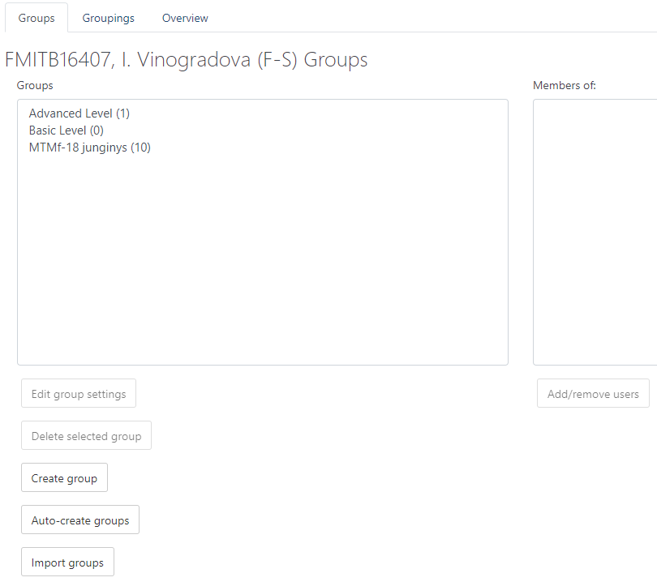
Fig. 17. Course-level group creation window
In MOODLE courses, all resources and activities (Fig. 7) have the access restriction option in their settings.
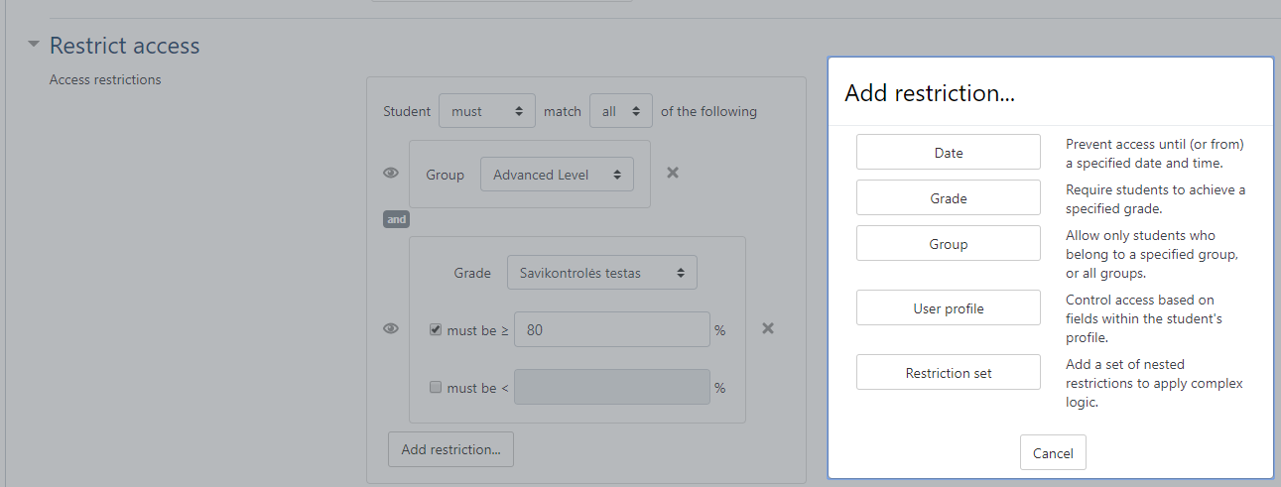
Fig. 18. An example of access restriction by group and grade
Several kinds of restrictions can be applied to each resource and activity. As part of course material customisation and personalisation, access is restricted based on course-level groups (Fig. 18).

It should be possible to add and manage details of a student’s preferred and selected learning module topics.
A course can include an activity where students can share their preferences (e.g. discussion forums; Fig. 19). Several types of discussion forums are available. The teacher can create a discussion around a single topic or allow each student to ask only one question. In the standard forum for general use, teachers and students can add as many questions as they want.
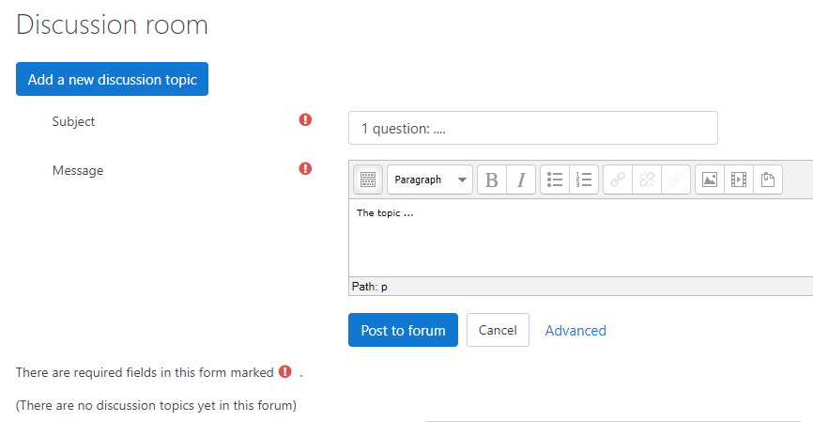
Fig. 19. Discussion room window

The Choice tool can be used for voting (Fig. 21) or event sign-up (Fig. 20). By voting you can learn student preferences related to certain issues. The sign-up option is helpful for choosing review paper or research paper topics or signing-up students for thesis defence, presentation, etc.
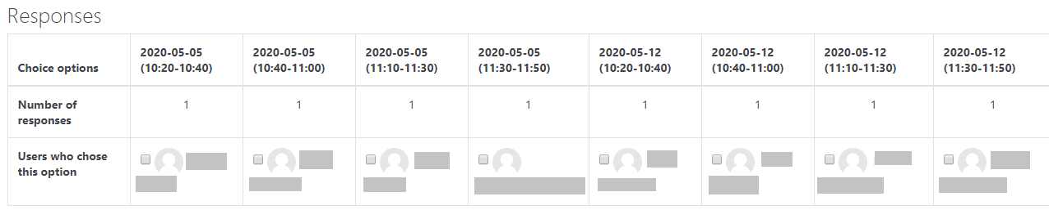
Fig. 20. Responses of students signing up for homework presentation in the Choice tool

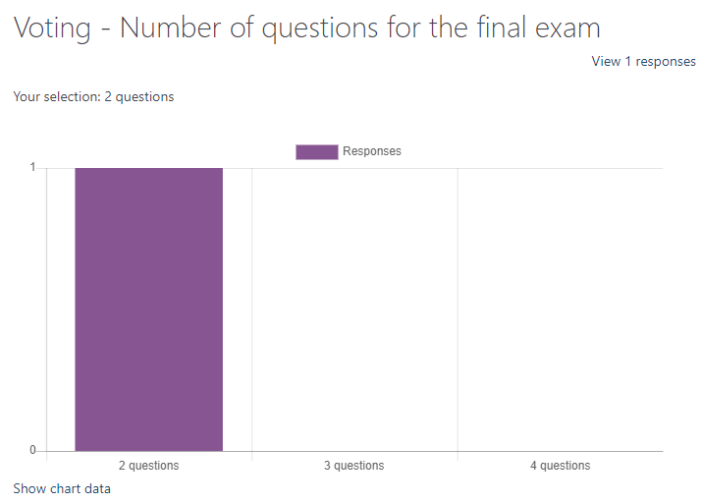
Fig. 21. Voting options in the Choice tool
Survey activities can be used to learn student opinions. Several types of survey tools are available where the teacher creates own questions. They are Feedback and Questionnaire.
MOODLE Questionnaire offers a wide range of survey options. This plugin is optional and must be installed in MOODLE at https://moodle.org/plugins/mod_questionnaire. Questionnaire offers more types of questions than Feedback (Fig. 23). The main types of questions, however, are similar, including essay, multiple choice, numeric, Yes/No, etc.
Questionnaires can be created as templates and published in MOODLE. This allows the institution to standardise its surveys (Fig. 22), and teachers can use them with ease.
The teacher can make a survey recurring (e.g. weekly or monthly) in Questionnaire settings. Surveys can also be set as anonymous. Viewing options for respondent answers can also be set.
Questionnaire is better than Feedback in several other ways: answers can be visualised in diagrams and alternative answers to certain questions can be rated on a specific (e.g. five-point) scale.
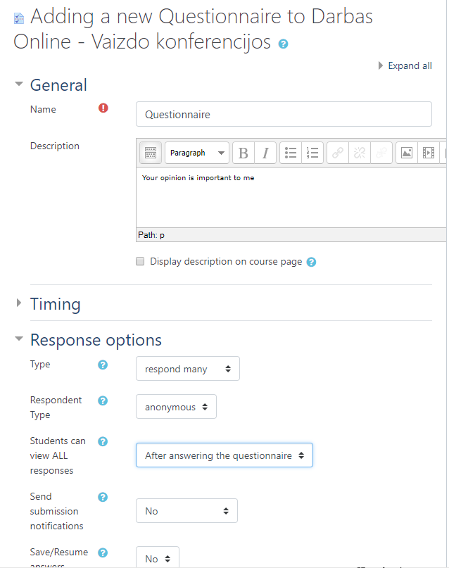
Fig. 22. The settings window of Questionnaire tool
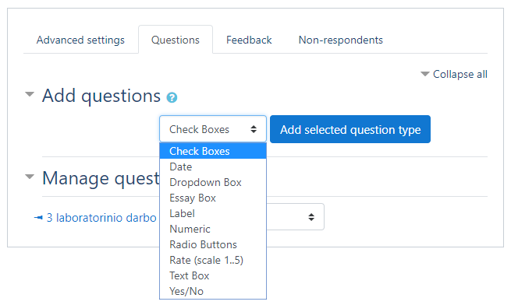
Fig. 23. Types of questionnaire questions

It should be possible to add and manage details of a student’s module-related theoretical and practical knowledge, skill set, any subjects taken before and work-related activity.
Any MOODLE user can edit their profile/account details. Fig. 24 shows the general account settings such as first and last name, email (which acts as a unique user ID) and description. Users can add their personal details in the description field, where text can be enhanced with links, files, videos, etc.
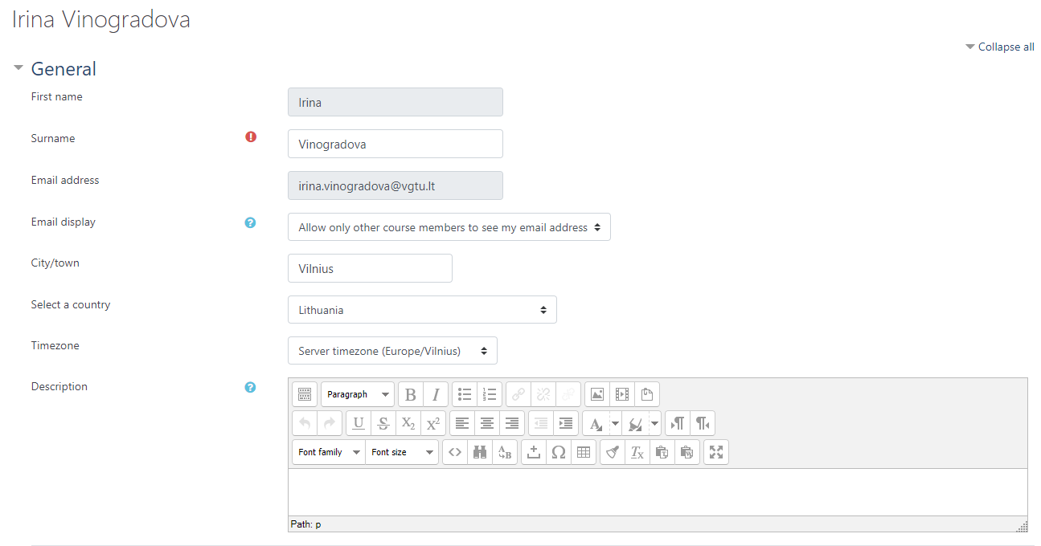
Fig. 24. General profile settings

Profiles include such sections as Interests and Optional (Fig. 25). MOODLE matches like-minded people based on their interests. The Optional section is for contact information (social media usernames, personal websites, business contact information, personal phone number, etc.).
MOODLE automatically stores the statistical information of user activity in MOODLE, such as logs (Fig. 4), activity grades, duration (Fig. 5) etc. The teacher can leave comments next to student grades. The comments can only be viewed by the learner and the teacher. The teacher can have a personal file storage or add certain files and chapters to a course and make them inaccessible to students. The teacher can use such storage or files to manage the details of the student’s theoretical and practical knowledge related to a certain module.
A personal Wiki is another way for the shared teacher and student management of theoretical knowledge (Fig. 26). Students then can add and store their personal details, which can be edited by the course teacher. The Wiki tool can display different edited versions side by side for comparison to see what is different and new. Two versions can be analysed side by side at a time. A student only has access to his or her own personal details and can edit or delete the details.
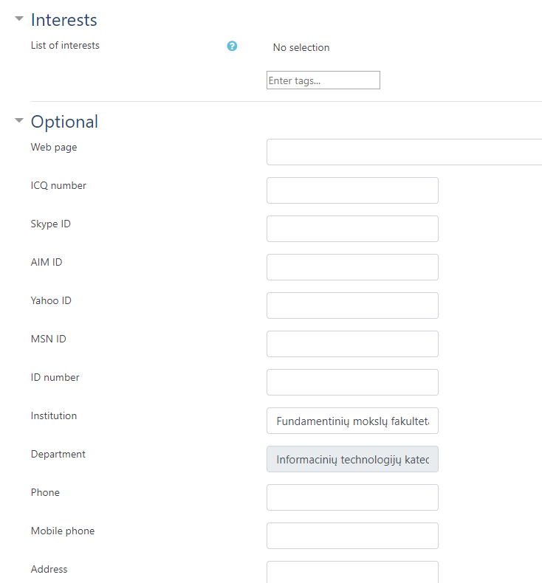
Fig. 25. Profile settings: Interests and Optional
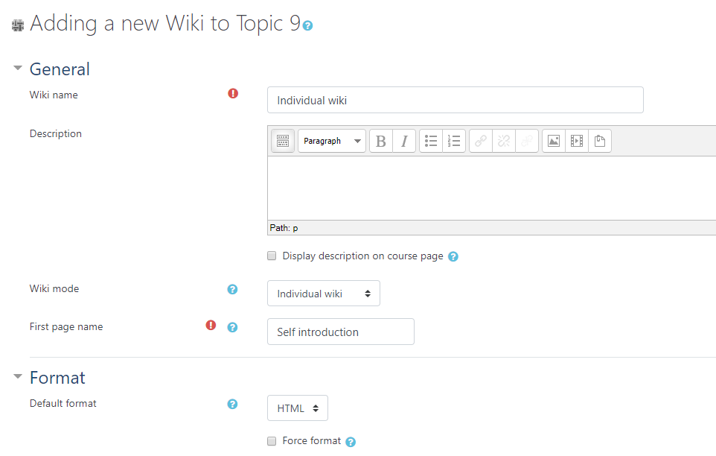
Fig. 26. Individual wiki mode settings
It is easy to save and keep student activity grades in a computer or print out as a report by simply exporting the grades to one of the file types as shown in Fig. 27.
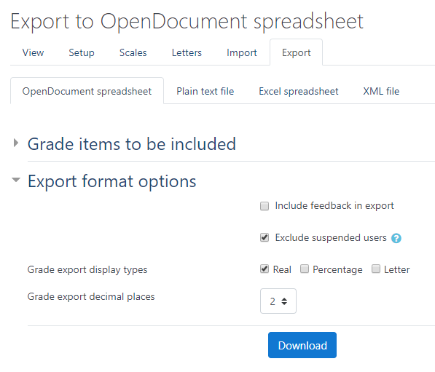
Fig. 27. Grade export window

The teacher can access many different reports (Fig. 28) about login details (Fig. 4), course activity and participation by user (Fig. 29) or activities (Fig. 30).
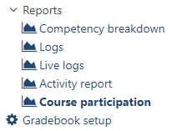
Fig. 28. Various login and participation reports
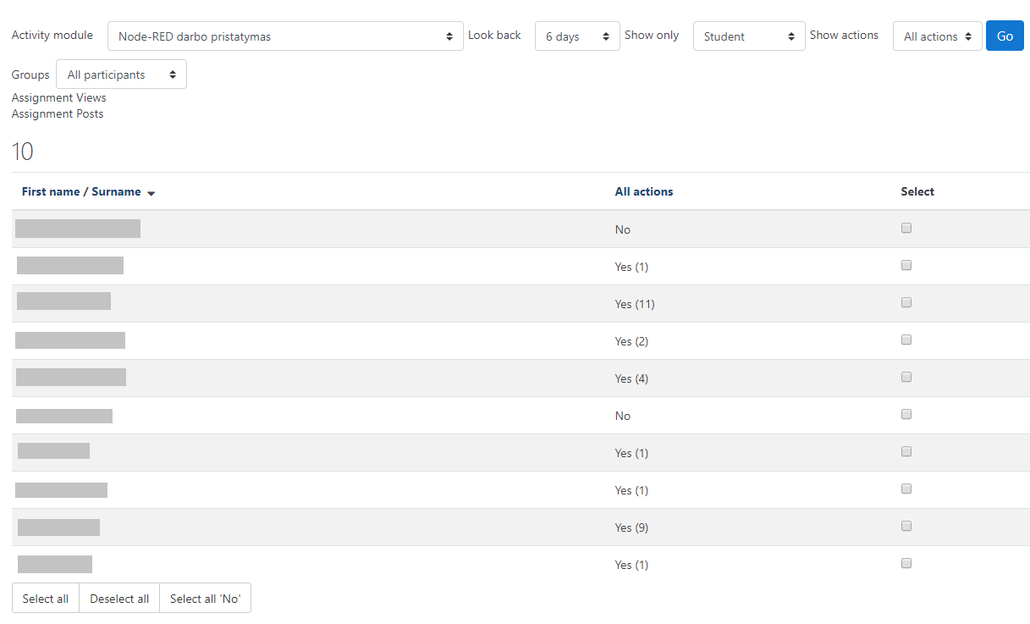
Fig. 29. Course participation report

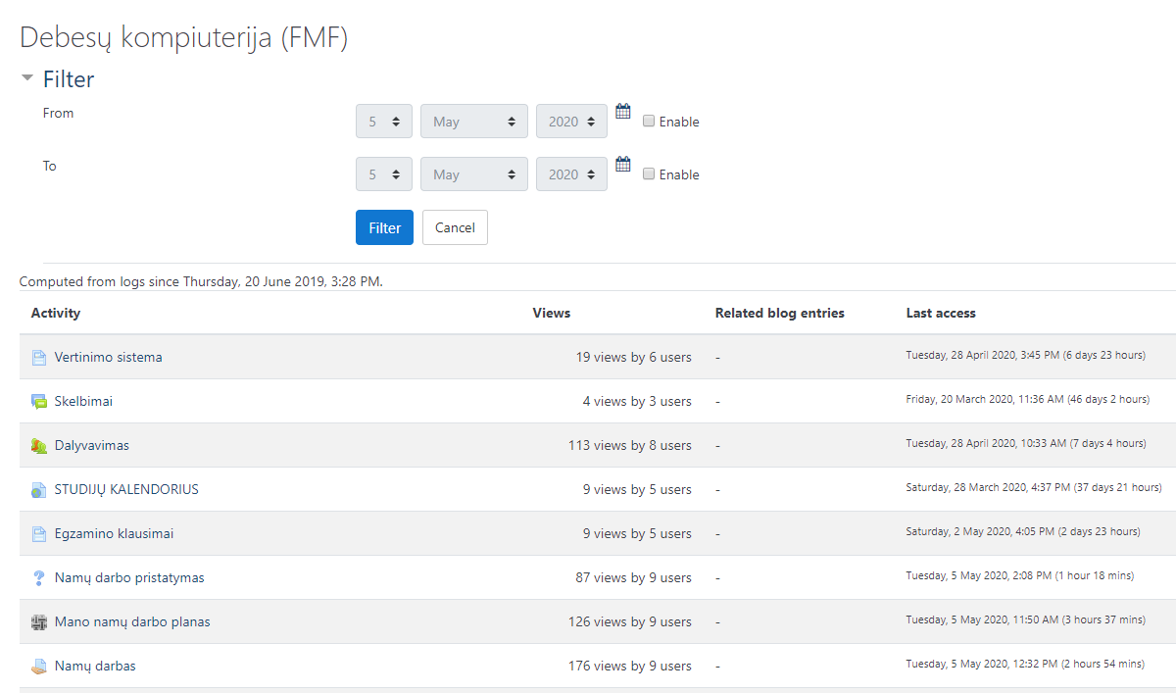
Fig. 30. Activity report
The teacher can use equations to calculate grades (Fig. 31). MOODLE can calculate intermediate grades and apply different equations in these calculations. Only the course teacher can access the final grades of all learners. Students can only see their own grades.
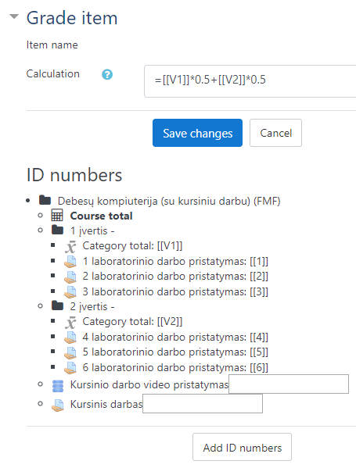
Fig. 31. Grade item calculation window

MOODLE should store a student’s personal learning history, educational background, educational needs, practice schedule, previous test results.
MOODLE stores student grades and login details. See section “It should be possible to add and manage details of a student’s module-related theoretical and practical knowledge, skill set, any subjects taken before and work-related activity” for details.
A student’s personal learning history, educational background, educational needs and practice schedule can be added to the user profile. The student can add these details to the profile as a description. The MOODLE administrator can add more fields to the profile (Fig. 32).

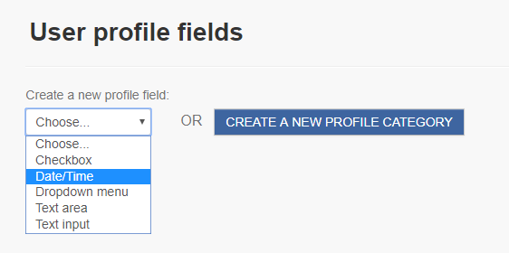
Fig. 32. Create a new profile field window

It should be possible to give students information about any selected learning module tasks and practical assignments or quiz grades.
MOODLE automatically stores grades given by the system (for quizzes) or entered by teachers (for assignments). The teacher can edit and comment homework and other Word or PDF documents uploaded to MOODLE. The process is similar to that done on a hard copy. Fig. 33 shows the main mid-page editor window where manual commenting and correcting of student work is possible. All changes and comments are saved and shown to the student. The right side panel is for grade entering and general feedback. The teacher can also attach any files the student should see.
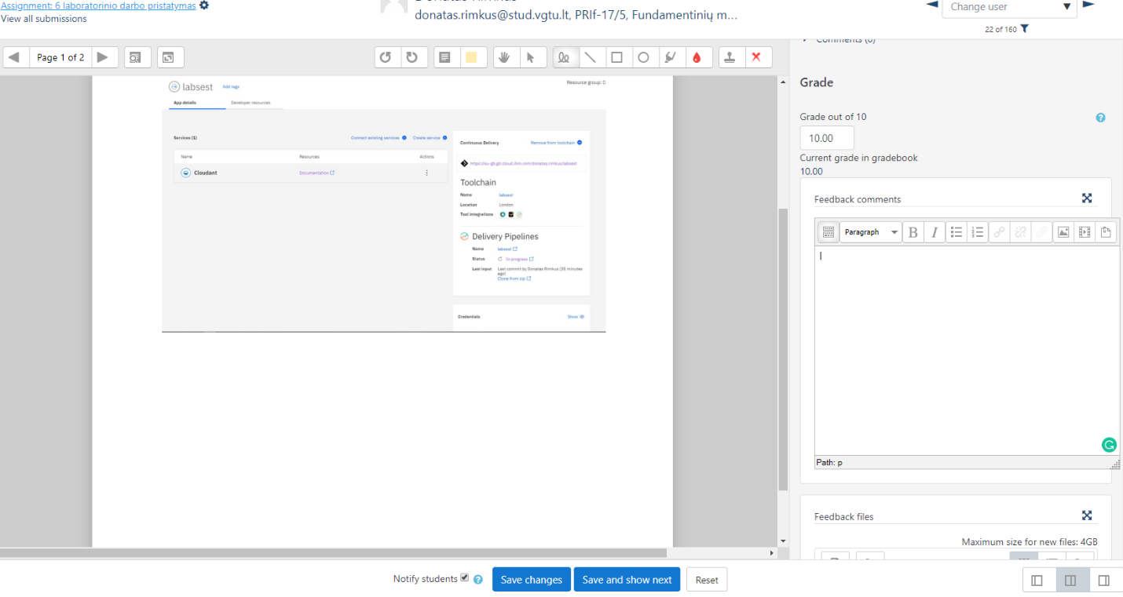
Fig. 33. Grade and feedback window in the Assessment tool
In quizzes, the teacher can add default overall feedback related to a grade (Fig. 34). Depending on the grade, the student will get relevant feedback with any details the student should see. Feedback can be provided as text with links, videos and other media files also included.
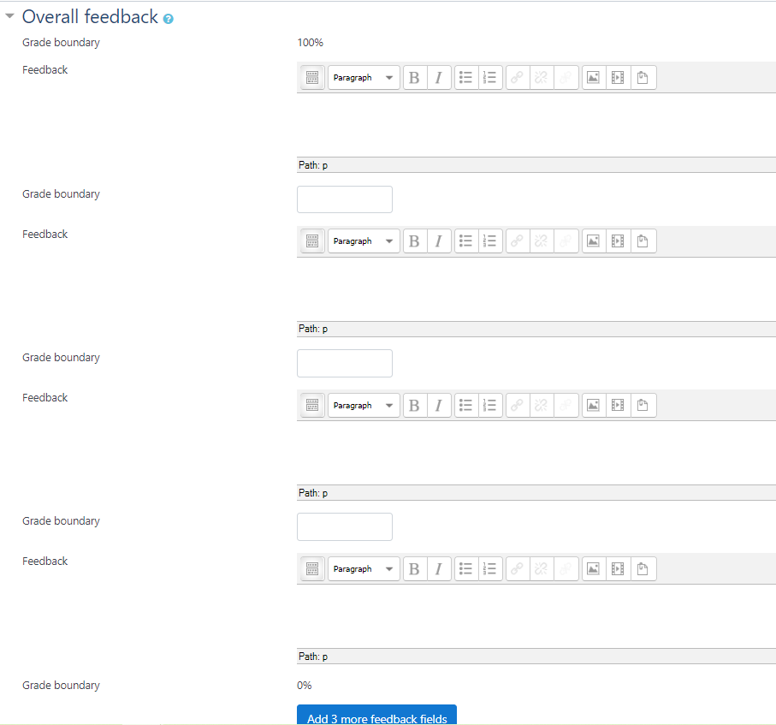
Fig. 34. Feedback fields in quiz settings

Each quiz question has feedback fields to make the quiz more interesting with correct and incorrect responses explained and the student referred to certain theoretical course materials.

It should be possible to provide statistical information about the learning module topics and practical assignments selected by students
Statistical information is logged when a student opens an activity or resource and begins the learning process (Fig. 35). The teacher can add a separate statistics file to the course page or add statistics as an attachment in the Assignment tool (Fig. 33). Each student can view only the details relevant to that student.
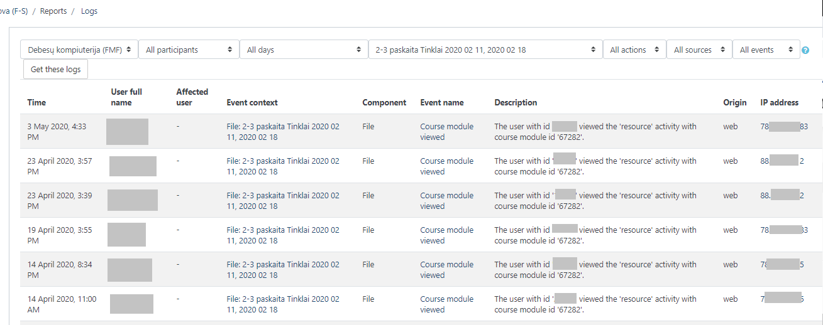
Fig. 35. Logs report by the lesson material

It should be possible to add and manage details of the teacher’s teaching and field-related work experience.
This feature can be implemented in the user profile either in the description or a separate special field (Fig. 24, Fig. 25). The MOODLE administrator can add more fields to the profile (Fig. 32).
Details of the teacher’s field-related work experience and contact information can also be provided at the beginning of the course as an attachment, an HTML page or embedded in the course content using the Label tool.

It should be possible to add and manage details of the teacher’s psychological skills and competence.
This feature can be implemented in the user profile either in the description or a separate special field (Fig. 24, Fig. 25). The MOODLE administrator can add more fields to the profile (Fig. 32).
The details of the teacher’s psychological skills, competence and contact information can also be provided at the beginning of the course as an attachment, an HTML page or embedded in the course content using the Label tool.

MOODLE can give quizzes to test a student’s theoretical knowledge, as well as knowledge and skills acquired during practical assignments.
In MOODLE, the teacher can test theoretical knowledge by giving both mid-term and final quizzes. Knowledge testing, however, is not the only purpose of such quizzes. They also serve as an educational measure designed to help students learn, understand and focus on the essential parts of theoretical materials. Several modes of quizzes are available (Fig. 39). Deferred feedback is a stricter mode designed for examinations, while the Adaptive mode is designed for quizzes of the self-assessment type.
As noted before, 14 types of questions are available in MOODLE. See section “It should be possible to add and manage examination questions for learning modules. Questions comprise the following elements: a reference number, the question text, possible responses, response grading, links to paragraphs of learning materials, difficulty rating at the module and topic level, and importance to the module and the topic” for details.
The Quiz tool has three options to add a new quiz question. The first option is to create a new question; then the question will be saved in the main directory of the question bank. The other two options are to add a question (of a certain category) from the question bank. Questions in that case must be already available and ready for use when the quiz is being created.
The second option is to select questions from the question bank and add them to a quiz; in this case, it is up to the teacher which questions will be added to the quiz. The third option means that MOODLE selects random questions automatically. The teacher only sets the category and the number of questions. When the teacher adds several variants of questions to certain categories and then sets a smaller number of questions, students get different/personalised quiz variants.

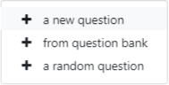
Fig. 36. Ways to create questions/add them to a quiz
Quiz feedback helps students understand their mistakes, find materials and so forth. In certain examination quizzes, the teacher can disable the correct responses and feedback from being displayed.

MOODLE can start with easier quiz questions and then move to more difficult ones or vice versa, depending on the student’s responses.
The sequence of questions can be locked in a quiz to start with easier questions and then move to more difficult ones (Fig. 37).
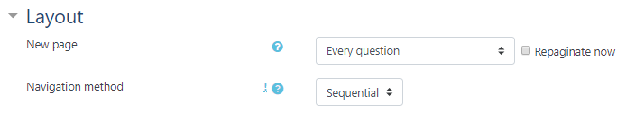
Fig. 37. Quiz layout settings
The quiz is then not personalised taking into account the difficulty of questions.
Several quizzes can also be created and linked with an IF condition to enable switching to more difficult questions depending on the students’ responses. If you get, for instance, 65% in the first quiz, you can move to a more difficult one (Fig. 38).
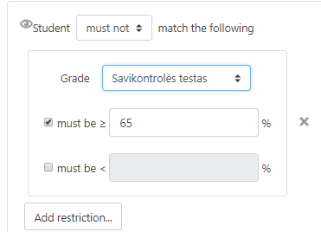
Fig. 38. Restriction rule when moving from one quiz to another

Based on a student’s previous average practice performance, interests and experience, MOODLE can set a certain quiz difficulty.
The course creator can add the rules of switching from one activity to another based on grades or date (Fig. 38). Several interest-based course groups can be created and assigned different course activities. For more information on the personalisation of course materials see page 12.

MOODLE can explain why a response to a quiz question was correct or incorrect, suggest further similar tasks and examples, and give links to additional resources for failed tasks.
Feedback fields for different responses (correct, incorrect, partly correct, etc.) are available in the Quiz tool. Comments and links to course or external materials can be added in the feedback field (Fig. 34).
Feedback fields get activated during a quiz only in the adaptive quiz mode (Fig. 39) designed for self-assessment.
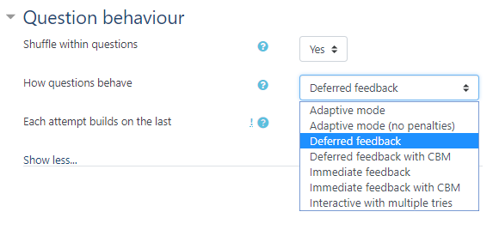
Fig. 39. Question behavior settings
In a learning module, MOODLE can start with easier topics and then move to more difficult ones based on the learners’ previous average quiz/examination performance. The programme being developed will have to calculate criteria based on the grading system presented in the source [7].
Students can get quizzes and questions of different difficulty. Switching to more difficult questions can be sequential (Fig. 37). See section “MOODLE can start with easier quiz questions and then move to more difficult ones or vice versa, depending on the student’s responses” for details.
MOODLE can add random questions from the question bank. This can be used in examinations. Such examination quizzes are rather easy to implement (Fig. 40). The teacher only has to set the category and the number of questions.
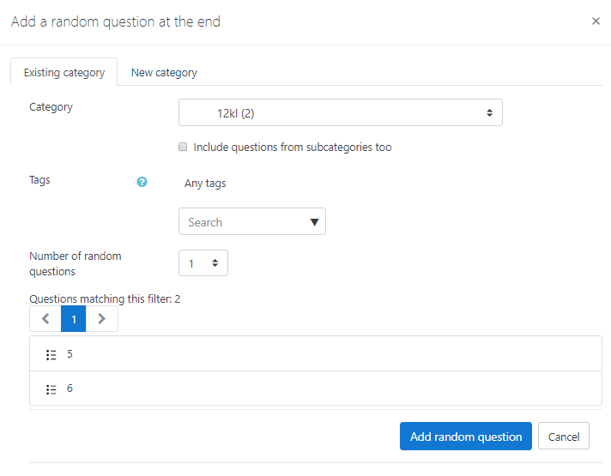
Fig. 40. Adding random questions to a quiz from a new or existing category
The grading system discussed in the source [7] can be used. New grading scales can be added in MOODLE. The system administrator can add a new scale (Fig. 41).

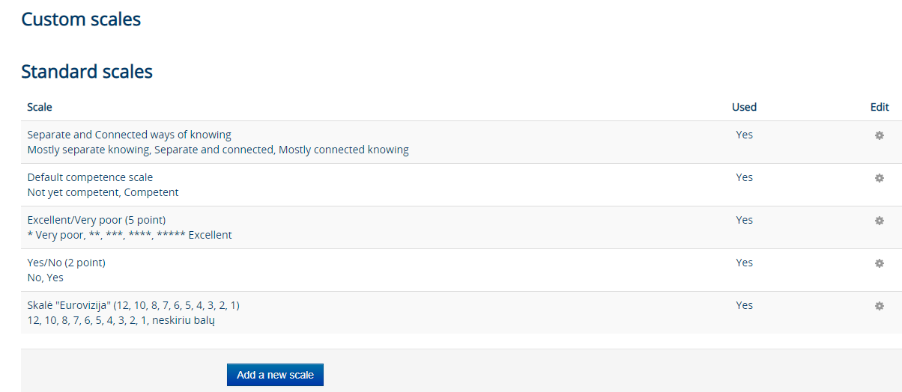
Fig. 41. MOODLE scale editing and adding window
Fig. 42 shows a ten-point grading scale selected in the grading settings of the Assignment activity.
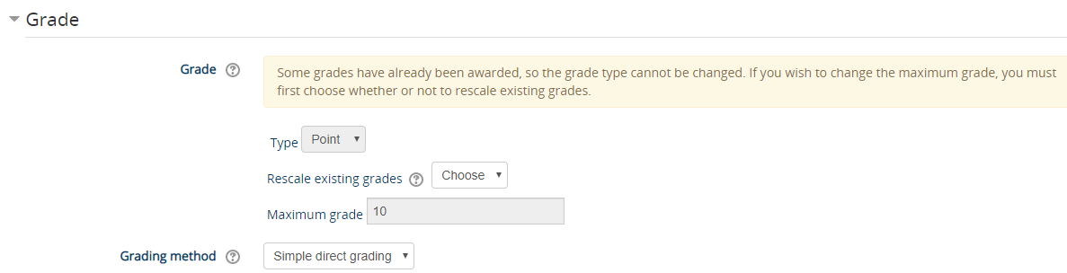
Fig. 42. Ten-point grading scale in Assignment settings

MOODLE can repeat the learning process for any topic students fail (based on a student’s quiz/examination performance).
Course materials can be made accessible for the entire semester, which means unrestricted access to any topics. Alternatively, access to content can be restricted by date (Fig. 43), grade, the number of attempts (Fig. 44) or other conditions. Content restriction parameters can be changed based on the teacher’s teaching methods.
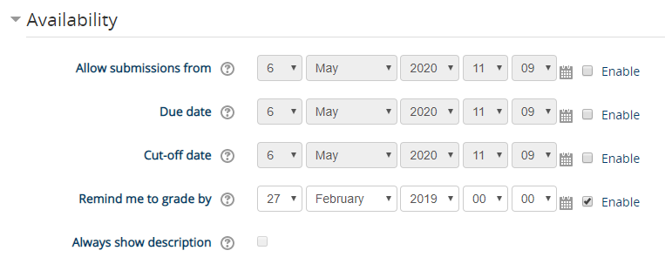
Fig. 43. Content access settings by date in the Assignment activity
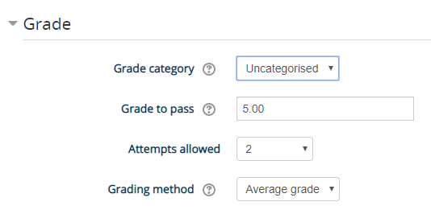
Fig. 44.Number of quiz attempts

MOODLE can give practice assignments of medium difficulty to learners new to practice sessions
The teacher can (manually) add students to different groups based on their performance in a preliminary quiz or other activities. For more information on personalisation of different level materials see page 12.

Students should be allowed to choose the level of difficulty they want
Course materials can be of different difficulty (Fig. 45) with no access restrictions. Students then have access to the full set of course materials and can choose their preferred level of difficulty for their studies.
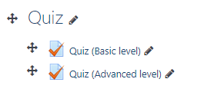
Fig. 45. Basic and advanced level quizzes

MOODLE can automatically create random quizzes from questions of similar difficulty for specific learning module topics.
No. Either the teacher or the course creator creates quizzes.

MOODLE can automatically grade and analyse a student’s quiz responses and then send the analysis results to the student. The result analysis should include details such as the correct and incorrect responses, grades, examples, notes on where to look for more question-specific information and the responses explained.
MOODLE supports these features. Fig. 46 shows the quiz responses report. The teacher can restrict student access to statistical information to prevent them from saving the information or sharing it with other learners.
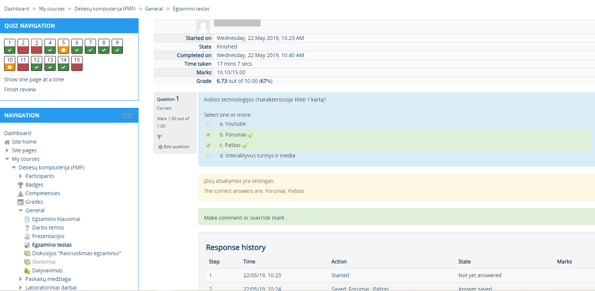
Fig. 46. Quiz response history

MOODLE can display testing details as a matrix or chart including the correct and incorrect responses, the time taken to respond, how many times students changed their solving approach and the grade scored for each task.
MOODLE can display testing details. Each student can view personal statistics to the extent allowed by the teacher. The teacher can see full details including the list of students, grades, etc. (Fig. 47). Quiz reports are available in quiz (grade, response and statistics) windows. Statistical details can be stored as Excel, JSON, CSV, ODS or PDF files. Any stored details can be shown as a table, which has similarities to a matrix. Some statistics can be shown in histograms (Fig. 48).

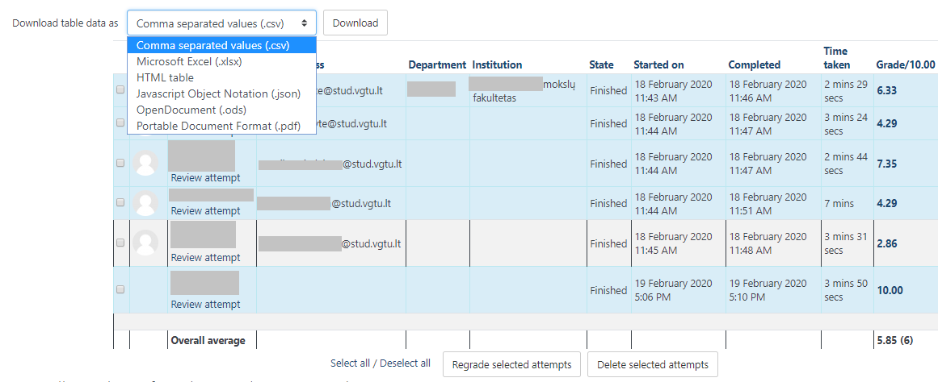
Fig. 47. Grading table with the option to download the results as an Excel matrix

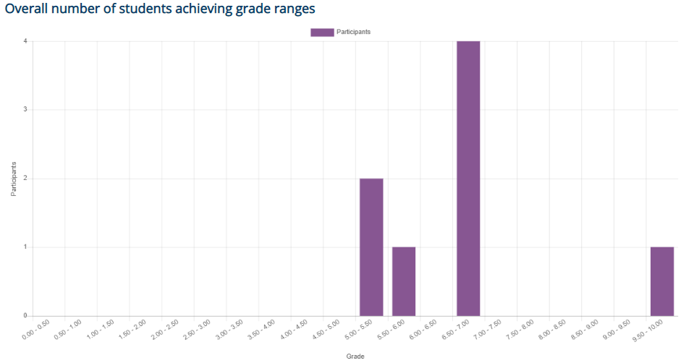
Fig. 48. Histogram of student quiz grades

MOODLE can set and show advanced criteria which, in addition to whether the response is correct or incorrect, also take into account the time a student took to solve a practical task and hesitation before choosing a response. These advanced performance criteria may impact the final grade students get for their skills.
All quizzes track time, but it has no effect on the final grade. When the time expires, the quiz is automatically closed and grades are determined based on the questions students managed to answer before the quiz ended (Fig. 49).
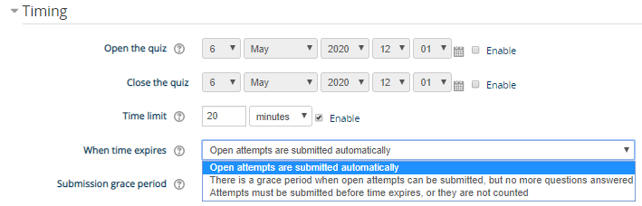
Fig. 49. Time settings in quiz
A set of advanced grading criteria can be applied to an Assessment (review papers or homework). The teacher determines such criteria and they are applied using a grading scale set by the teacher (Fig. 50).
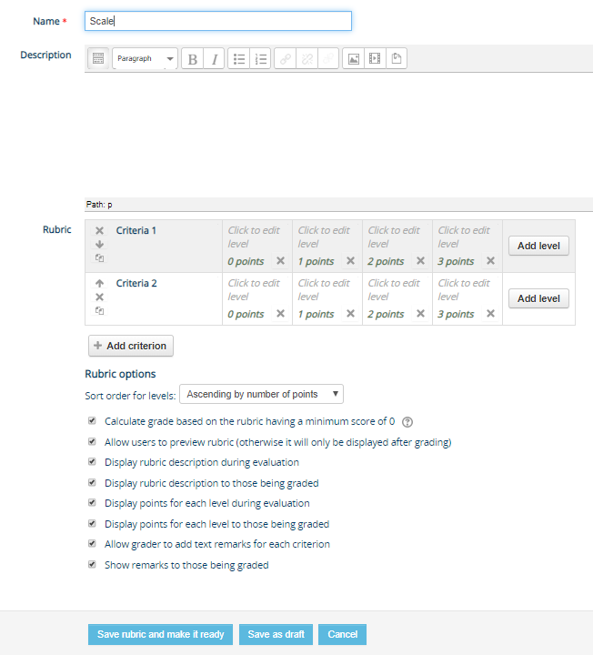
Fig. 50. Setting rubric scales in the Assessment activity

MOODLE can show statistics about the facility of quiz questions and assess questions against advanced quiz criteria.
The section of quiz statistics (Fig. 51) includes an analysis of quiz structure based on its facility index, standard deviation, discriminative efficiency (Fig. 52, Fig. 53, Fig. 54).
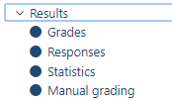
Fig. 51. Quiz results reports
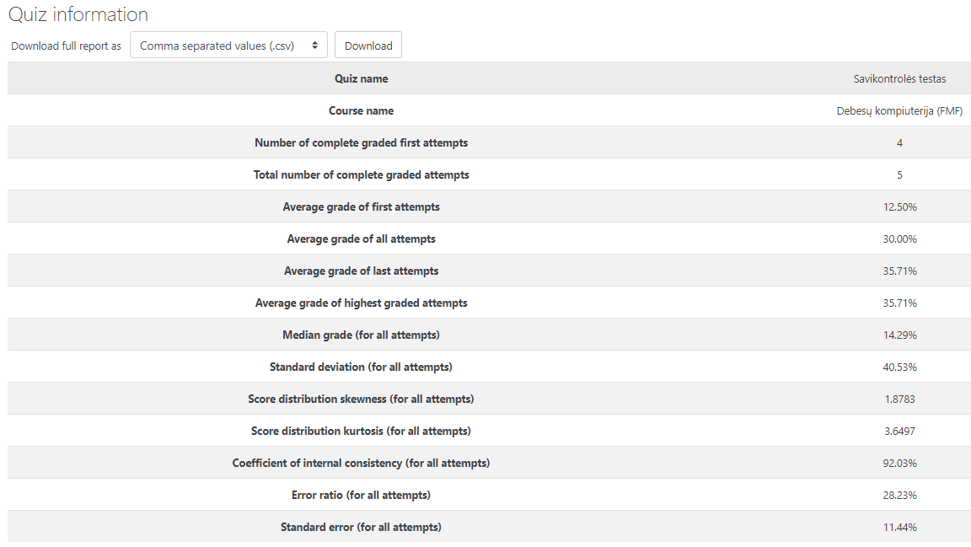
Fig. 52. Statistical quiz information
The parameters are overviewed at https://docs.moodle.org/38/en/Quiz_statistics_report.
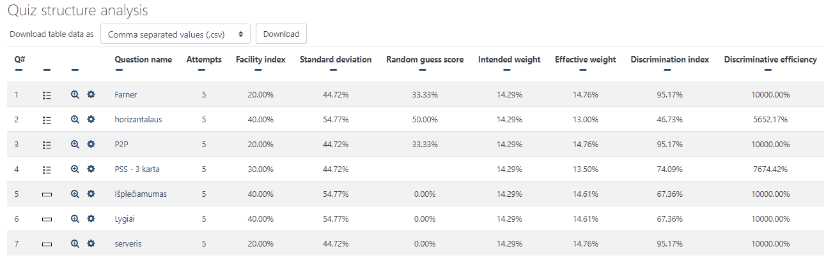
Fig. 53. Quiz structure analysis

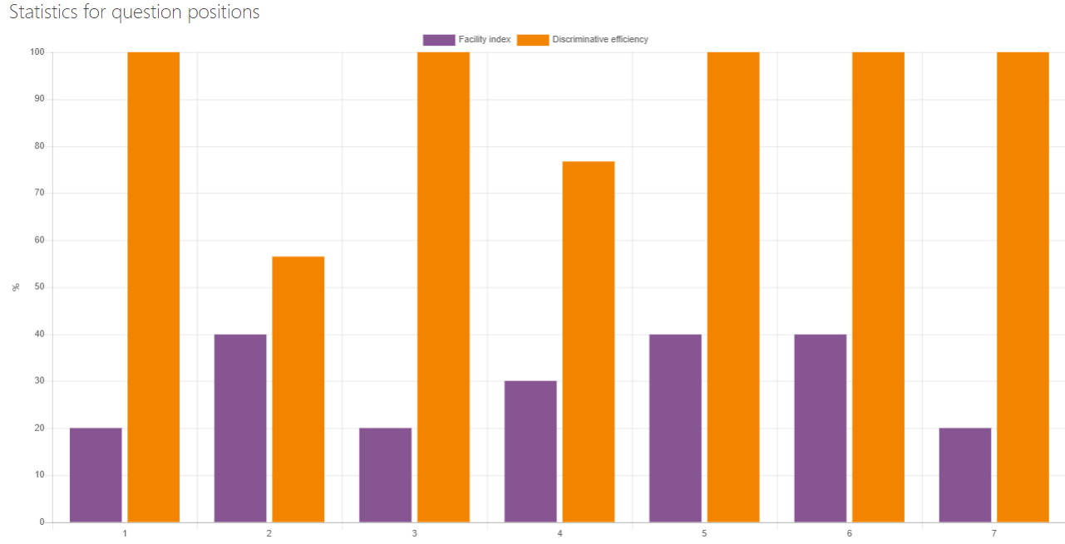
Fig. 54. Statistics for question position

MOODLE shows the teacher the statistical analysis of student responses by sex or type of studies (remote or full-time).
MOODLE cannot show such statistics. The teacher, however, can survey students with a poll in the Questionnaire tool. See section “It should be possible to add and manage details of a student’s preferred and selected learning module topics” for details.
Student quiz response statistics can be filtered by selecting users who have or have not attempted the quiz (Fig. 55) and by student name.
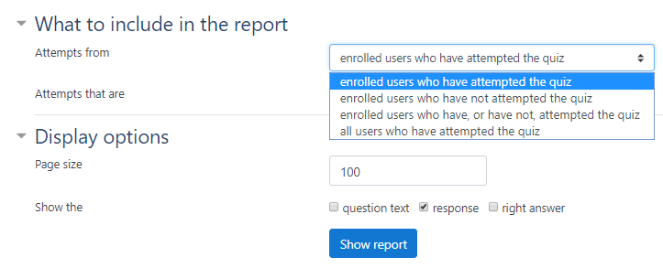
Fig. 55. Quiz results reports filters

MOODLE stores the following information:
- Tasks by module
MOODLE stores tasks and resources grouped in blocks by topic or date (Fig. 56). A single course can have an unlimited number of blocks.
Fig. 56. Materials and tasks stored by topic

- Response options
Questions with several response options, such as Multiple choice and Matching questions, are available in MOODLE (Fig. 12).
- Grades for each response option. Incorrect response scores zero, correct response scores one and partly correct responses score between 0 and 1
The default MOODLE score for a correct response to a question is 1 (Fig. 11). Students who fail to answer a question score 0. In case the response is partly correct, the score is between 0 and 1. The teacher can rate a question higher and give, for instance, 2 or 3 points for a correct response (Fig. 11).
- Task difficulty based on students’ performance in previous tasks
For more information about task personalisation based on difficulty see page 12.
- Real-life examples
Files of any type can be uploaded to MOODLE in lesson blocks.
- Links to task-related theoretical materials
Each activity and resource have description or feedback fields where links to internal course materials or external URLs can be provided.
- Explanations of correct or incorrect responses
Each response can be explained in the Feedback fields of quiz questions.
In addition to commenting, any assignment submitted via the Assessment tool can be also edited (Fig. 33).
- Task time limits
Quizzes are restricted by date and time; the submission of other MOODLE activity assignments is restricted by date.

MOODLE can add and manage student e-portfolio information about qualification, graduation and other certificates, achievements, goals, experience and other personal details that can be submitted to employers.
This feature can be implemented in the user profile either in the description or a separate special field (Fig. 24, Fig. 25). The MOODLE administrator can add more fields to the profile (Fig. 32). Such details can also be provided in an individual Wiki (Fig. 26) or the Assessment tool.

MOODLE can automatically store quiz response and practice assignment data.
MOODLE automatically stores quiz responses that can be accessed by the course teacher. The data can be saved/exported to a file and stored in a computer. Any historical data accumulated over time can be deleted from a course (Fig. 57).
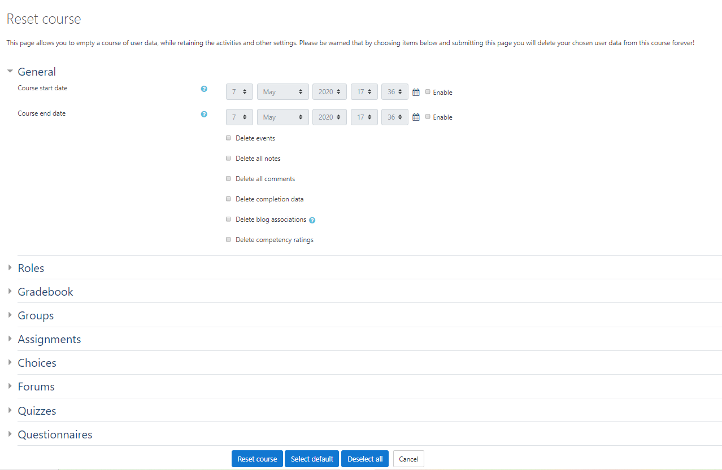
Fig. 57. Deleting stored course data.

Practice grades can also be exported to files. The Assessment tool has a handy option to store all submitted assignments in a single ZIP file. The system adds the author’s name to each submitted file. This speeds up the review and grading of multiple submissions. MOODLE also has a quick grading mode when grades are entered into Grade fields and saved in the system with a single hit on Enter.
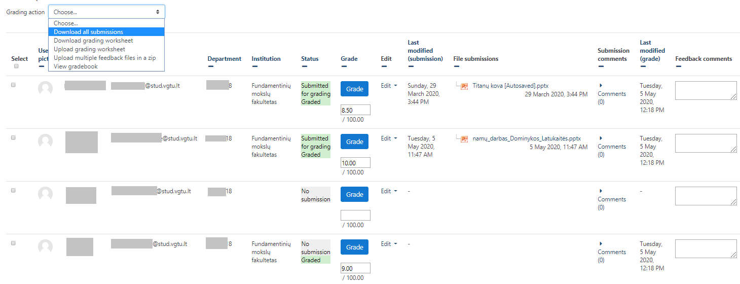
Fig. 58. Quick saving in the Assessment tool

MOODLE can automatically process quiz response details.
When the teacher adds a question to MOODLE, her or she also sets the correct responses to the question. The system can then automatically process quiz response details by matching a student’s answers to the correct responses. In case of open-ended Essays (Fig. 59), however, the teacher’s input is required. All answers to Essay questions are given in a separate Manual Grading window (Fig. 51).
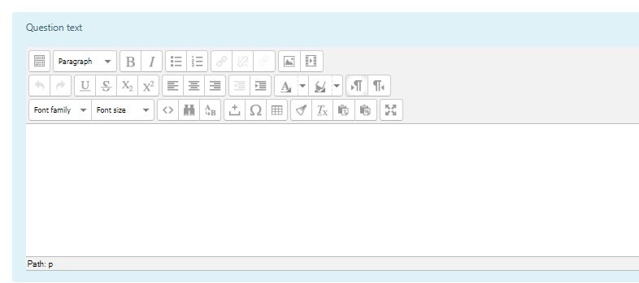
Fig. 59. Essay type question

List of figures:
Fig. 1. Grades reports link in the dashboard page 3
Fig. 2. Grade history tab 3
Fig. 3. Grade user or grade item tab 4
Fig. 4. Log reports page 4
Fig. 5. Quiz responses page 5
Fig. 6. Restriction parameters 6
Fig. 7. Add activity or resource window 7
Fig. 8. The document hierarchy 8
Fig. 9. Question bank functionality 8
Fig. 10. Example of the matching type question 9
Fig. 11. Question weights defining their contribution towards the final grade 9
Fig. 12. Question types window 10
Fig. 13. Available authentication plugins window 11
Fig. 14. Email-based self-registration settings 12
Fig. 15. User upload window 12
Fig. 16. Edit profile window 13
Fig. 17. Course-level group creation window 14
Fig. 18. An example of access restriction by group and grade 14
Fig. 19. Discussion room window 15
Fig. 20. Responses of students signing up for homework presentation in the Choice tool 15
Fig. 21. Voting options in the Choice tool 16
Fig. 22. The settings window of Questionnaire tool 17
Fig. 23. Types of questionnaire questions 17
Fig. 24. General profile settings 18
Fig. 25. Profile settings: Interests and Optional 19
Fig. 26. Individual wiki mode settings 19
Fig. 27. Grade export window 20
Fig. 28. Various login and participation reports 20
Fig. 29. Course participation report 21
Fig. 30. Activity report 21
Fig. 31. Grade item calculation window 22
Fig. 32. Create a new profile field window 23
Fig. 33. Grade and feedback window in the Assessment tool 23
Fig. 34. Feedback fields in quiz settings 24
Fig. 35. Logs report by the lesson material 25
Fig. 36. Ways to create questions/add them to a quiz 26
Fig. 37. Quiz layout settings 26
Fig. 38. Restriction rule when moving from one quiz to another 27
Fig. 39. Question behavior settings 28
Fig. 40. Adding random questions to a quiz from a new or existing category 28
Fig. 41. MOODLE scale editing and adding window 29
Fig. 42. Ten-point grading scale in Assignment settings 29
Fig. 43. Content access settings by date in the Assignment activity 30
Fig. 44.Number of quiz attempts 30
Fig. 45. Basic and advanced level quizzes 31
Fig. 46. Quiz response history 32
Fig. 47. Grading table with the option to download the results as an Excel matrix 33
Fig. 48. Histogram of student quiz grades 33
Fig. 49. Time settings in quiz 34
Fig. 50. Setting rubric scales in the Assessment activity 35
Fig. 51. Quiz results reports 36
Fig. 52. Statistical quiz information 36
Fig. 53. Quiz structure analysis 37
Fig. 54. Statistics for question position 37
Fig. 55. Quiz results reports filters 38
Fig. 56. Materials and tasks stored by topic 38
Fig. 57. Deleting stored course data. 39
Fig. 58. Quick saving in the Assessment tool 40
Fig. 59. Essay type question 40

