Computer Learning System
MANUAL

Contents

1 Login 2
1.1 Create a new Computer Learning sytem 2
1.2 Development of New Computer Learning Systems 4
2 Administration and development 5
2.1 Administration and development of computer learning systems 5
2.2 Creation of system object groups 6
2.3 System objects (alternatives) 7
2.4 System criteria 8
2.5 Measurement units 8
2.6 System Parameters 9

Login

Create a new Computer Learning System
- The system is a part of the BECK Centre developed during the project. Open the BECK project website http://beck-erasmus.com/ to access the system (Fig. 1)
- Go to the BECK project website, select BECK Centre in the menu and click Computer Learning systems in the drop-down menu (Fig. 1). You will be presented with a list of Computer Learning systems (Fig. 2).

Fig. 1. The BECK project website.

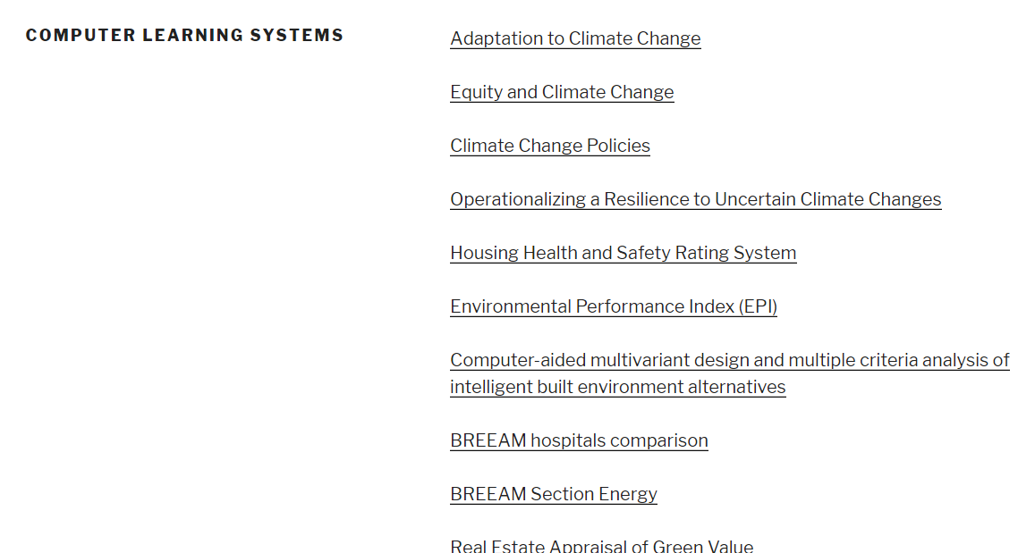
2 pav. Lists of Computer learning systems

- Select the system you are interested in and click on its name. As an example, let's consider the Adaptation to Climate Change system. The Description of alternatives window opens with an initial data matrix (1) (Fig. 3). In the top bar of the tools, you can also choose to see the calculation results of the computer training system (4) and the recommendations to the user (3).
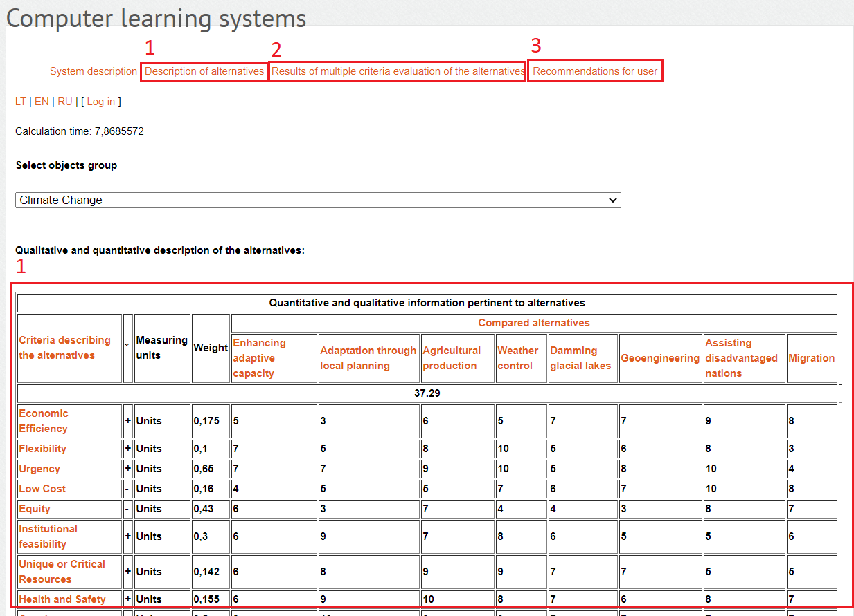
Fig 3. Primary data matrix.
- Click on Results of multiple criteria evaluation of the alternatives and the results (the alternatives significance, priority and utility degree) of calculations will be presented (Fig. 4).

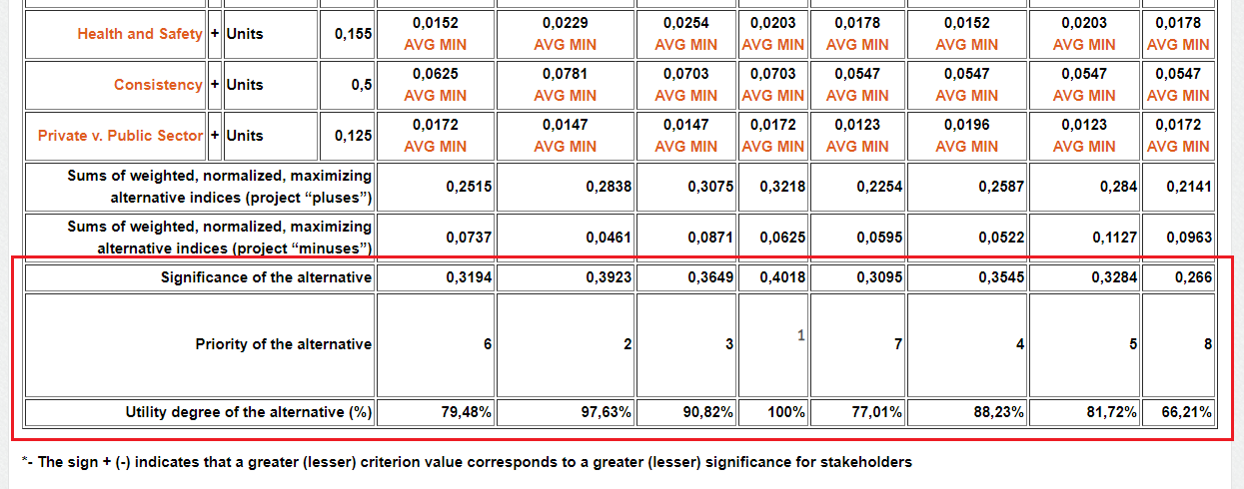
Fig. 4. Multi criteria evaluation results.

Development of New Computer Learning Systems

System could be accessed via Internet browser opening the following address: http://iti3.vgtu.lt/becksystems/Account/Login.aspx. After successful loading of the Web page content the user would be able to see logging in page, displayed in the upper left corner (Fig. 1.). Login to system by using:
- UserName: 007
- Password: 007.
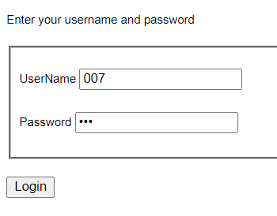
Fig. 1. Login to the system

After successful login to the system, registered user will see main system window and menu (Fig.2.).
Links enabling the selection of required language (LT, EN, RU) to display texts are provided at the right side of the page. Name of connected user and Log out button are displayed below.
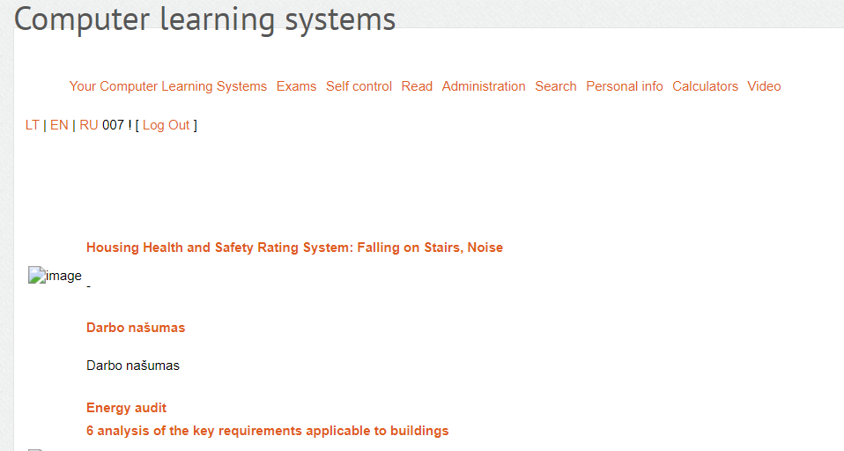
Fig. 2. Main system window and menu

Administration and development

Administration and development of computer learning systems
- Select “Administration” -> “Create a new system” (fig. 3).
- Created systems could be viewed, edited, deleted after the selection of topics and subtopics.
- Enter system title, short description, logo, tick the box to publish it immediately and click on „Add system“ (fig. 4)

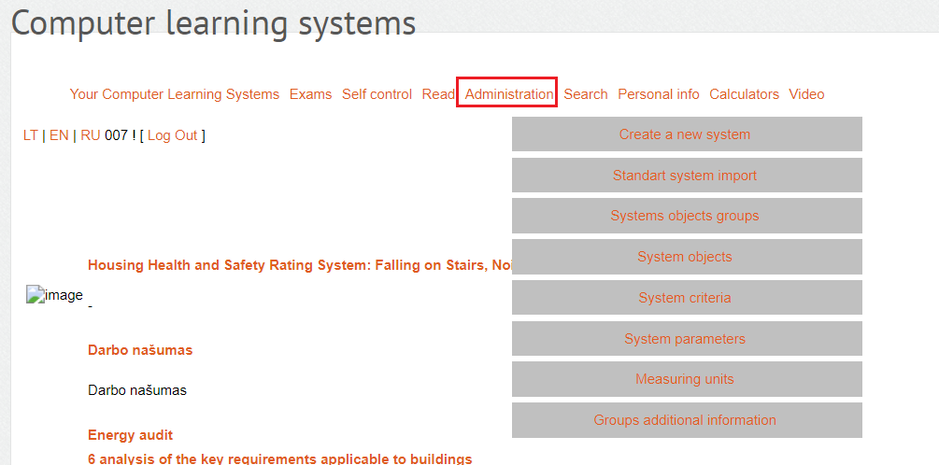
Fig. 3. Administration of Computer Learning Systems
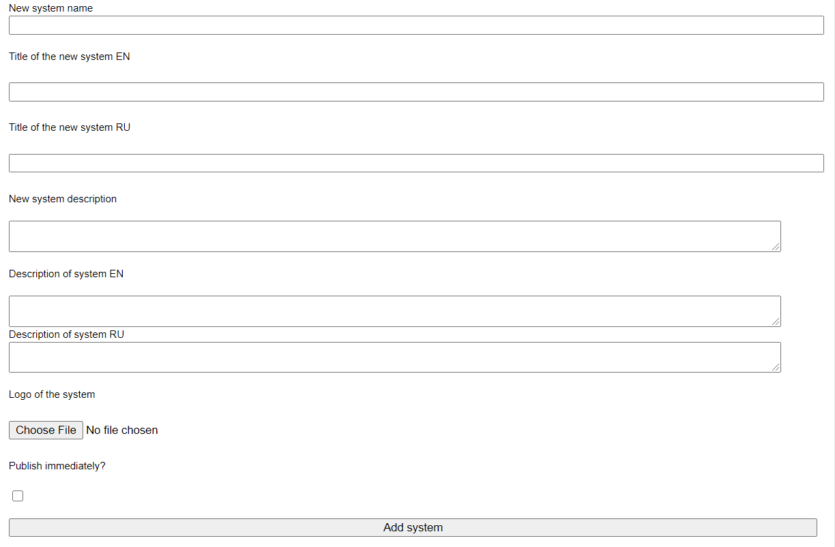
Fig. 4. Development of new computer learning systems

Creation of system object groups

- Select “Adminitration” -> “System object groups” in the menu.
- Select created system to be used for object group assignment in the list “My systems”.
- Type in designation of an object group in the “Object group name” field (e.g., Roof, the other one will be named as Windows, Doors, etc.).
- Type in designation in English in the “Object group name EN”.
- “Object group description”.
- Click “Add group” when all fields are filled in.

Object groups shall be deemed as designations of groups assigned to concerned alternatives. For example, residential building should be analyzed in accordance with the Project scope. For this purpose the following designation of object groups could be selected: “Roof”, “External walls”, “Internal walls”, “Foundations”, “Windows”, “Doors”, etc. Each object group incorporates objects of alike properties and purposes (concerned alternatives).

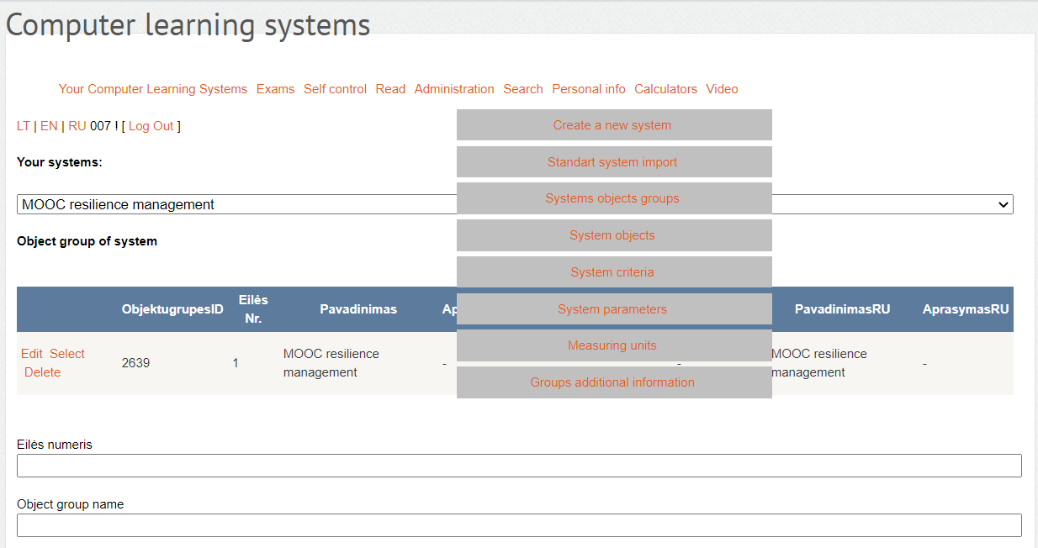
Fig. 5. Section of the “System object groups” page

System objects (alternatives)

- Select “Administration” -> “System objects” in the menu.
- Select created system to be used for alternative assignment in the list “My systems”.
- Select object group to be used for alternative assignment in the list “System object groups”.
- Type in short designation of the alternative in the “Object title” field.
- Type in short designation of the alternative in English in the “Object title EN” field.
- “Object description”.
- Click “Add object” when all fields are filled in.
Fields could be edited or deleted with the help of reference at the right part of the field, namely, “Edit” or “Delete”, see Fig.6.

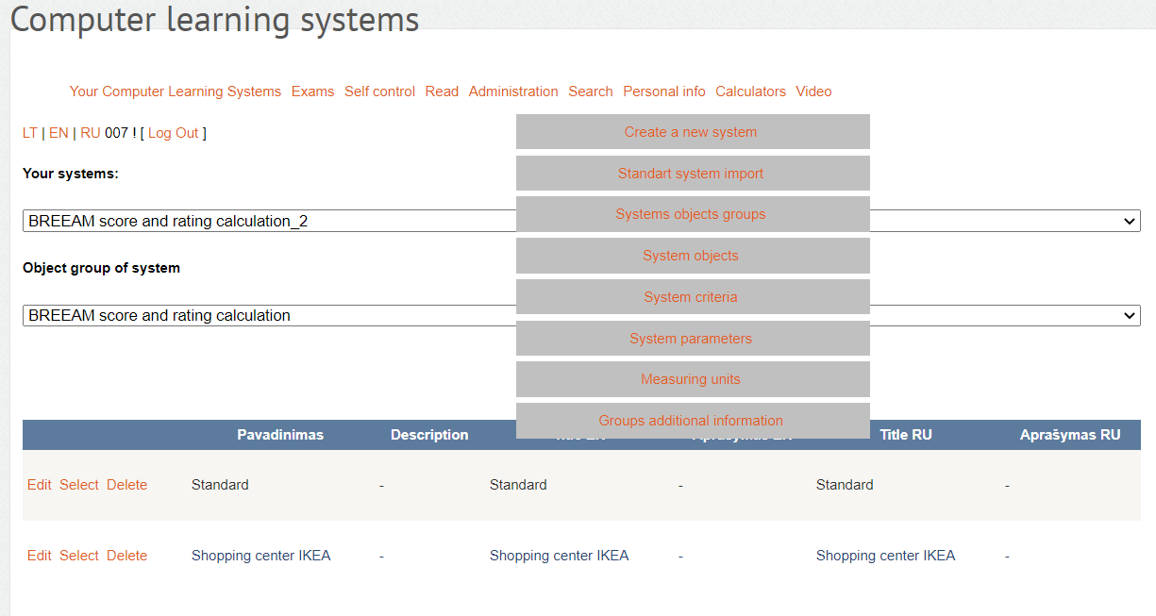
Fig. 6. Section of the “System objects” page

System criteria

- Select “Administration” -> “System criteria” in the menu.
- Select created system to be used for alternative assignment in the list “My systems”.
- Select object group to be used for criteria assignment in the list “System object groups”.
- Type in criteria designation in Lithuanian and English.
- Fill in description of criteria.
- Tick the field “Maximizing criterion” if criterion is maximizing (+), leave the field blank if criterion is minimizing (-).
- Weighted coefficient (e.g., 0.089) should be indicated in the “Criterion weight” field.
- Select measurement units to be used for selected criterion in the “Criterion measurement units” field (e.g., 1000 Eur., points, etc.).
  - If the list does not include the required measurement unit:
    - Select “Administration” -> “Measurement units” in the menu.
    - Type in required measurement unit in the “Title” field (it will be included in the list, described in clause 9).
    - Click “Add”.
- Click “Add”.

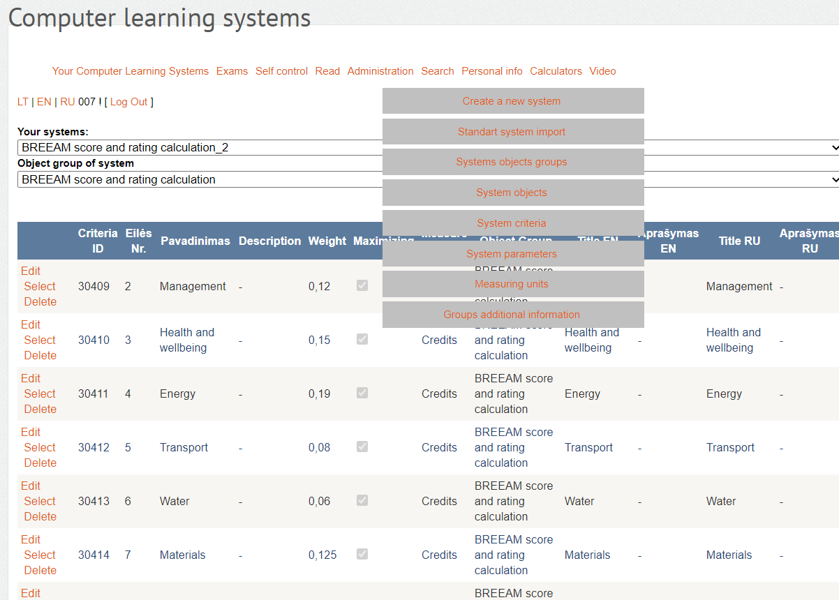
Fig. 7. Window including the List of system criteria

Measurement units

- Select “Administration” -> “Measurement units” in the menu.
- Type in required measurement unit in Lithuanian and English.
- Click “Add”.

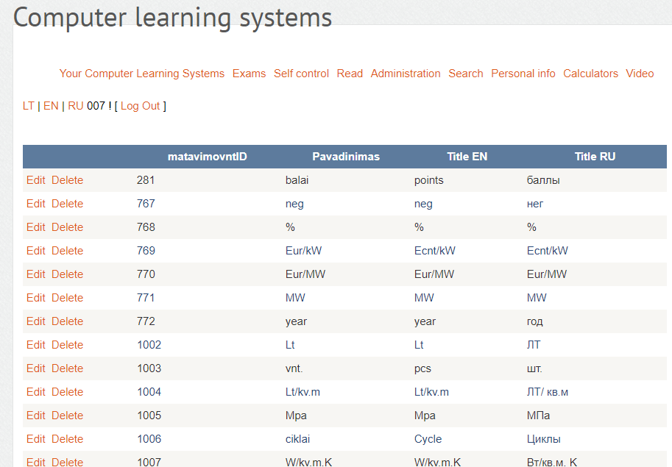
Fig. 8. Window including the list of measurement units

System Parameters

- Select “Administration” -> “System parameters” in the menu.
- Select created system to be used for alternative assignment in the list “My systems”.
- Select object group to be used for criteria assignment in the list “System object groups”.
- Select the alternative in the list “System object groups”.
- Select the criterion to be used for value (parameter) indication in the list “System object group criteria” (e.g., “RE demand value”).
- Type in criterion value of the alternative in the field “Parameter” (e.g., 247.2) and click “Update”.
  - In order to include all values of alternative criteria, use the fast entry field between the “Update” and “Fast multiple values input” buttons.

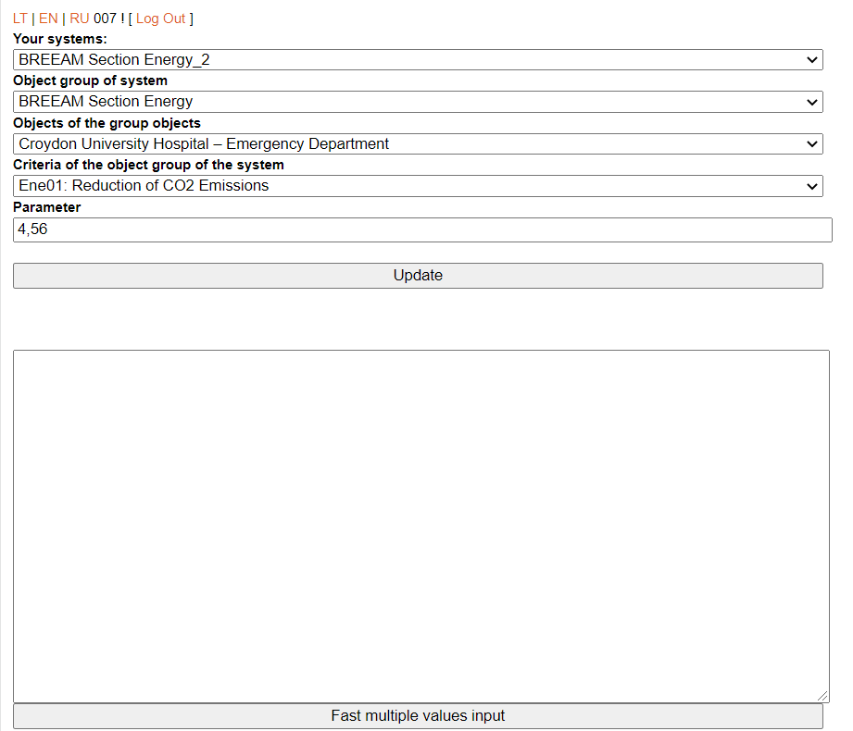
Fast entry field, e.g.:
124.0
126.7
125.4
12.12

Fig. 9. Window including the system parameter entry

  - Data shall be typed in columns; it could be added with the help of Ctrl+V shortcut key.
  - Click “Fast multiple values input”.
- Values of other alternatives are indicated by analogy selecting it on the list “Objects of an object groups”.
- To exit the system click [Logout] at the upper right corner of the window.

