Intelligent Tutoring System
User Manual

Note: Internet Explorer is not fully supported and may cause issues.

To open the Intelligent Tutoring System, use the following steps:
- The system is a part of the BECK Centre developed during the project. Open the BECK project website http://beck-erasmus.com/ to access the system (Fig. 1).
- Go to the BECK project website, select BECK Centre in the menu and click Affective Tutoring System in the drop-down menu (Fig. 1).
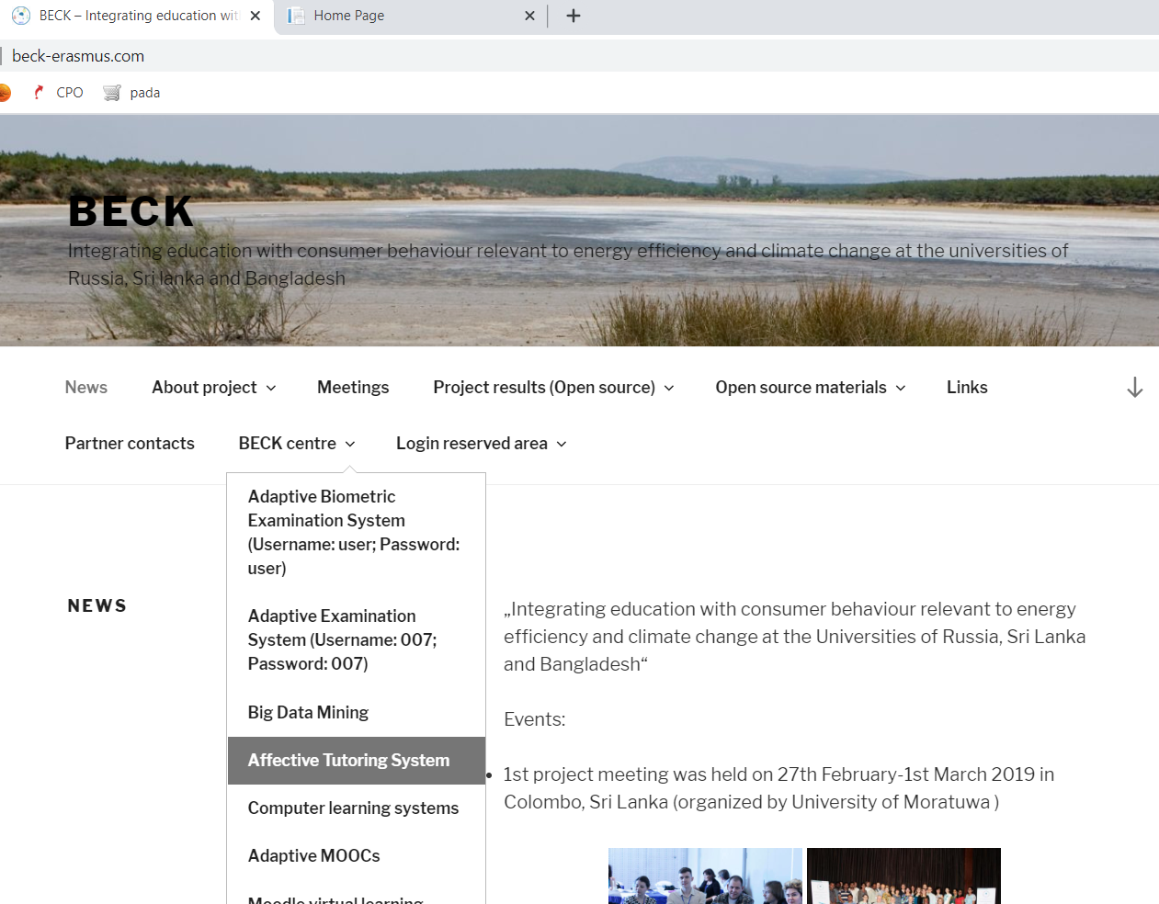
Fig. 1. The BECK project website.

- A window will open. Choose Intelligent Tutoring System (Username: 007 ; Password: 007) (Fig. 2).

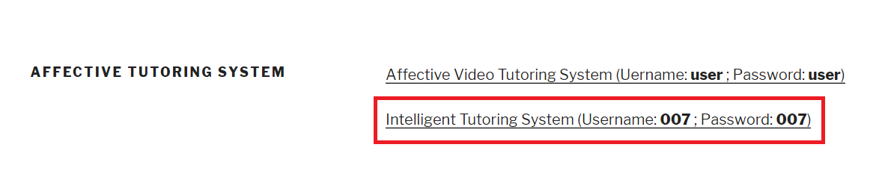
Fig. 2. The link to Intelligent Tutoring System.

- To search for articles, check the box next to Only articles and click Add a keyword to start the search (Fig. 3).

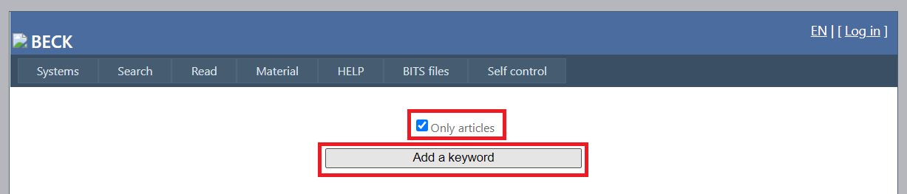
Fig. 3. Affective MOOCs log-in screen.

- A window will open. Enter the keywords (1) and their weights (2) and click Add a keyword (Fig. 4):

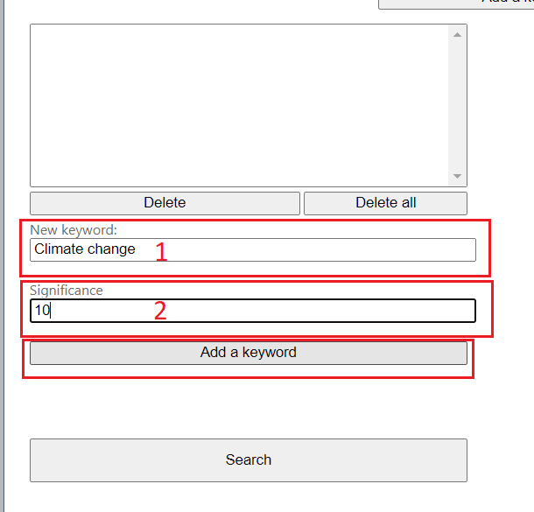
Fig. 4. Adding keywords.

- Check the box next to Advanced search options at the bottom of the page. Select Publications and enter the number of publications (Fig. 5). The system will show that specific number of publications with the highest count of the given keywords.

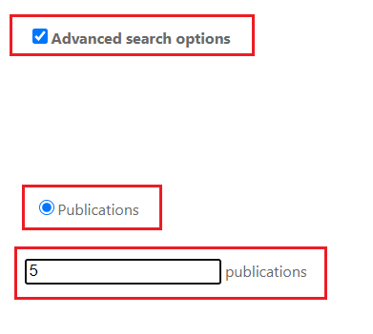
Fig. 5. Advanced search options.

- Set the search parameters and start the search. To see your search results, click the Search button (Fig. 6).
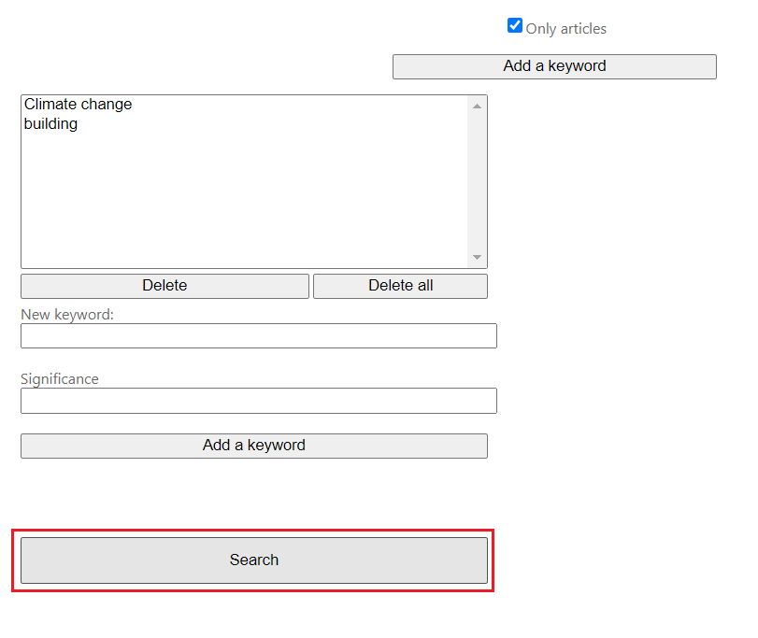
Fig. 6. The Search button.

- The search results will be shown at the bottom of the page, when the Advanced search options are set. The system combines any found articles in a PDF file (1) and also shows a table with the details of the articles (2) (Fig. 7)

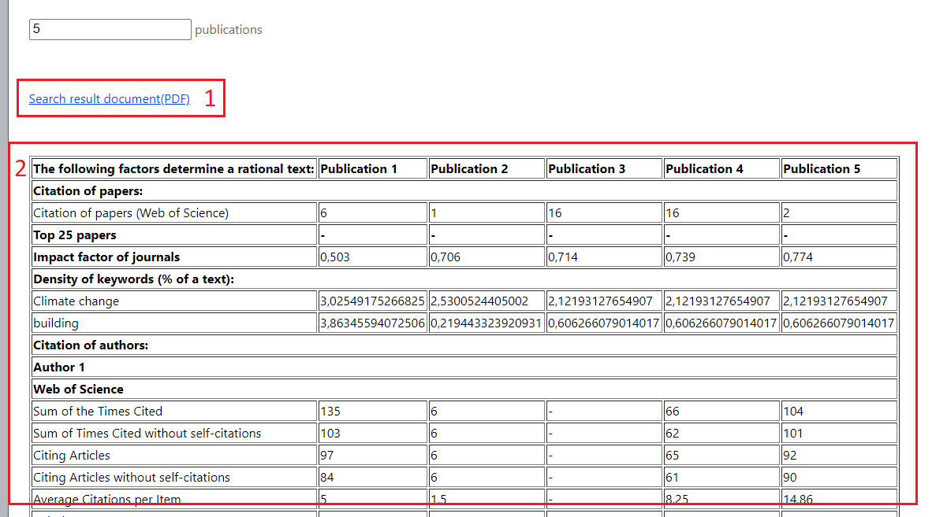
Fig. 7. Search results.

- When you open the Search result document, the articles selected based on your keywords will be automatically displayed (Fig. 8).
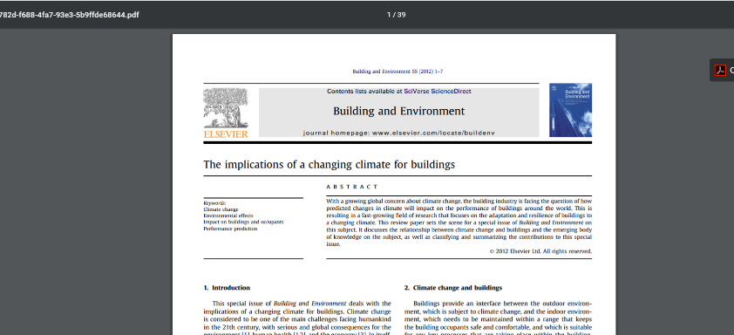
Fig. 8. Open Search result document.

