Intelligent Tutoring System
ADMIN MANUAL

Contents

1 Login 2
2. Inclusion of a substance 4
3. Keyword loading 5
4 Administration 5
4.1 Administration of all practical systems 5
4.2 Creation of system object groups 6
4.3 System objects (alternatives) 6
4.4 System criteria 7
4.5 Measurement units 8
4.6 System Parameters 9
5. Material loading 11
5.1. Modules names loading 11
5.2. Material loading 13
5.3. Additional material loading 14
6. System settings 15
8. Student administrative 16
8.1. Students 16
8.2. Students according to the group. 17
8.3. Institution loading 18
8.4. New faculty loading 18
8.5. New program loading 18
8.6. New group loading 19

Login
System could be accessed via Internet browser opening the following address: http://iti3.vgtu.lt/Beck. After successful loading of the Web page content the user would be able to see logging in page, displayed in the upper left corner (Fig. 1.).
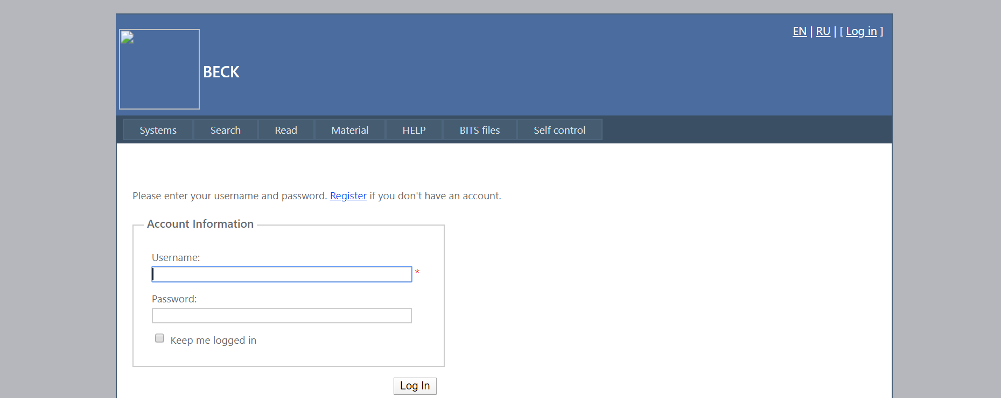
Fig. 1. Login to the system

In order to login to the system, user should use previously developed name, i.e. “User name” and provided password, i.e. “Password”. At the beginning user could use the same combination both for “User name” and “Password”, later the password could be changed. Unregistered user could use password preliminary created by user, having an administrator’s rights (system administrator).
To enter the system type in provided data to the “UserName” and “Password” fields and click “Login” at the right lower corner of the page.
System informs the user about failed login (incorrect user name or password) (Fig. 2.).

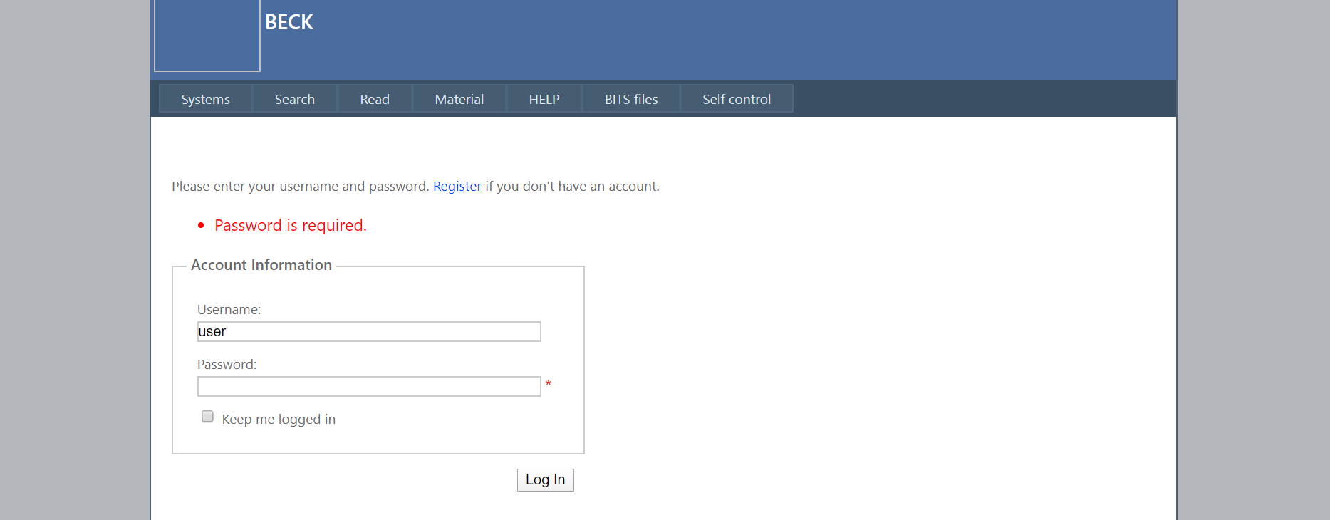
Fig. 2. System message about failed login to the system

Note: if the “UserName” already exists in the system, i.e., system includes registered user with particular name and login failure occurred due to incorrect password, the system will restrict further login after three unsuccessful attempts (in order to prevent automated matching of password recovery programs). In this case it is recommended to contact system administrator.
After successful login to the system, registered user will see main system window and menu (Fig. 3.).
Links enabling the selection of required language ( EN, RU) to display texts are provided at the right side of the page. Name of connected user and Log out button are displayed below.

Inclusion of a substance
To view and include guides on select „Inclusion of a substance“.
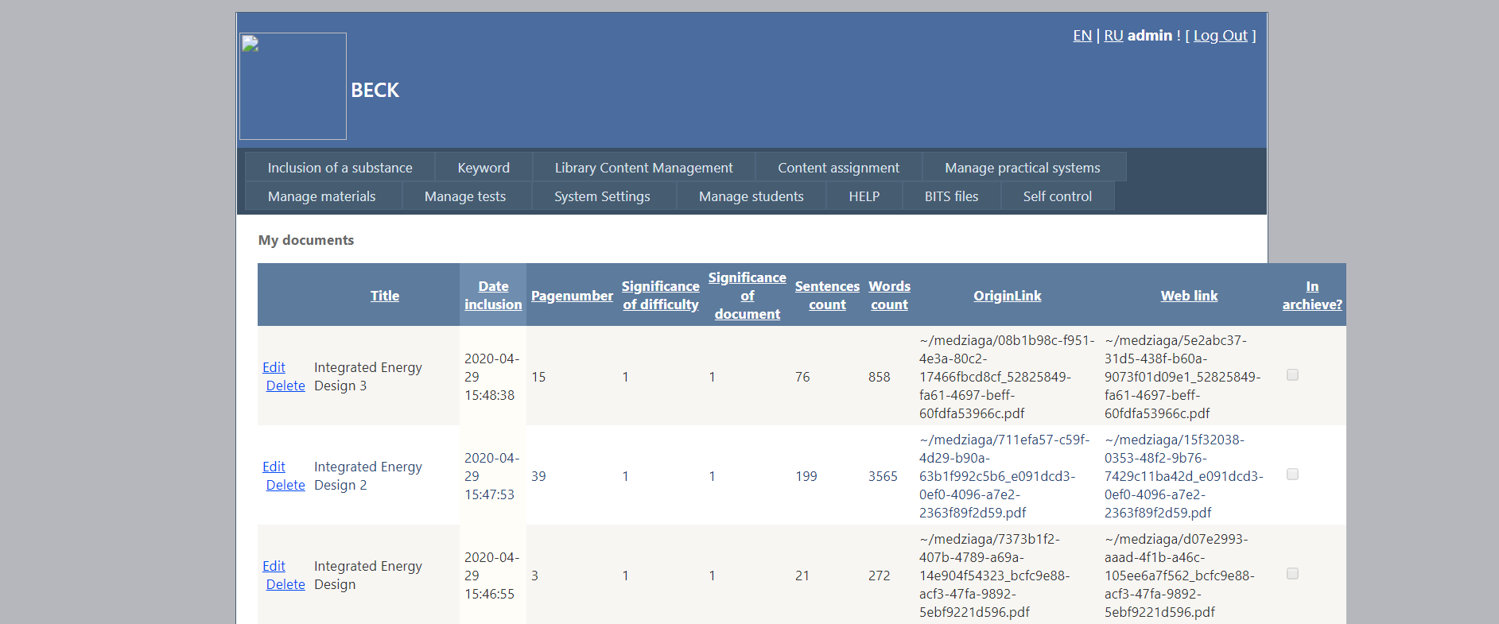
Fig 3. Material list
To add name type language and choose document file with browse button and press „Add new material“
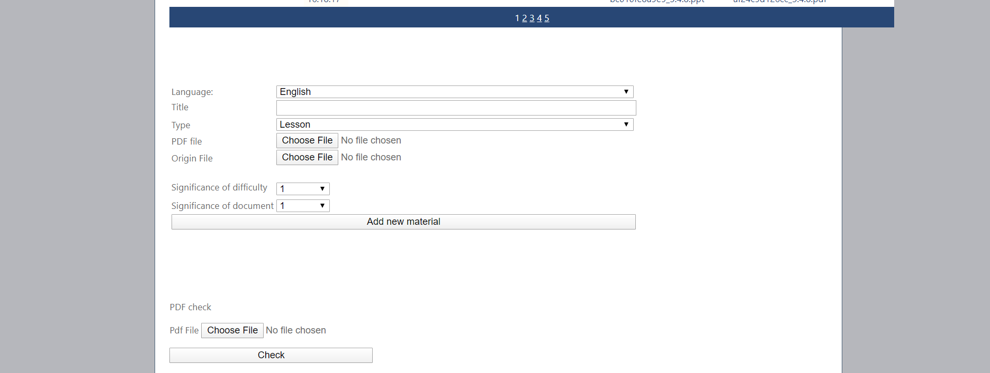
Fig 4. Material add

Keyword loading
To add a list of keywords with search system to facilitate the search, select the "Keyword" When you enter a keyword press enter.
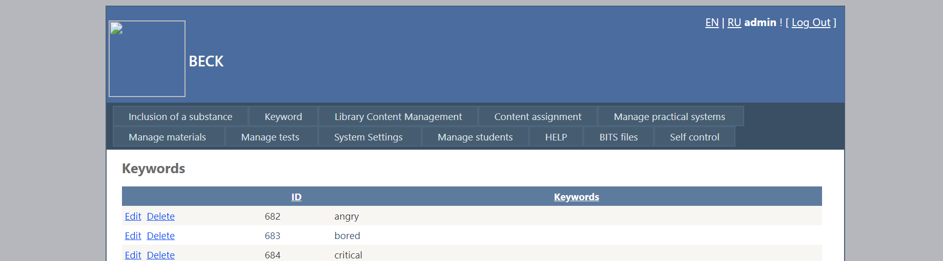
Fig 5. Keywords list

Administration

Administration of all practical systems
- Select “Manage practital systems” -> “Manage of all practical systems” in the menu.
- Created systems could be viewed, edited, deleted after the selection of topics and subtopics.

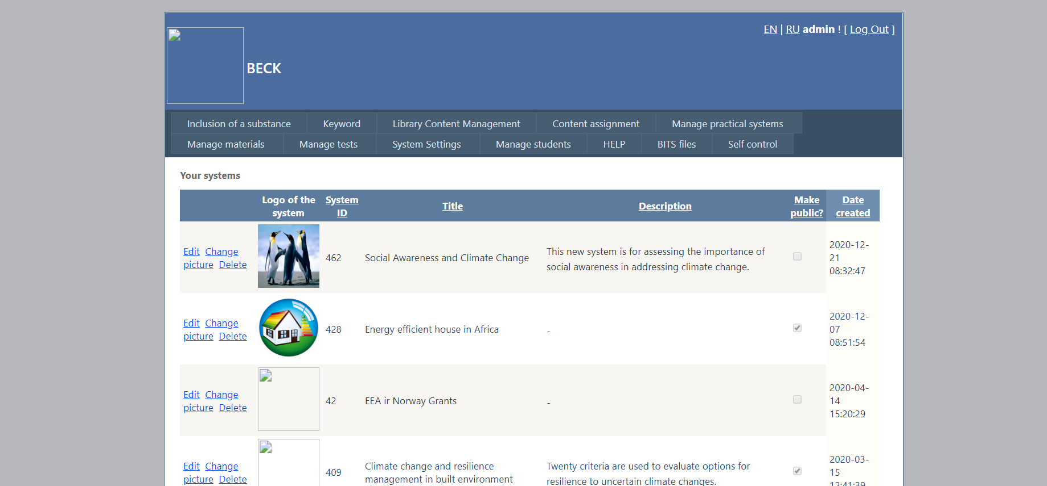
Fig. 6. The list of all practical systems

Creation of system object groups

- Select “Manage” -> “System object groups” in the menu.
- Select created system to be used for object group assignment in the list “My systems”.
- Type in designation of an object group in the “Designation of object group” field (e.g., Roof, the other one will be named as Windows, Doors, etc.).
- Type in designation in English in the “Designation of object group EN” as it is described in point (3).
- “Object group description”.
- Click “Add group” when all fields are filled in.

Object groups shall be deemed as designations of groups assigned to concerned alternatives. For example, residential building should be analyzed in accordance with the Project scope. For this purpose the following designation of object groups could be selected: “Roof”, “External walls”, “Internal walls”, “Foundations”, “Windows”, “Doors”, etc. Each object group incorporates objects of alike properties and purposes (concerned alternatives).

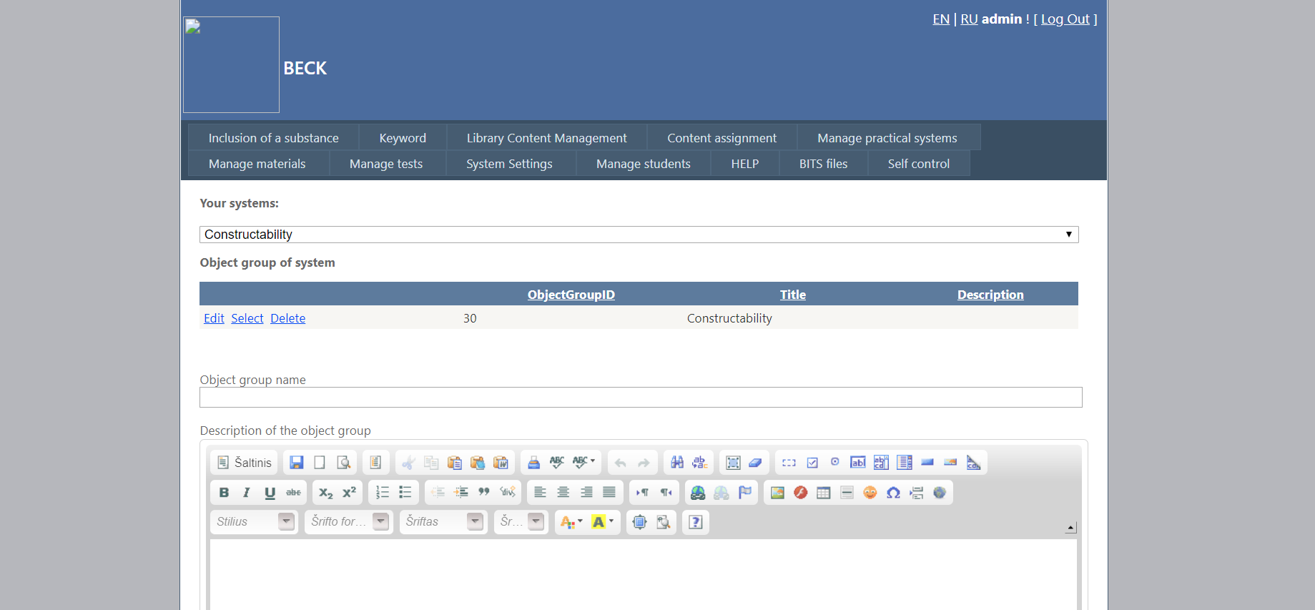
Fig. 7. Section of the “System object groups” page

System objects (alternatives)

- Select “Manage” -> “System objects” in the menu.
- Select created system to be used for alternative assignment in the list “My systems”.
- Select object group to be used for alternative assignment in the list “System object groups”.
- Type in short designation of the alternative in the “Object designation” field.
- Type in short designation of the alternative in English in the “Object designation EN” field.
- “Object description”.
- Click “Add object” when all fields are filled in.
Fields could be edited or deleted with the help of reference at the right part of the field, namely, “Edit” or “Delete”, see Fig. 8.

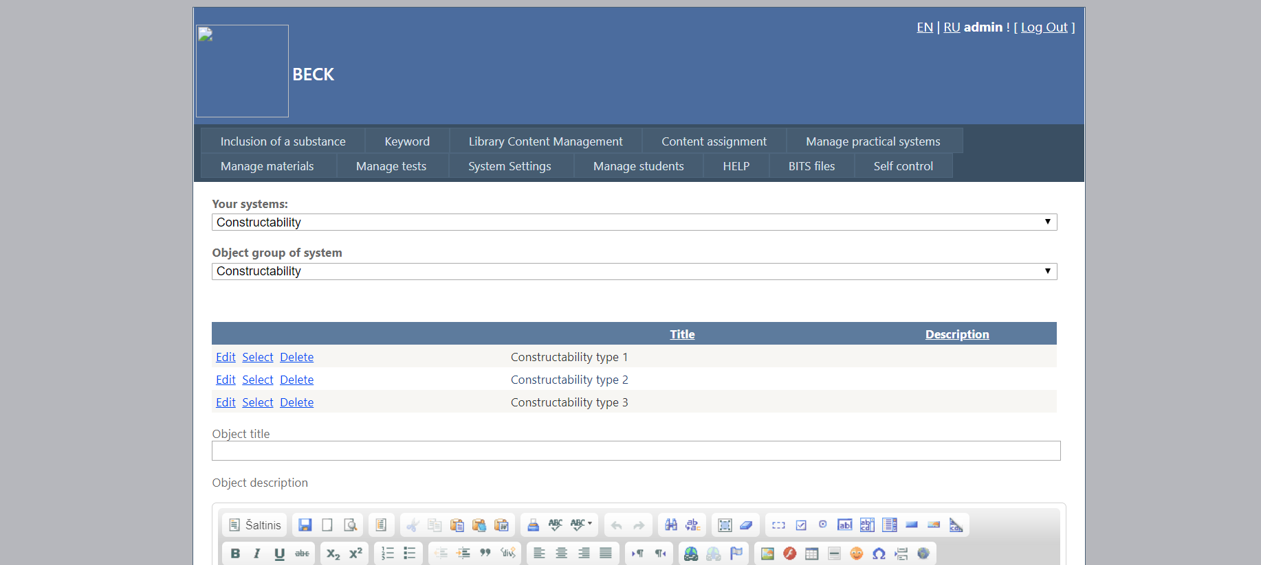
Fig. 8. Section of the “System objects” page

System criteria

- Select “Manage” -> “System criteria” in the menu.
- Select created system to be used for alternative assignment in the list “My systems”.
- Select object group to be used for criteria assignment in the list “System object groups”.
- Type in criteria designation in Lithuanian and English.
- Fill in description of criteria.
- Tick the field “Maximizing criterion” if criterion is maximizing (+), leave the field blank if criterion is minimizing (-).
- Weighted coefficient (e.g., 0.089) should be indicated in the “Criterion weight” field.
- Select measurement units to be used for selected criterion in the “Criterion measurement units” field (e.g., 1000 Eur., points, etc.).
  - If the list does not include the required measurement unit:
    - Select “Administration” -> “Measurement units” in the menu.
    - Type in required measurement unit in the “designation” field (it will be included in the list, described in clause 9).
    - Click “Add”.
- Click “Add”.

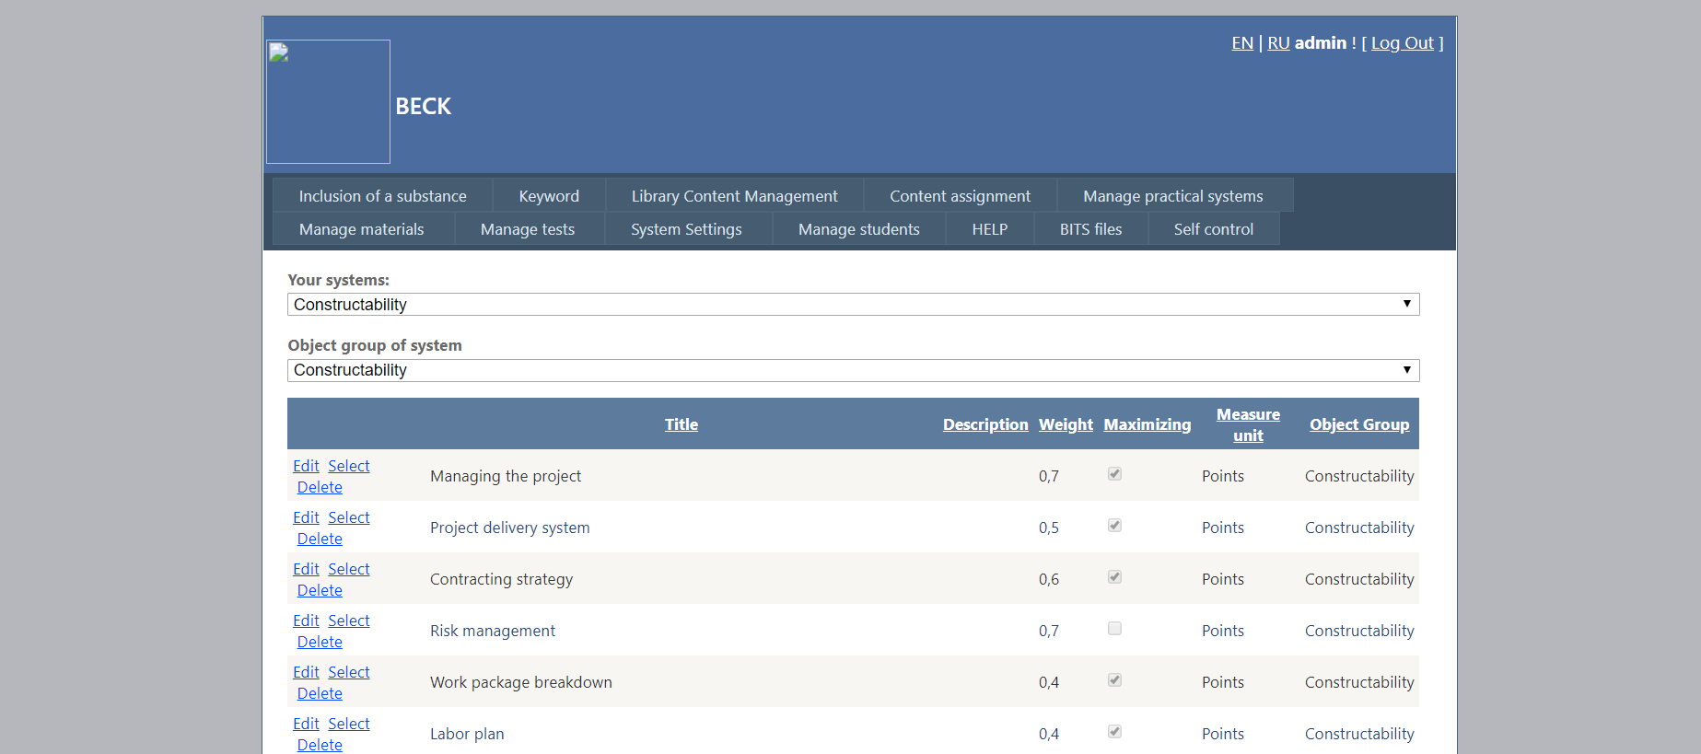
Fig. 9. Window including the List of system criteria

Measurement units

- Select “Manage” -> “Measurement units” in the menu.
- Type in required measurement unit in Lithuanian and English.
- Click “Add”.

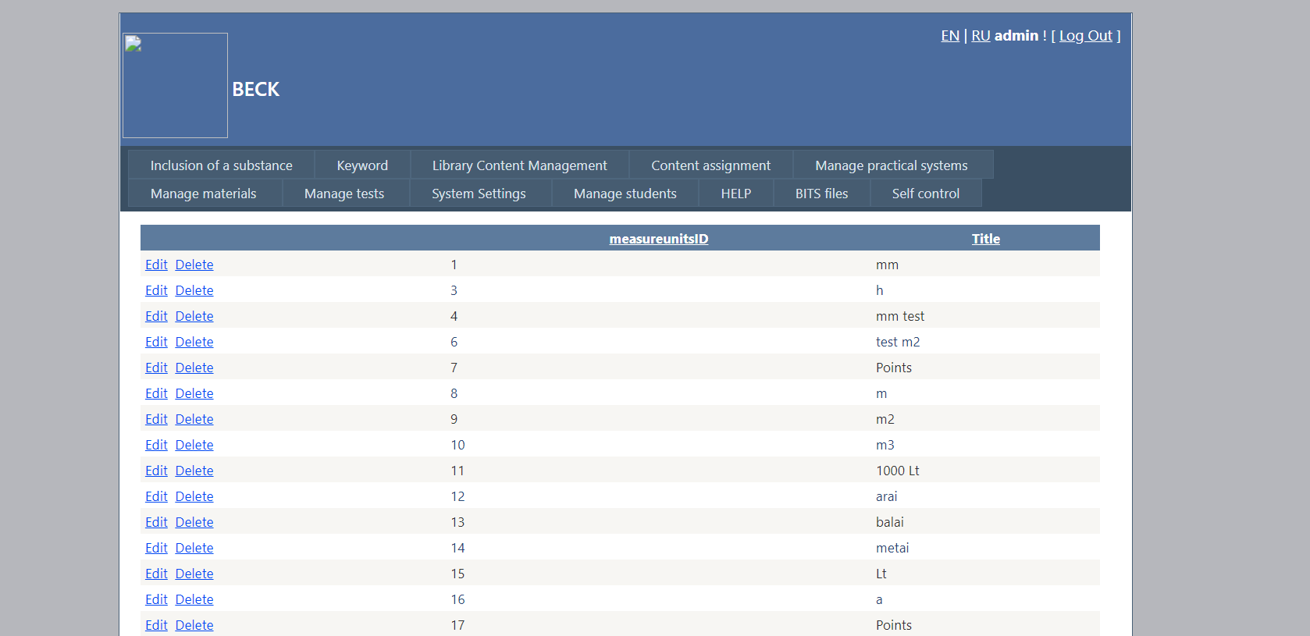
Fig. 10. Window including the list of measurement units

System Parameters

- Select “Manage” -> “System parameters” in the menu.
- Select created system to be used for alternative assignment in the list “My systems”.
- Select object group to be used for criteria assignment in the list “System object groups”.
- Select the alternative in the list “System object groups”.
- Select the criterion to be used for value (parameter) indication in the list “System object group criteria” (e.g., “RE demand value”).
- Type in criterion value of the alternative in the field “Parameter” (e.g., 247.2) and click “Refresh”.
  - In order to include all values of alternative criteria, use the fast entry field between the “Refresh” and “Quick refresh” buttons.
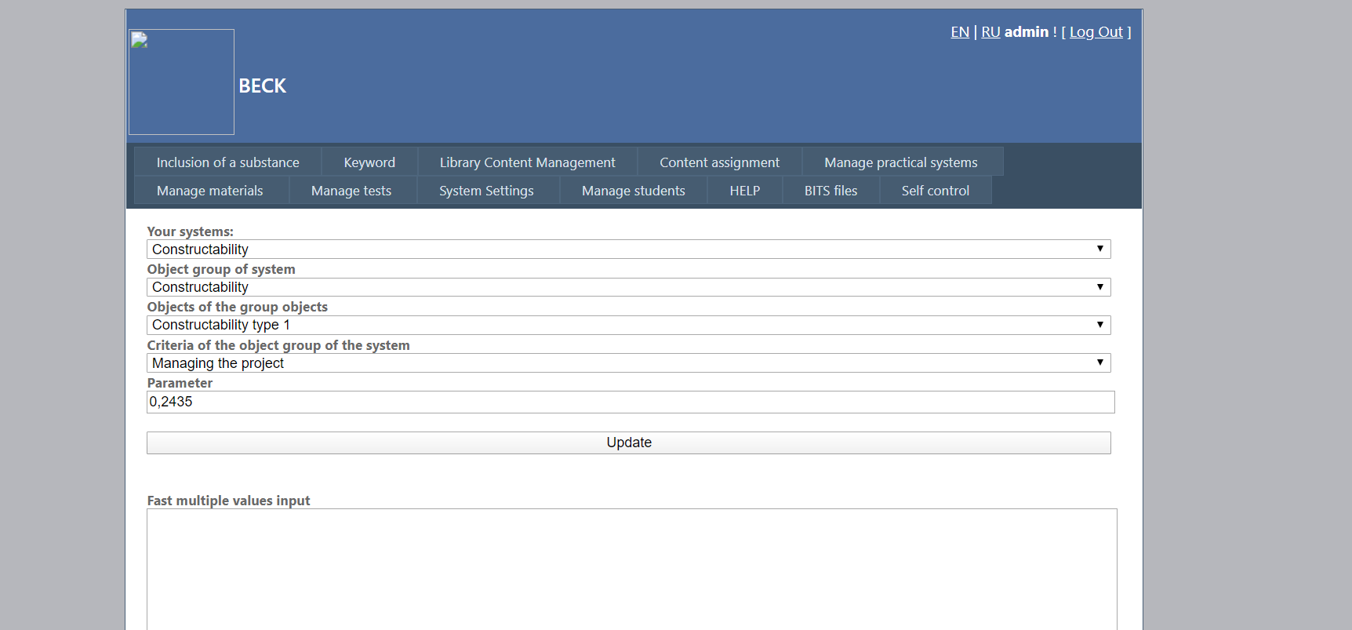
Fast entry field, e.g.:
124.0
126.7
125.4
12.12

Fig. 11. Window including the system parameter entry

  - Data shall be typed in columns; it could be added with the help of Ctrl+V shortcut key.
  - Click “Quick refresh”.
- Values of other alternatives are indicated by analogy selecting it on the list “Objects of an object groups”.
- To exit the system click [Logout] at the upper right corner of the window.

The user should indicate the system to be used in order to assign parameter to the required object. According to the title select created system to be used for parameter editing in the list “My systems”. Select the object group in the menu “System object groups” for further editing of parameters. Use “Objects of the object group” to select the required object (alternative). Then, using the “Criteria of the system object group” list select the criterion to be used for indication or editing of a value (parameter) (e.g.: “Price”, Fig. 12). Type in/edit the value of alternative parameter in the “Parameter” field (e.g.: 471.74) and press “Refresh”. In order to include all values of alternative criteria, use the fast entry field between the “Refresh” and “Quick refresh” buttons. To prevent the blank fields assigned to particular parameters of objects (not to disturb calculation process), special validation mechanism could be used. Validation mechanism should be activated by clicking the “Validate system” button at the bottom part of the page. User would be informed about errors on page, detected by the validation system, displaying them on the screen.
Page, containing initial data (Fig. 17), could be reviewed after system creation by entering the “My systems” option and clicking the system title link.
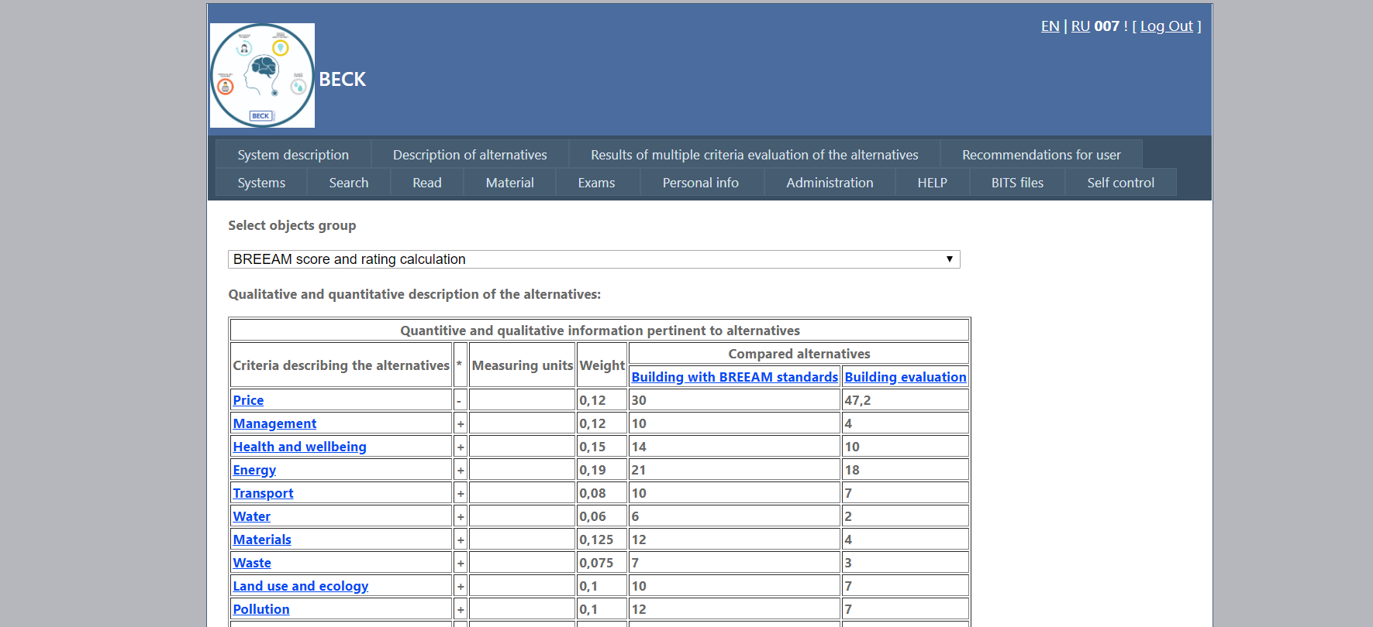
Page 12. Section of the page containing the list of initial data used for practical training system
Activated page will include the following links:
  - “System description” – information about the system which has been indicated by the user;
  - “Alternative description” – accessible description of alternatives (objects), which could be viewed by clicking the title of the required alternative (object) on the initial data list (Fig. 17.);
  - “Assessment results of several alternatives” – calculation results of the particular object group;
  - “Trial design” – the best combinations of alternatives selected out of each object group during the trial design;
  - “Alternative multicriterion analysis” – the best combinations of alternatives selected out of each object group during the multicriterion analysis;
  - “Recommendations to users” – includes automatically generated recommendations regarding the improvement of alternative competitiveness for concerned parties (e.g.: which criteria impact the rating most);

Material loading

Modules names loading

In the resulting window, in the field of „The new module name“, add new module name.
The training module name can be changed by pressing the module next to the name (left side) on the link "Edit". Then the module name field becomes editable. To disable editing features, you press the "Cancel". Clicking the 'Update' editing changes made are confirmed.
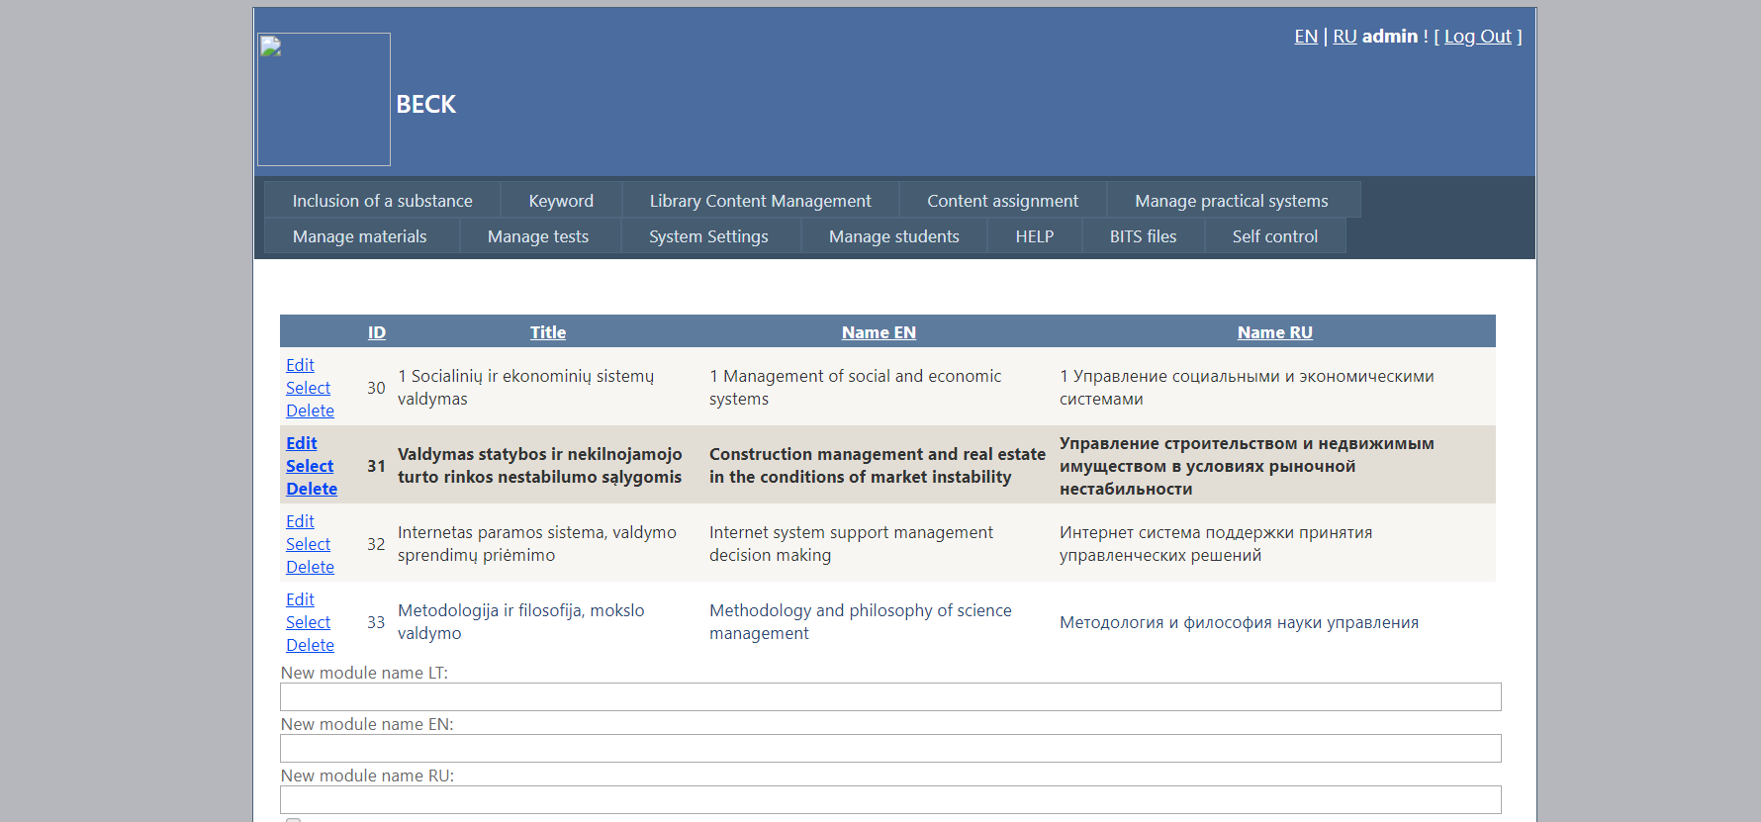
Fig. 13. New learning module loading

To add a topic to be recorded in its name under "New Subject" of the fields and click "Add new topic". To edit the name of the topic already created, press the right side of the title of the link "Edit". Clicking the link, "Name" field becomes editable.
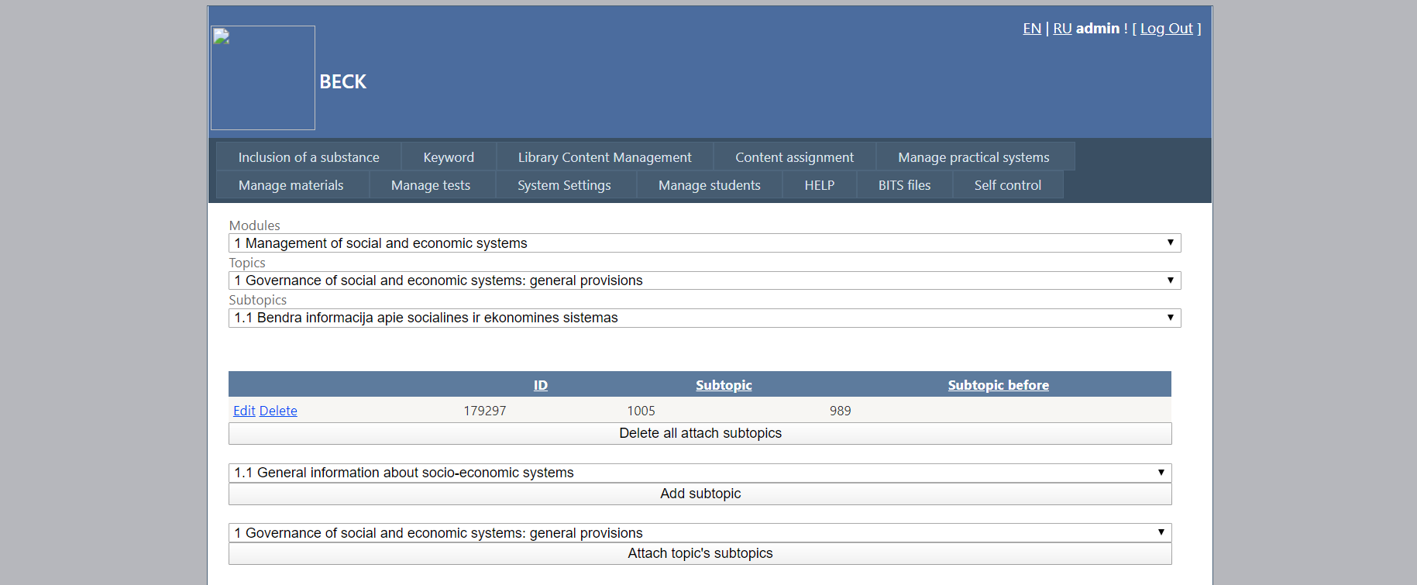
Fig. 14. New theme of module loading

To add a new sub-topic to be recorded in its name under "Name the new sub-themes" of the fields and click the button "Add a new sub-topic. To edit the name of the sub-themes are already in place, press the right side of the title of the link "Edit". Clicking the link, "Name" field becomes editable.
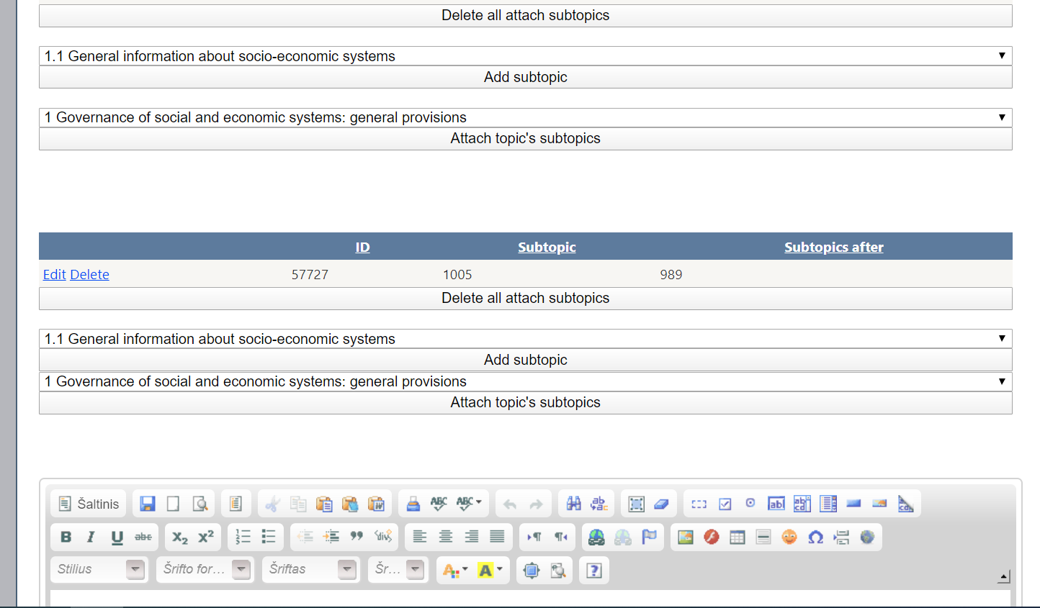
Fig 15. New Subtopic loading

Material loading

To assign a training module topics and material need subthemes:
1) select the text on the "Modules" in the drop down menu the desired module, for example. "Exceptional construction project manager;
2) next to the text "View" in the drop down menu the desired subject, for example.: 1. Preparation of design data;
3) over the button "Add subtheme" drop down menu, you can select a sub-topic, which we want to assign learning materials;
4) Click "Add sub-topic" button.
The following procedure describes how to specify the topics that should learn before and after learning the subject.
After the text "What topics should be learned for the study of this topic can specify which sub-topics to study, you should choose a drop down menu above the button" Add sub-topic and subtopic you want to click "Add a subtopic.
If you want to include all of one sub-topics , then it can be over the button "Add sub-topics " to select the section of the main points you want to add and click the button " Add sub-topics .
If an error is made under sub-themes , you can press the " Delete all assigned sub-themes , in this case the whole assignment must be specified again.
After the text " What topics should study under this topic can be specify which sub-topics to study , you should choose a drop down menu above the button " Add sub-topic and subtopic you want to click " Add a subtopic .
If an error is made under sub-themes , you can press the " Delete all assigned sub-themes , in this case the whole assignment must be specified again.
If you want to include all of one sub-topics , then it can be over the button "Add sub-topics " to select the section of the main points you want to add and click the button " Add sub-topics .
If an error is made under sub-themes , you can press the " Delete all assigned sub-themes , in this case the whole assignment must be specified again.
Specifying what subtopics to study before and after the module to the sub-themes are tached study material .
The following is a description of the opportunity to provide links to additional sources of training topics (publications and web links )
Under " Additional study literature" in the text box is loaded studying literature and pressed the button "Add additional literature .
To edit additional studying literature " pressing" Edit " after changes need to click " Update " to discard changes " Cancel . "
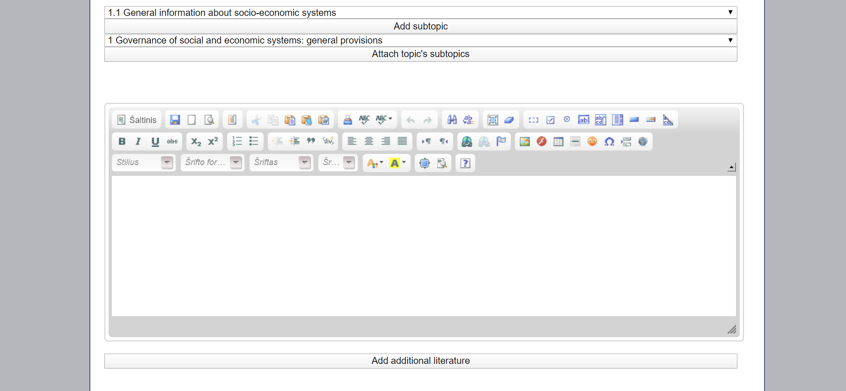
Fig. 16. Material loading

Additional material loading

Select "add additional material, can be selected course topic and the type of place links to additional materials.
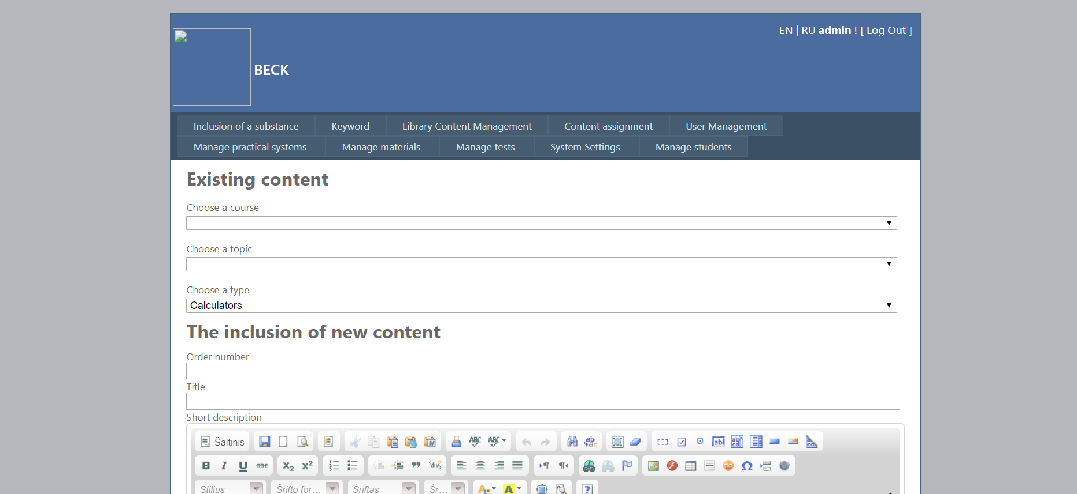
Fig. 17. Additional material loading

System settings

- System Settings - User Management
- Optional role "Student"
- Filled with fields: User Name, Password and Email
- Click "Create an Account"
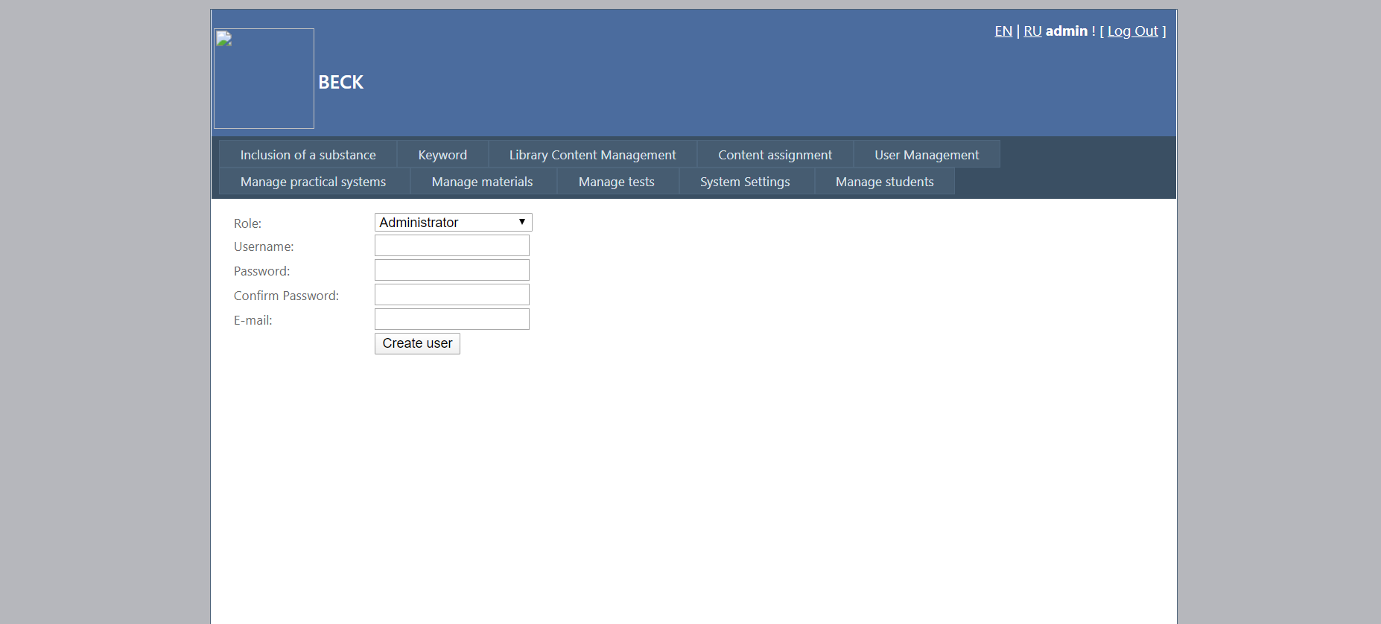
Fig.25. New tutor account name creation.

Student administrative

Students

When you click on the link in the main menu "Manage students -" Students, all students featured list. After filling in the required fields (Student ID, First Name, Last Name, etc.). Creates a new user.

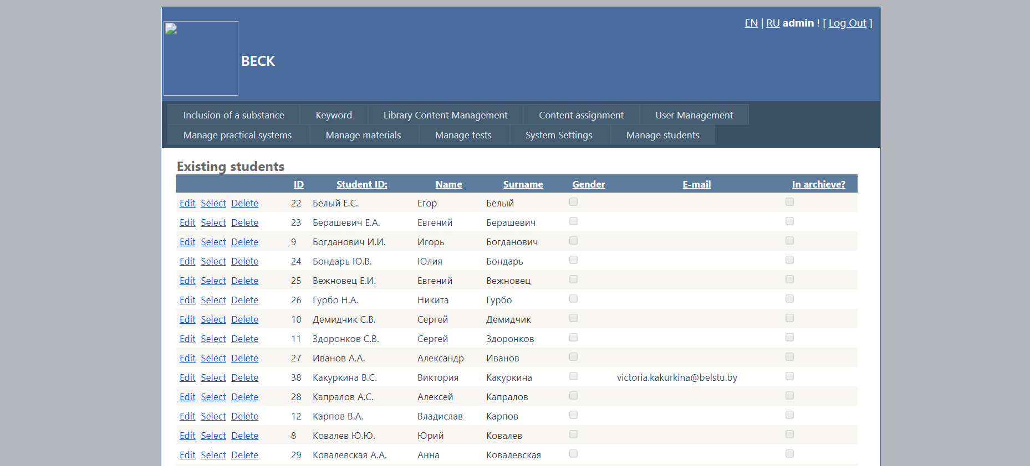
Fig. 26. Students acounts list

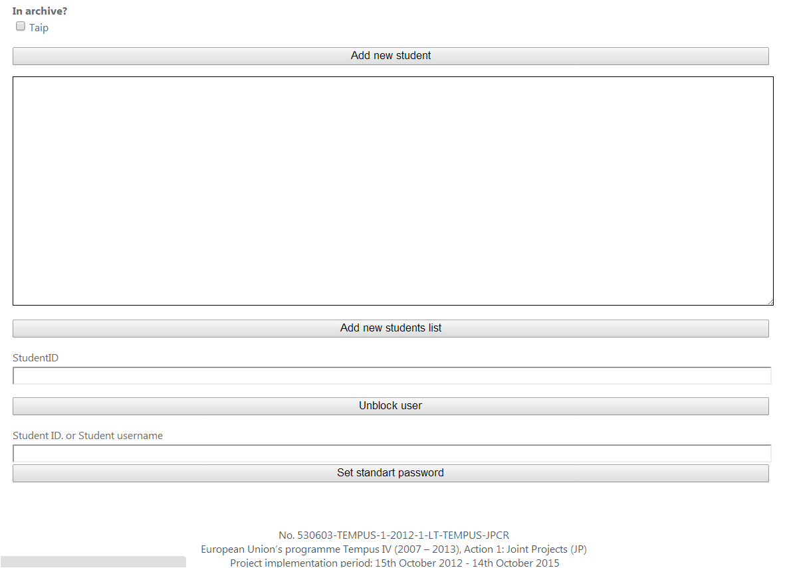
Fig. 27. Student acounts creation

Students according to the group.

To assign a group of students, select the menu link "Manage students -" Students by Group. After selecting the appropriate institution, faculty, program, and a group of students and a student or a list, click on the "Add student"

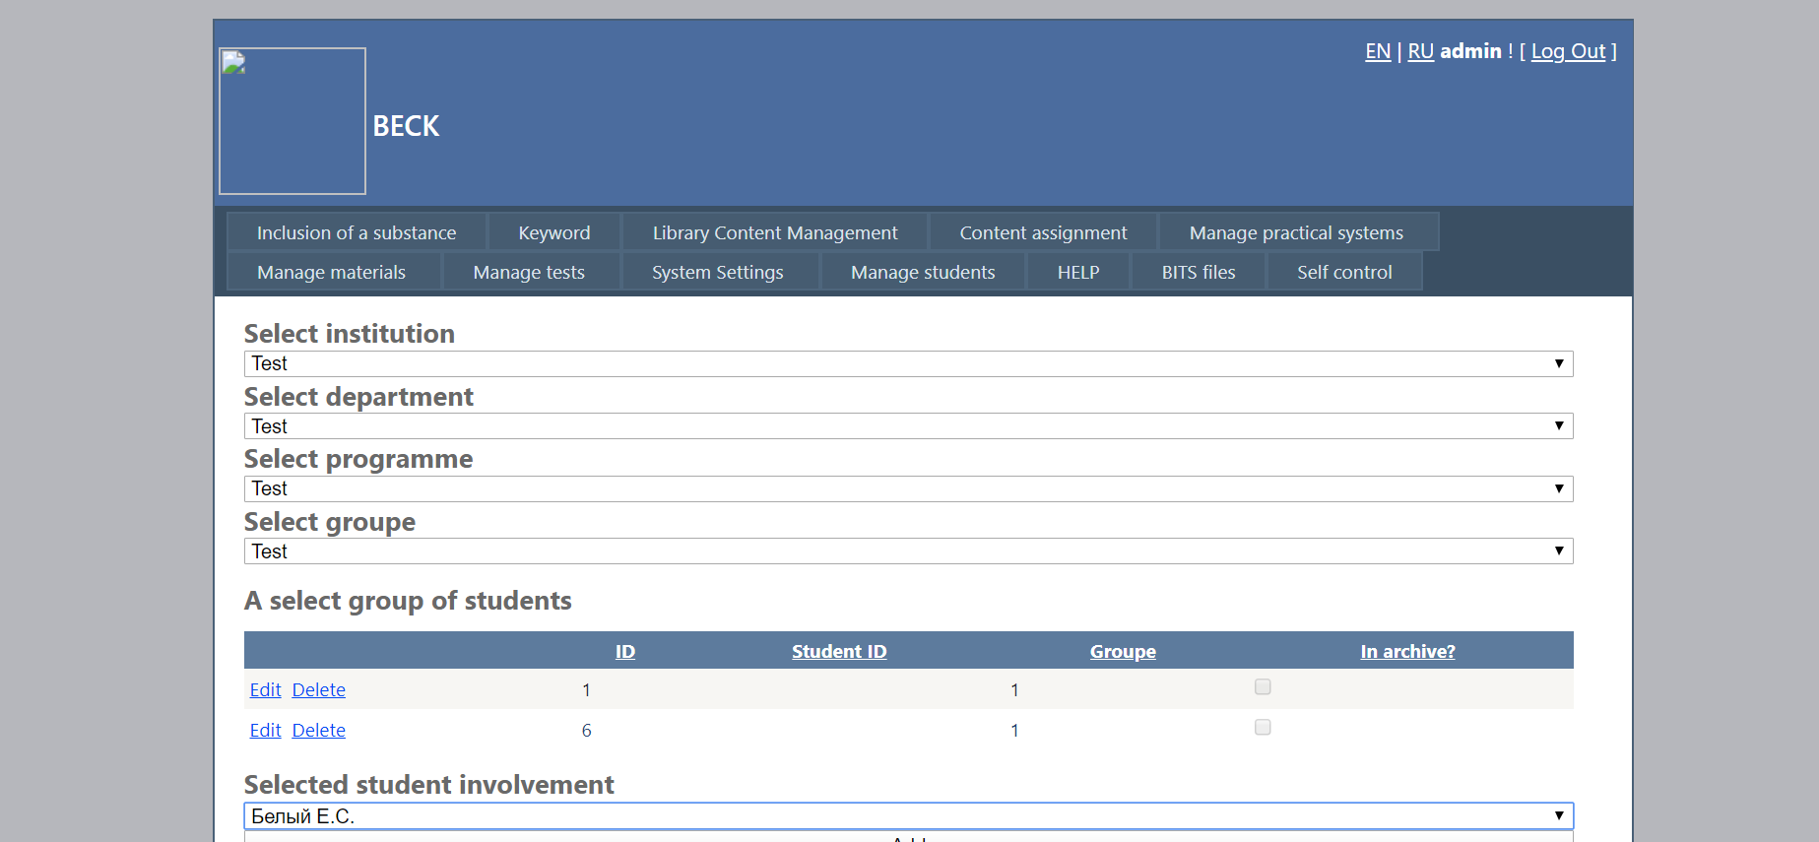
Fig. 28. Studento or they list assign to group

Institution loading

To add a new authority, click on the menu link "Manage Students" - "Manage Institutions.
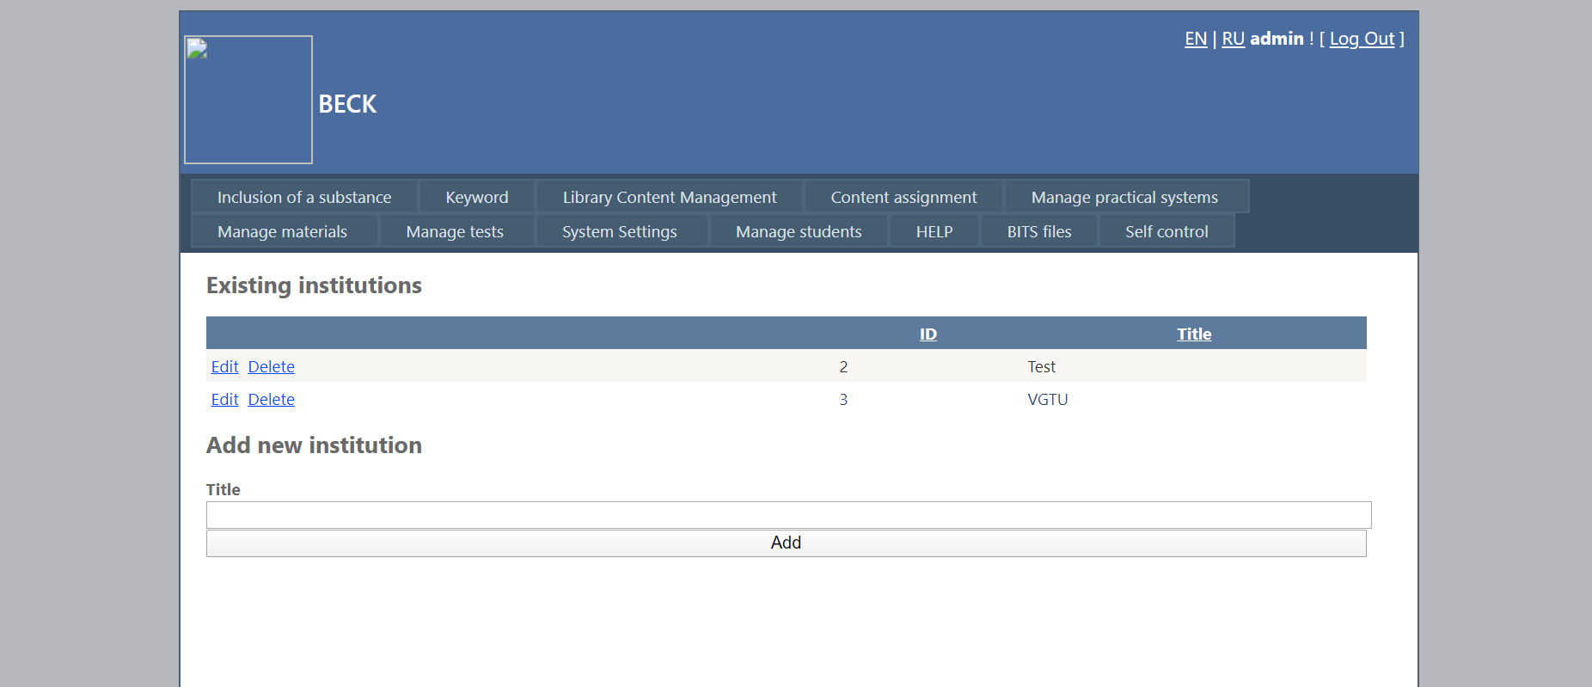
Fig 29. New institution loading

New faculty loading

To add new faculty, click on the menu link "Manage Students" - "Manage Faculties. Select an institution and have written a new faculty, click "Add"

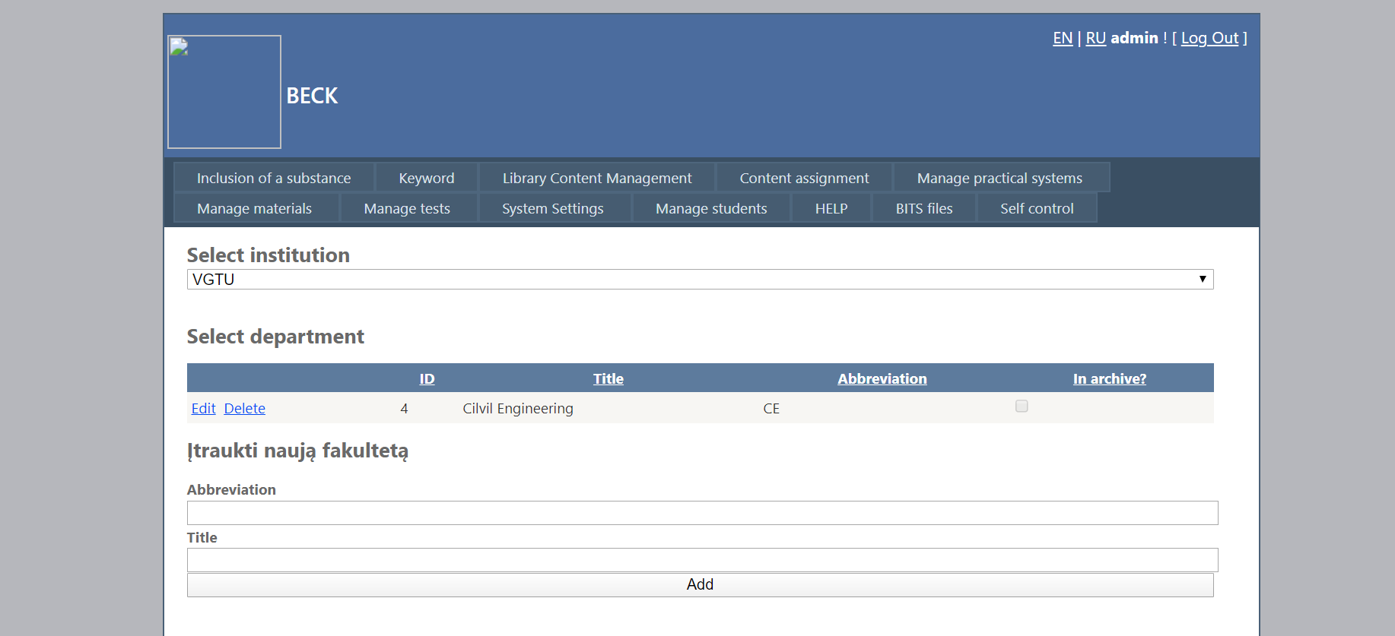
Fig. 30. New faculty loading

New program loading

To add a new program, click on the menu link "Manage Students" - "Manage study program". After selecting the desired body and faculty, write a new program name and acronym. Check if undergraduate studies. Click the "Add"

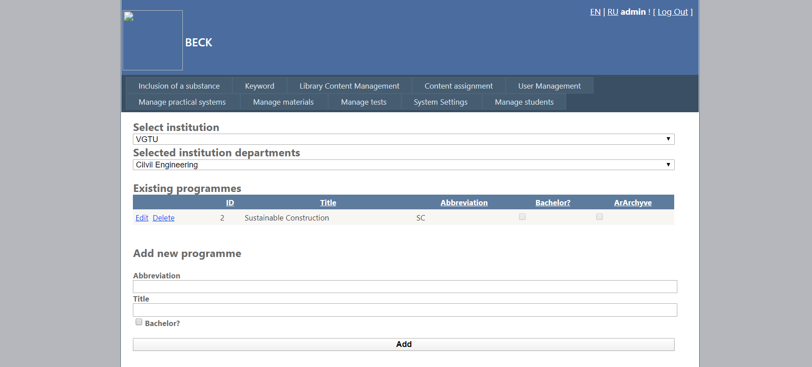
Fig. 31. New program loading

New group loading

To add a new program, click on the menu link "Manage Students" - "Manage groups". After selecting the appropriate authority, the faculty and the program, enter a new group abbreviation, and year. Click the "Add"

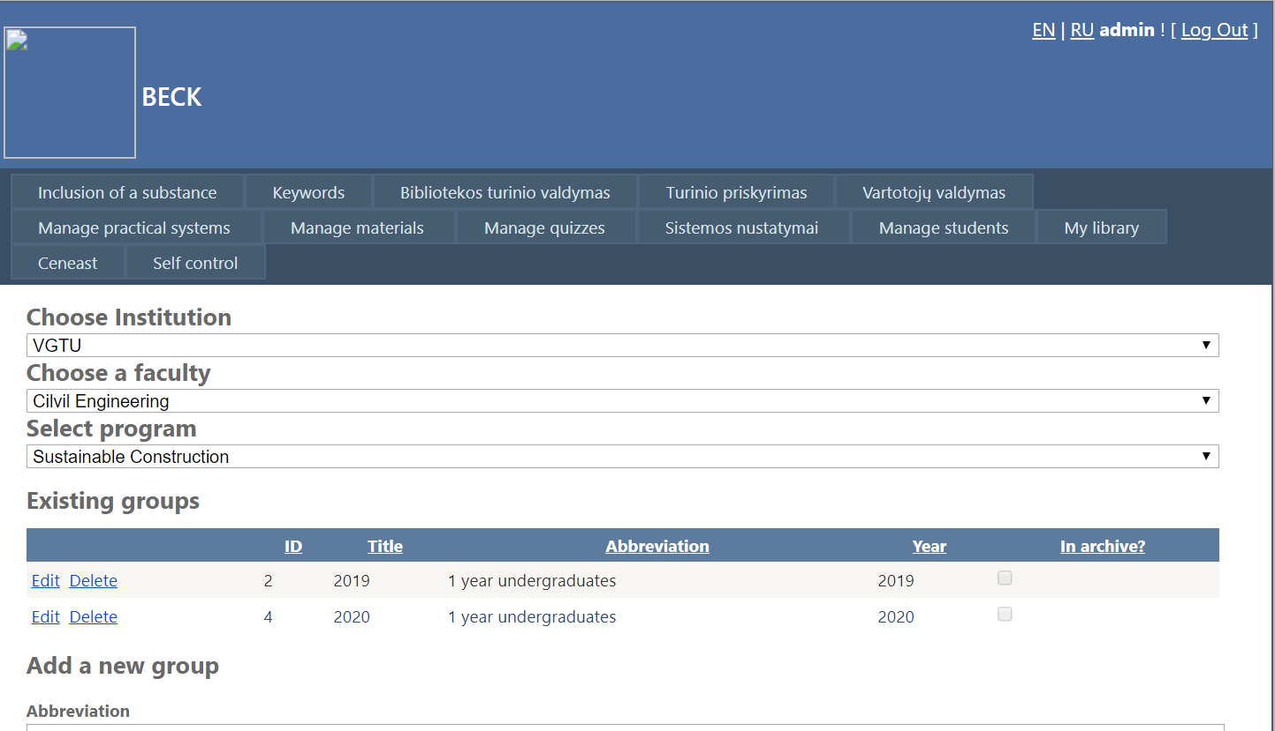
Fig 32. New group loading

